Unit 8 Lesson 14: Sort and Color Expressions and Images within 5

Choral Count: Practice Counting On (Warm up)

Student Task Statement

1 Owl Color

Student Task Statement
Color each section.
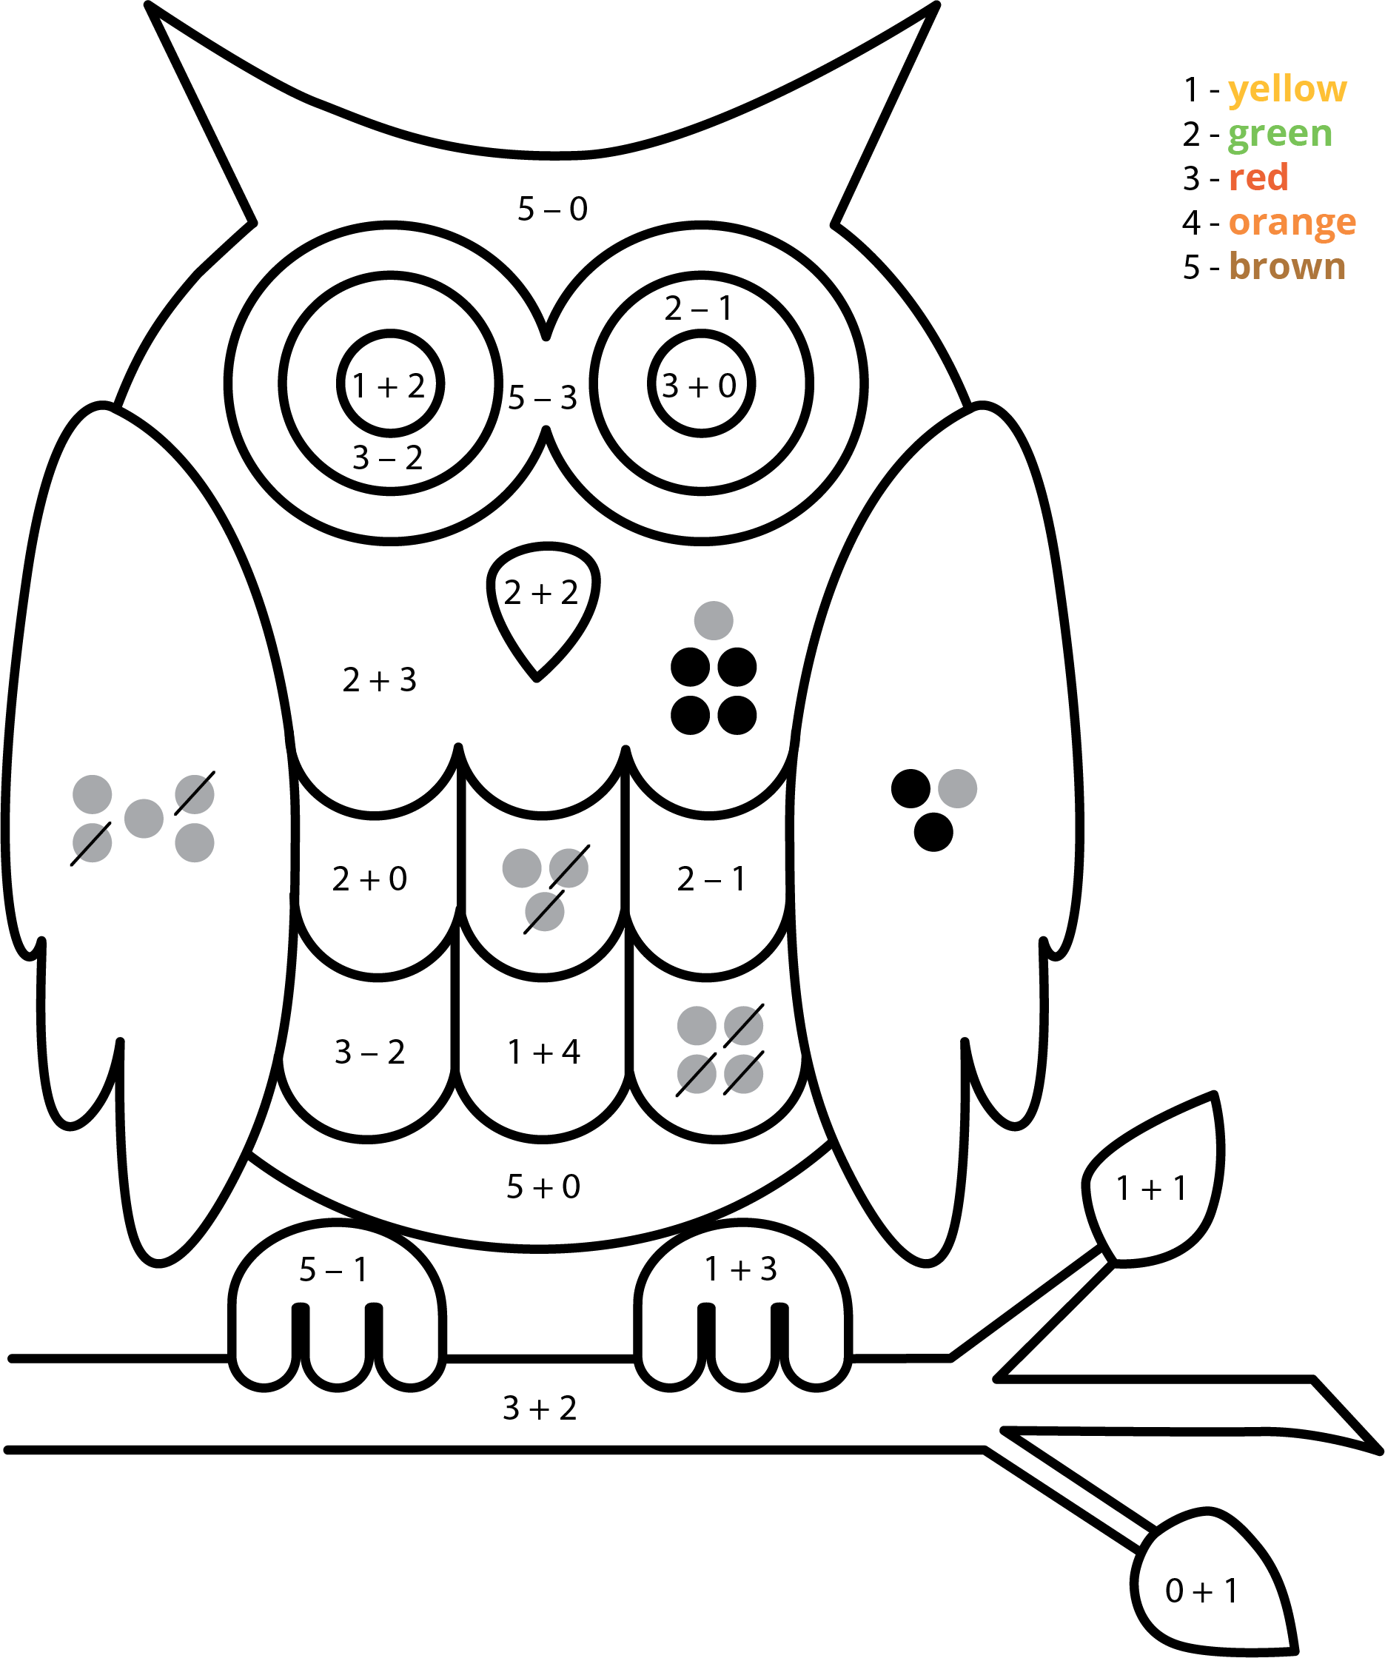

2 Sort Expressions by Total and Difference

Student Task Statement

3 Centers: Choice Time

Student Task Statement
Choose a center.
5-frames
Roll and Add
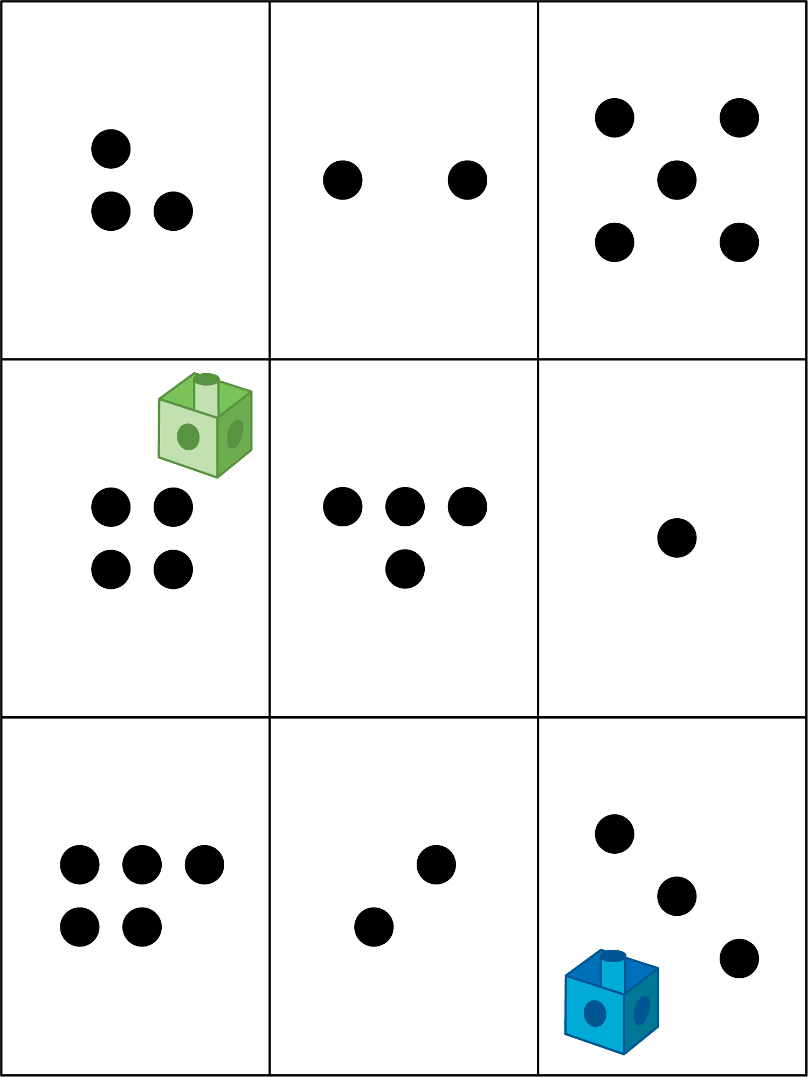
Bingo
Geoblocks
Find the Value of Expressions

Images for Activity Synthesis
© CC BY 2021 Illustrative Mathematics®

