Unit 1 Lesson 1 Cumulative Practice Problems
- The six frames show a shape's different positions.
- 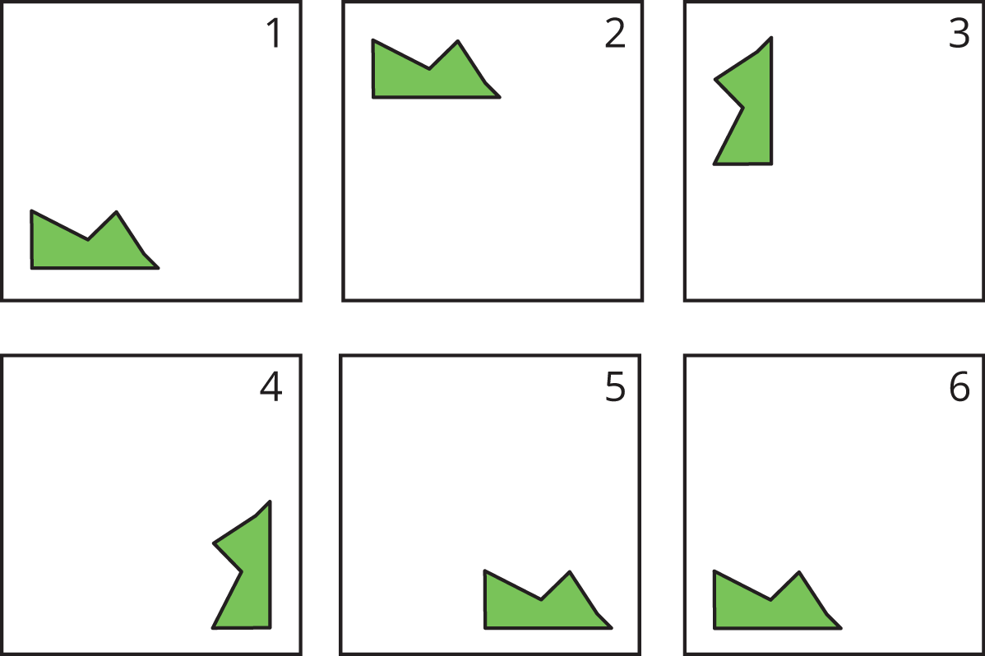
- Describe how the shape moves to get from its position in each frame to the next.
- These five frames show a shape's different positions.
- 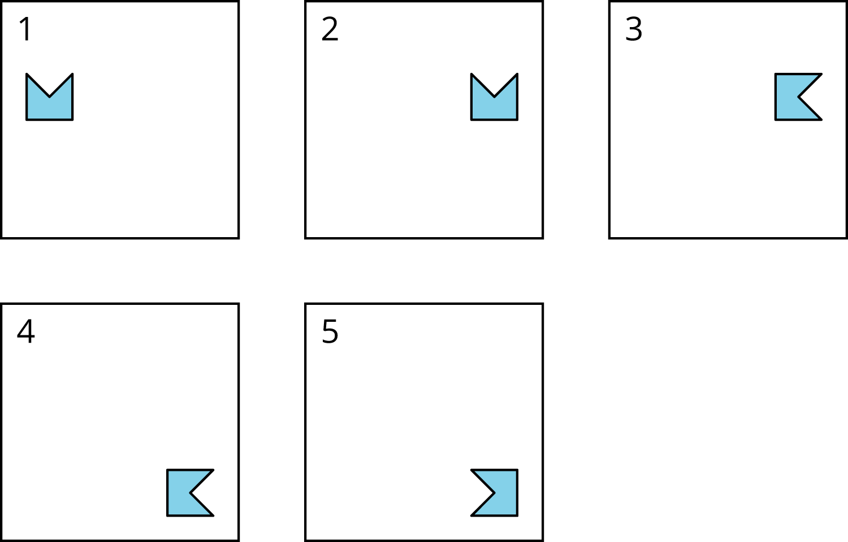
- Describe how the shape moves to get from its position in each frame to the next.
- Diego started with this shape.
- Diego moves the shape down, turns it 90 degrees clockwise, then moves the shape to the right. Draw the location of the shape after each move.
© CC BY Open Up Resources. Adaptations CC BY IM.

