Unit 2 Lesson 3: Dilations with no Grid

1 Points on a Ray (Warm up)

Student Task Statement
- Find and label a point $C$ on the ray whose distance from $A$ is twice the distance from $B$ to $A$.
- Find and label a point $D$ on the ray whose distance from $A$ is half the distance from $B$ to $A$.
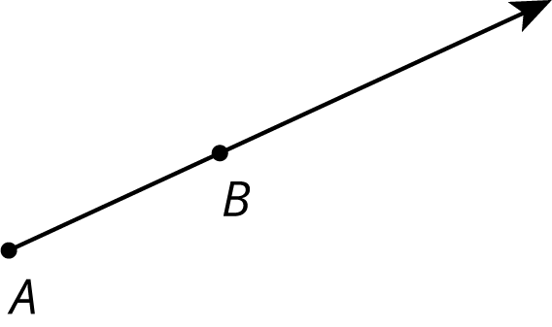

2 Dilation Obstacle Course

Images for Launch
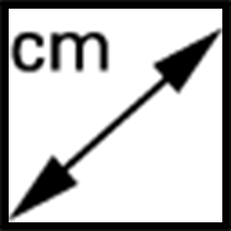

Student Task Statement
Here is a diagram that shows nine points.
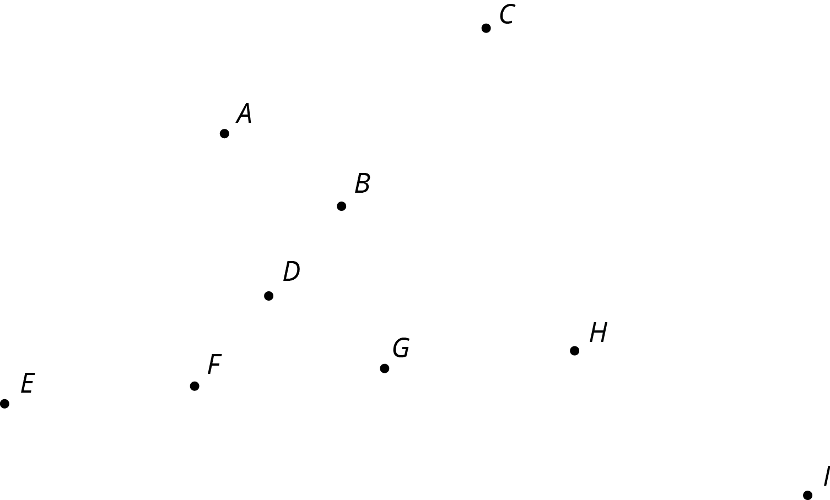
- Dilate $B$ using a scale factor of 5 and $A$ as the center of dilation. Which point is its image?
- Using $H$ as the center of dilation, dilate $G$ so that its image is $E$. What scale factor did you use?
- Using $H$ as the center of dilation, dilate $E$ so that its image is $G$. What scale factor did you use?
- To dilate $F$ so that its image is $B$, what point on the diagram can you use as a center?
- Dilate $H$ using $A$ as the center and a scale factor of $\frac{1}{3}$. Which point is its image?
- Describe a dilation that uses a labeled point as its center and that would take $F$ to $H$.
- Using $B$ as the center of dilation, dilate $H$ so that its image is itself. What scale factor did you use?

3 Getting Perspective

Images for Launch
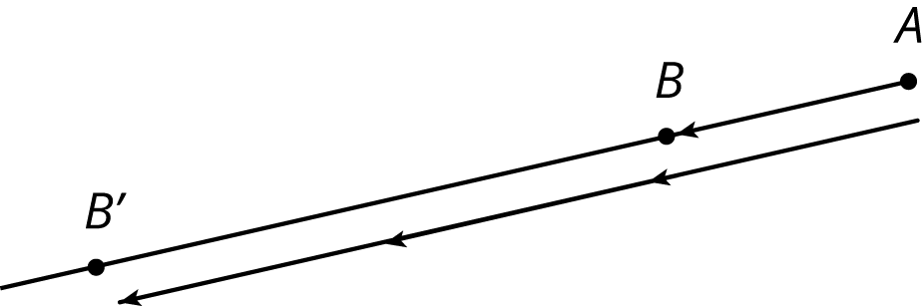
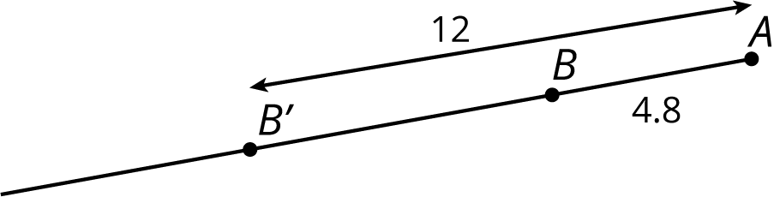
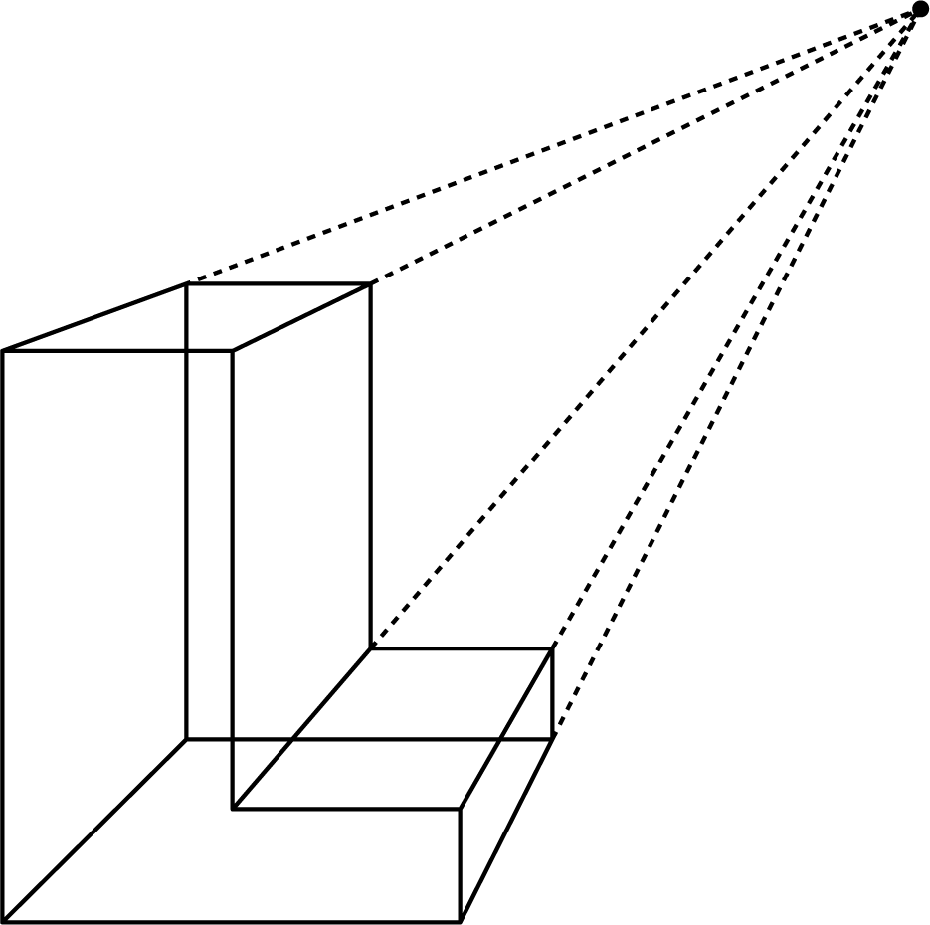

Student Task Statement
- Using one colored pencil, draw the images of points $P$ and $Q$ using $C$ as the center of dilation and a scale factor of 4. Label the new points $P^{′}$ and $Q^{′}$.
- Using a different color, draw the images of points $P$ and $Q$ using $C$ as the center of dilation and a scale factor of $\frac{1}{2}$. Label the new points $P^{″}$ and $Q^{″}$.
- Pause here so your teacher can review your diagram. Your teacher will then give you a scale factor to use in the next part.
- Now you’ll make a perspective drawing. Here is a rectangle.
  - Choose a point inside the shaded circular region but outside the rectangle to use as the center of dilation. Label it $C$.
  - Using your center $C$ and the scale factor you were given, draw the image under the dilation of each vertex of the rectangle, one at a time. Connect the dilated vertices to create the dilated rectangle.
  - Draw a segment that connects each of the original vertices with its image. This will make your diagram look like a cool three-dimensional drawing of a box! If there’s time, you can shade the sides of the box to make it look more realistic.
  - Compare your drawing to other people’s drawings. What is the same and what is different? How do the choices you made affect the final drawing? Was your dilated rectangle closer to $C$ than to the original rectangle, or farther away? How is that decided?
© CC BY Open Up Resources. Adaptations CC BY IM.

