Lesson 10: Fractional Side Lengths Less Than 1
- Let’s find the area of rectangles with a fractional side length.

Warm-up: Estimation Exploration: What is the Area?
What is the area of the shaded region?
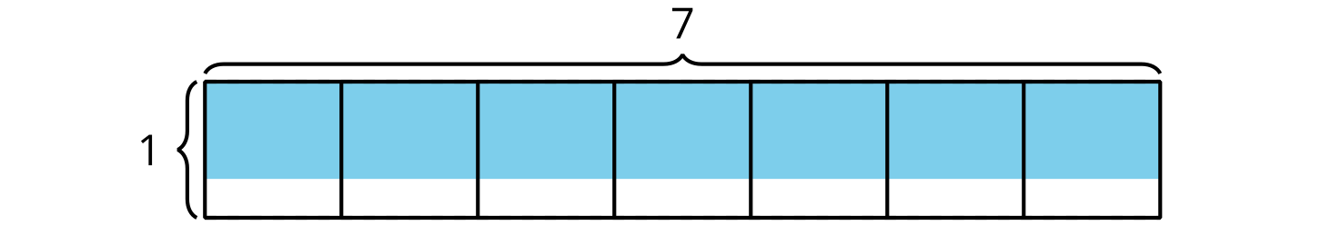
Record an estimate that is:
too low | about right | too high

10.1: Rectangle With a Fractional Side Length
Write a multiplication expression to represent the area of each shaded region. Then find the area.

- 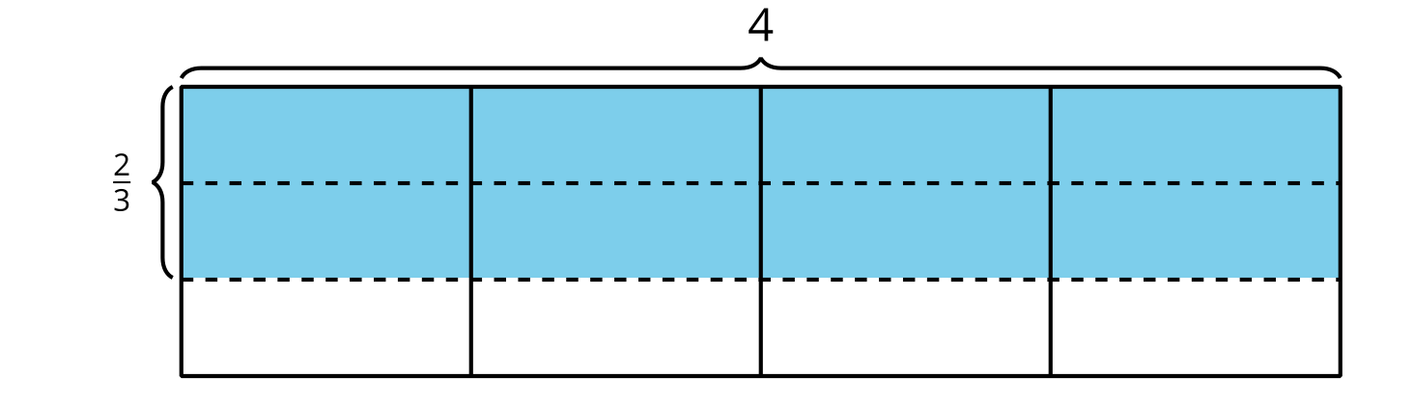

- 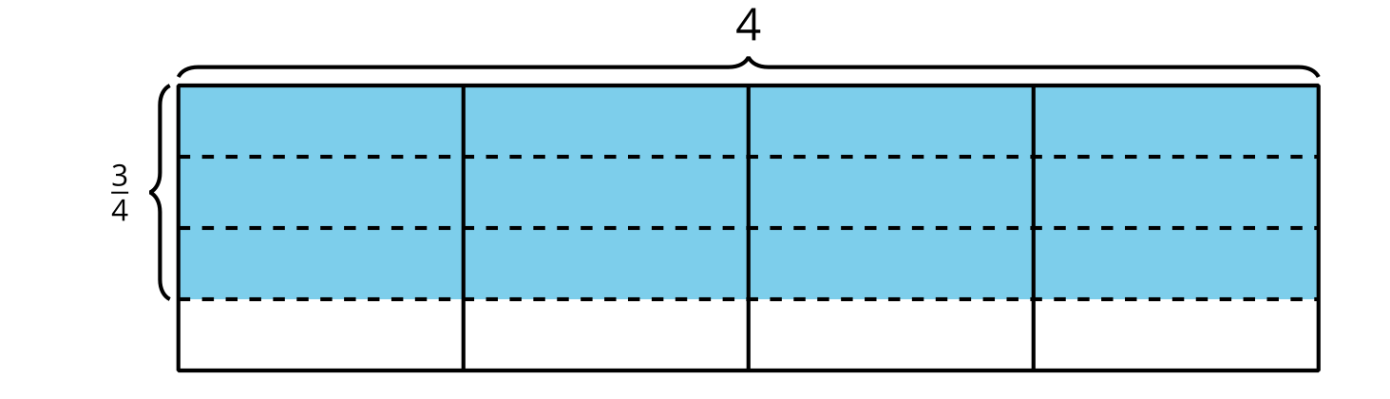

- 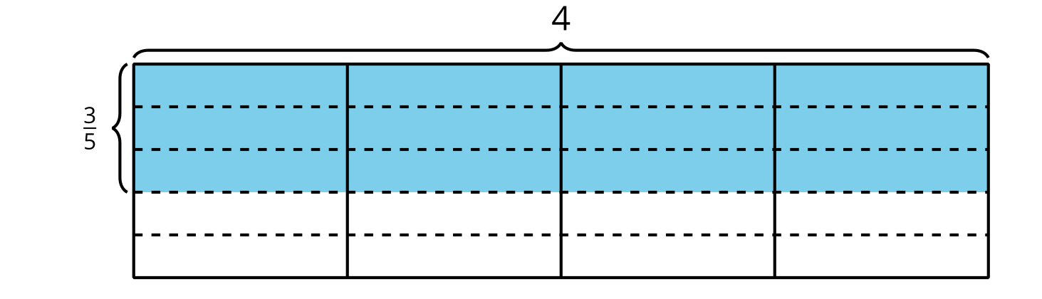

10.2: What Are the Side Lengths?
- Write a multiplication expression to represent the area of the shaded region. What is the area?
- 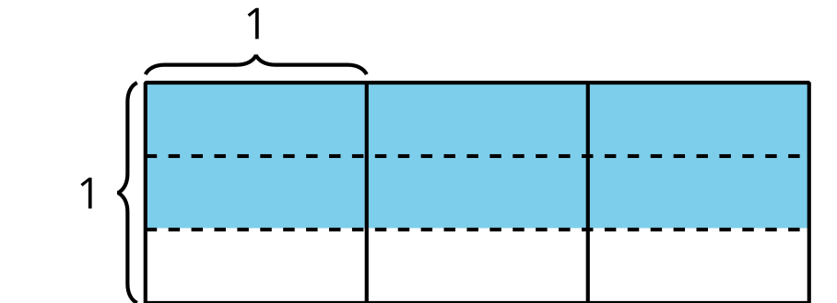
- Here are two diagrams. Consider each expression and decide whether it represents the shaded region in one of the diagrams. Be prepared to share your thinking.
- X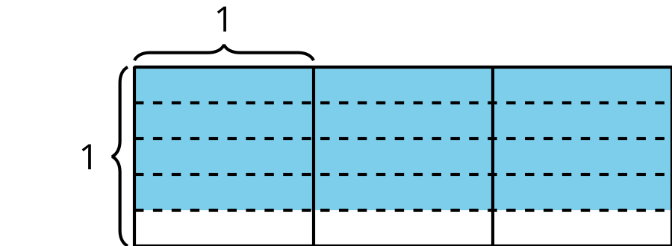
- Y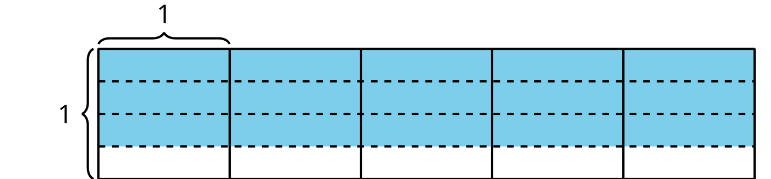
  - $\frac{3}{4}×5$
  - $3×\frac{3}{5}$
  - $3×4×\frac{1}{5}$
  - $4×\frac{3}{4}$
  - $3×3×\frac{1}{4}$
- For each diagram, what is the area?
© CC BY 2021 Illustrative Mathematics®

