Unit 8 Lesson 3: Count to Add and Subtract

WU Choral Count: Forward and Backward (Warm up)

Student Task Statement

1 Ride the Bus

Student Task Statement
- There were 7 people on the bus.
Then 1 more person got on the bus.
How many people are on the bus now?
- Show your thinking using objects, drawings, numbers, or words.
- _______________
- There were 10 people on the bus.
Then 1 person got off the bus.
How many people are on the bus now?
- Show your thinking using objects, drawings, numbers, or words.
- _______________

2 Singing Students

Student Task Statement
- __________ students were singing.
Then 1 more student came to sing with them.
How many students are singing now?
- Show your thinking using objects, drawings, numbers, or words.
- _______________
- __________ students were singing.
Then 1 student stopped singing and went home.
How many students are singing now?
- Show your thinking using objects, drawings, numbers, or words.
- _______________

3 Centers: Choice Time

Student Task Statement
Choose a center.
Less, Same, More
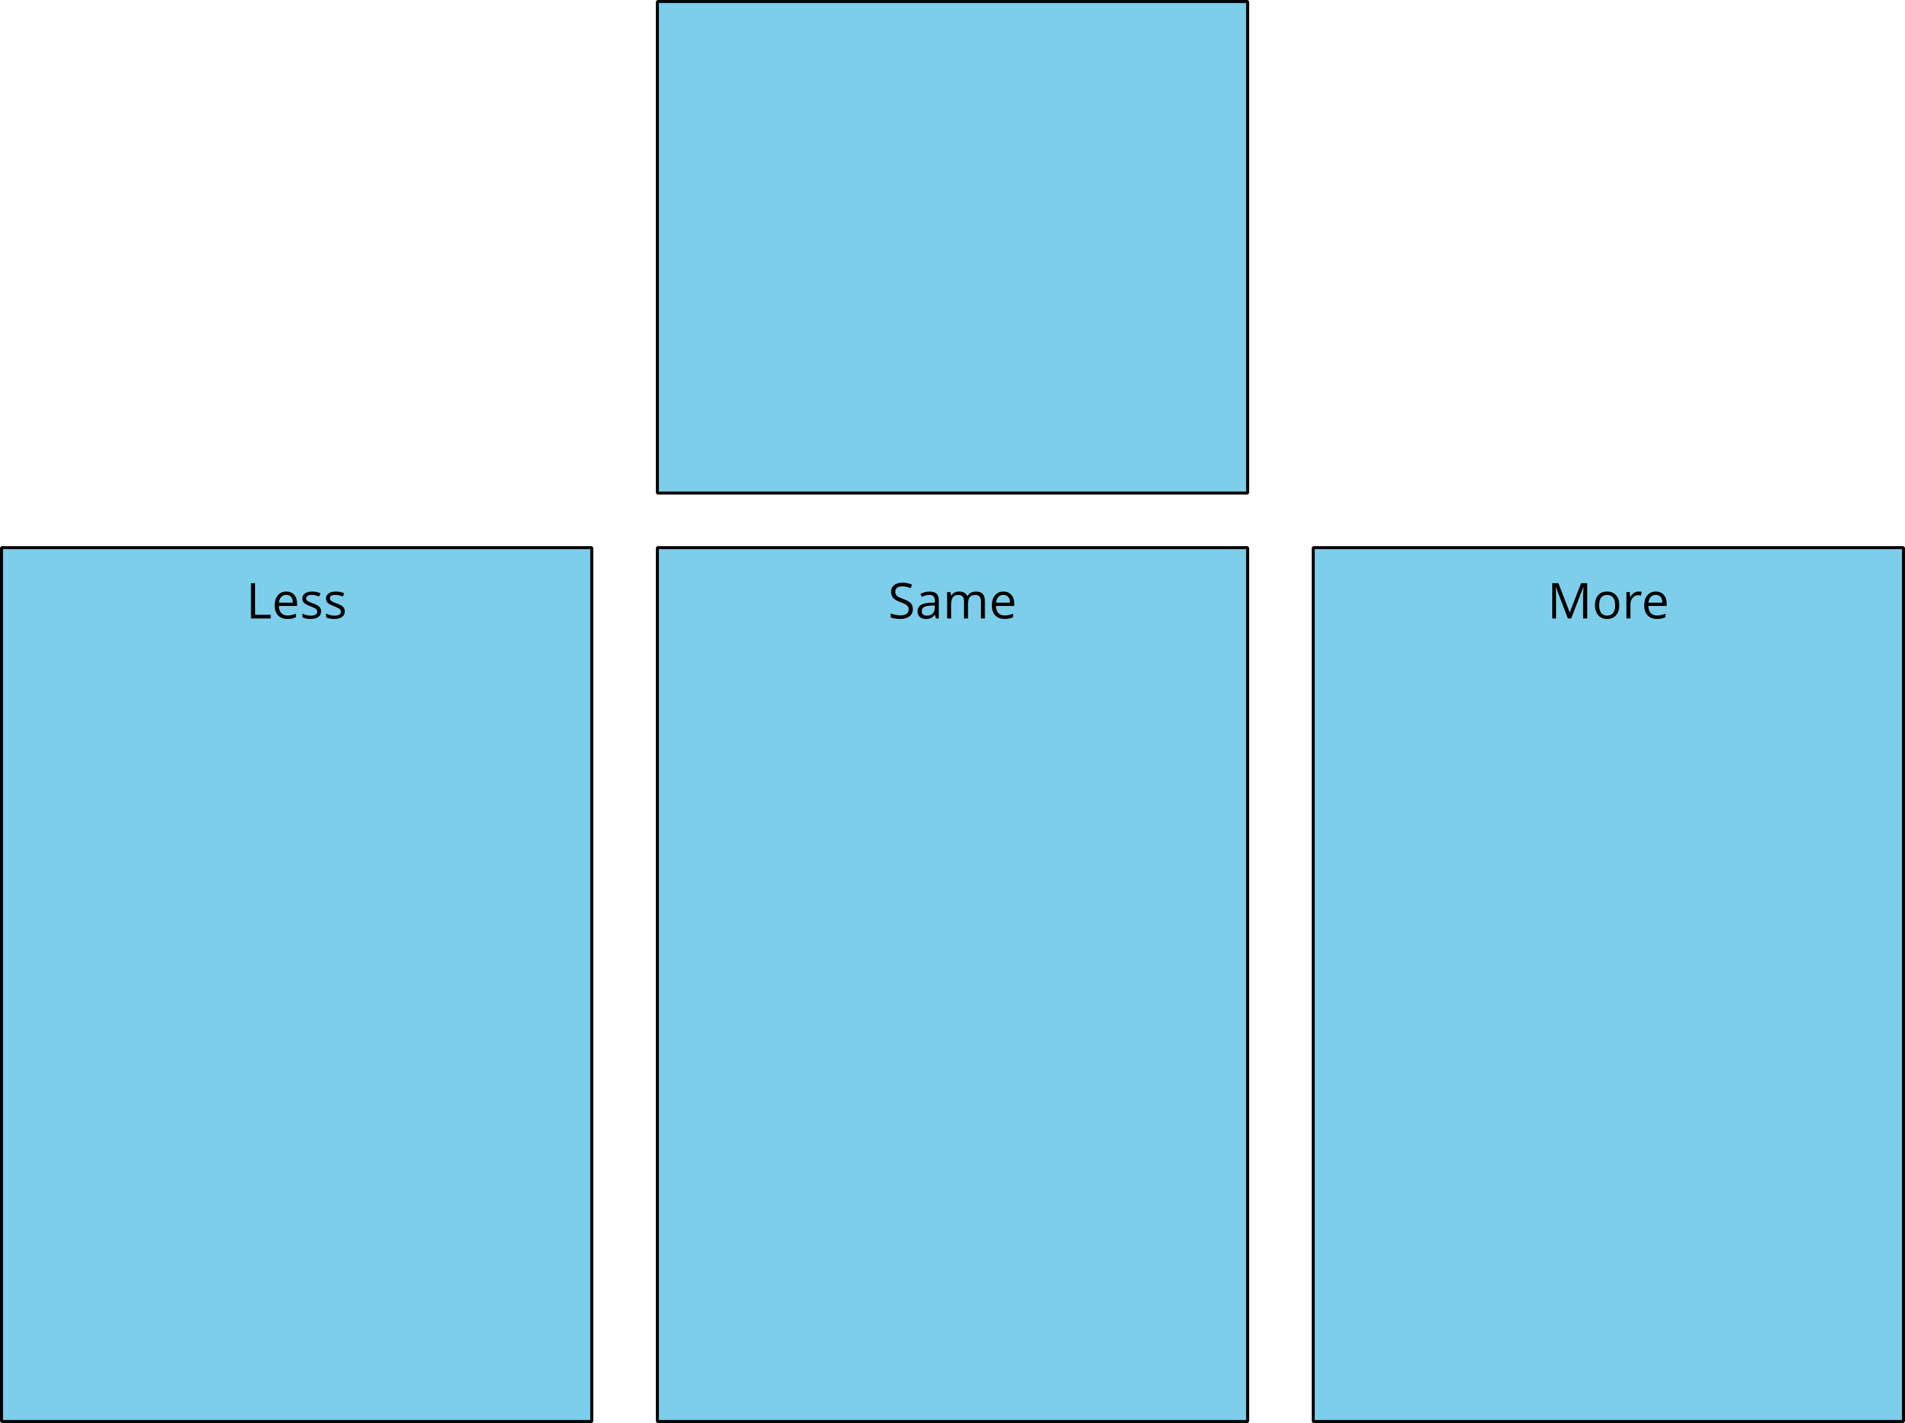
Math Fingers
Tower Build
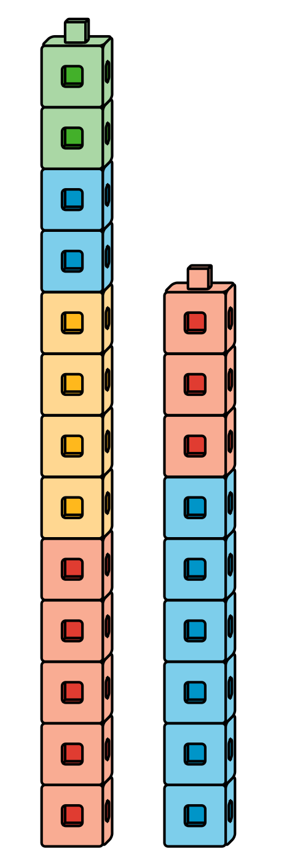
Math Stories
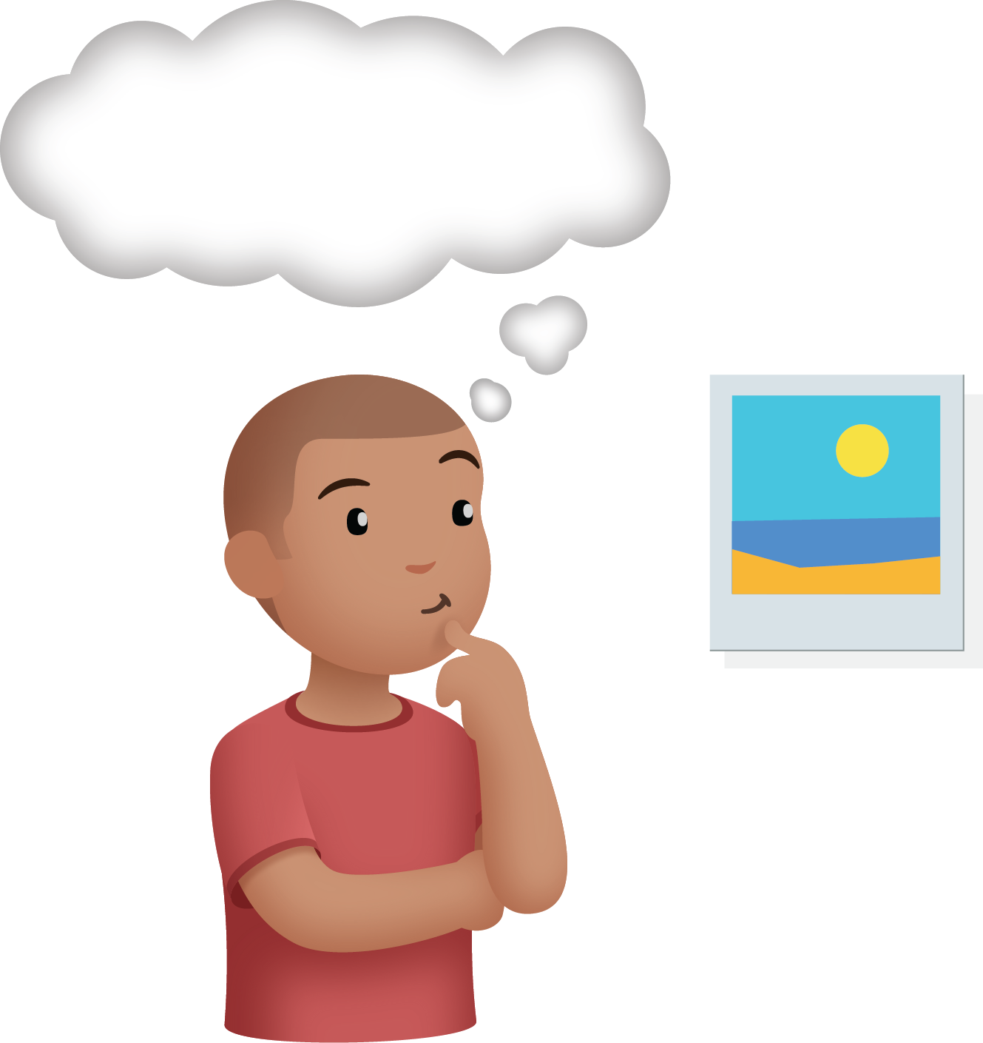
Which One
© CC BY 2021 Illustrative Mathematics®

