Lesson 11: Different Ways to Add and Subtract
- Let’s add and subtract by using a ten.

Warm-up: Number Talk: Use Tens
Find the value of each expression mentally.
- $32−6$
- $43−8$
- $51−5$
- $52−7$

11.1: Compare Methods
Diego and Tyler found the value of $53−29$. Their work is shown.
Diego’s Method:
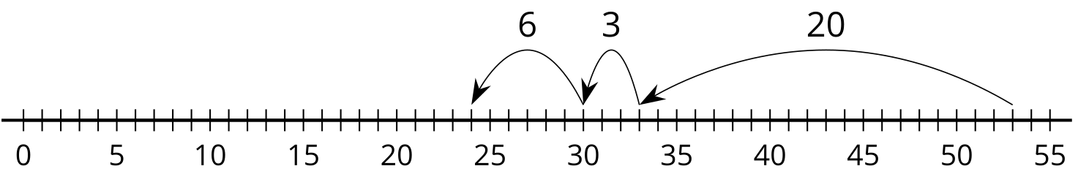
Tyler’s Method:
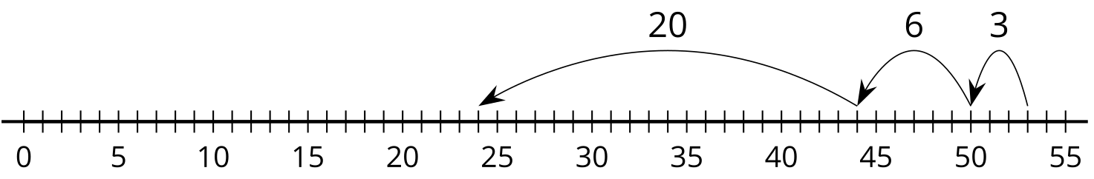
- Use Diego’s method to find the value of $82−35$.
- Use Tyler’s method to find the value of $66−28$.

11.2: More Methods
Partner A
- Find the value of $59+27$.
- Find the value of $65−18$.
Partner B
- Find the value of $68−39$.
- Find the value of $22+49$.
© CC BY 2021 Illustrative Mathematics®

