Lesson 13: Compare Favorite Art Supply Data
- Let’s compare data.

Warm-up: Notice and Wonder: More and Fewer
What do you notice?
What do you wonder?
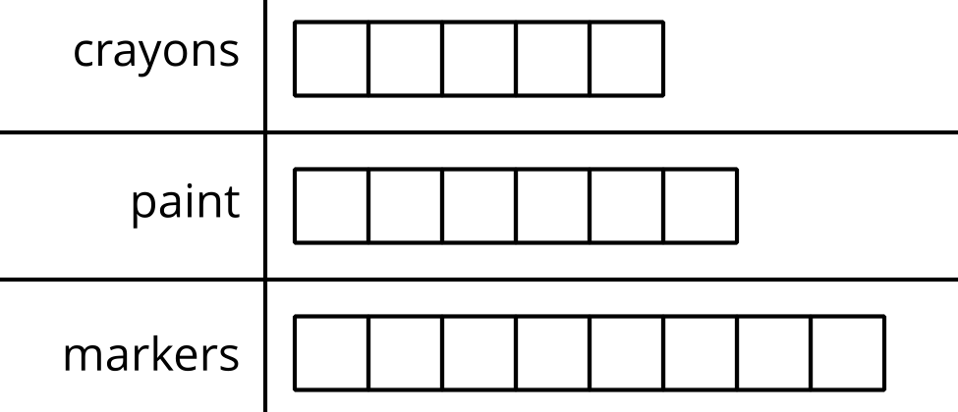

13.1: Compare Data (Part 1)
A group of students was asked, “What is your favorite art supply?”
Their responses are shown in this chart.
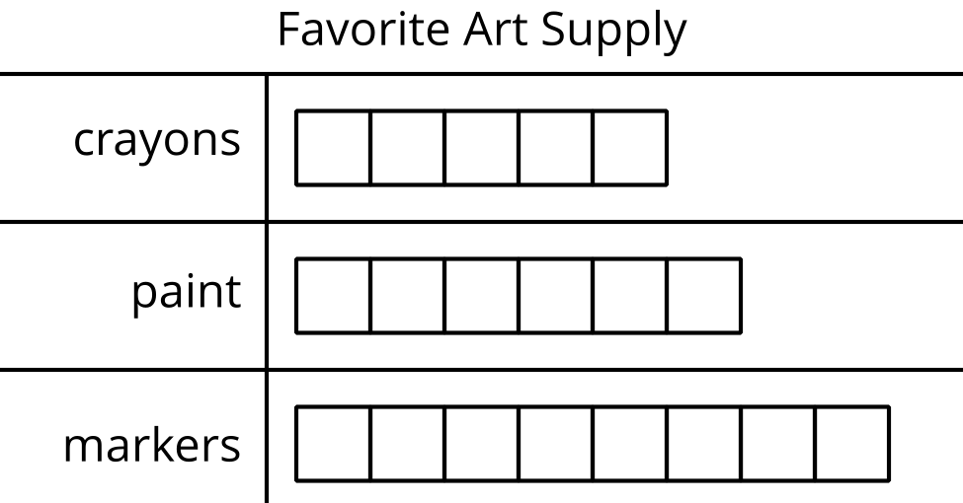
- More students voted for crayons than markers.
- Fewer students voted for crayons than paint.
- Three more students voted for markers than crayons.
- Show your thinking using drawings, numbers, or words.
- One more student voted for paint than crayons.
- Show your thinking using drawings, numbers, or words.
- One fewer student voted for paint than markers.
- Show your thinking using drawings, numbers, or words.
If you have time: Change the false statements to make them true.

13.2: Compare Data (Part 2)
Another group of students was asked, “What is your favorite art supply?”
Their responses are shown in this chart.
- How many more students voted for crayons than for paint?
Show your thinking using drawings, numbers, or words.
- How many fewer students voted for markers than paint?
Show your thinking using drawings, numbers, or words.
- How many more students voted for crayons than markers?
Show your thinking using drawings, numbers, or words.
- How many fewer students voted for markers than crayons?
Show your thinking using drawings, numbers, or words.
© CC BY 2021 Illustrative Mathematics®

