Lesson 3: Add or Subtract to Solve Story Problems
- Let’s solve story problems.

Warm-up: How Many Do You See: Base-ten Diagram
How many do you see? How do you see them?
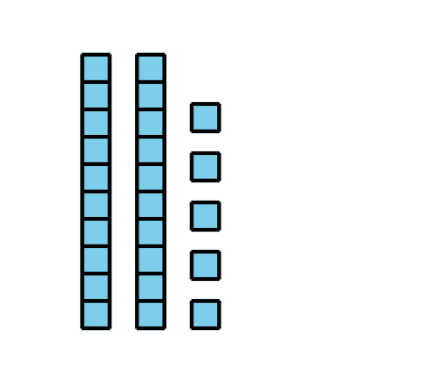
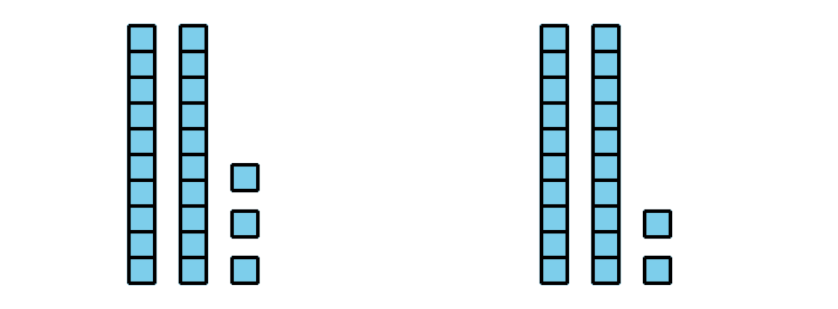
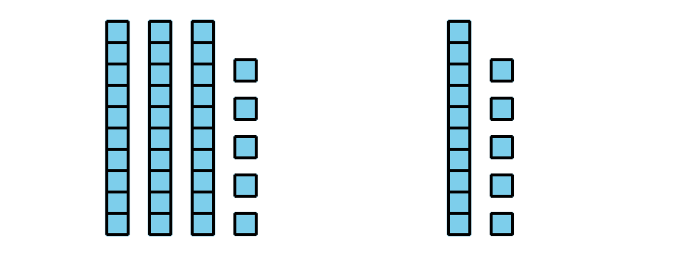

3.1: Fun at the Zoo
Some students were waiting on the bus to go to the zoo. Then 34 more students got on. Now there are 55 students on the bus. How many students were on the bus at first?
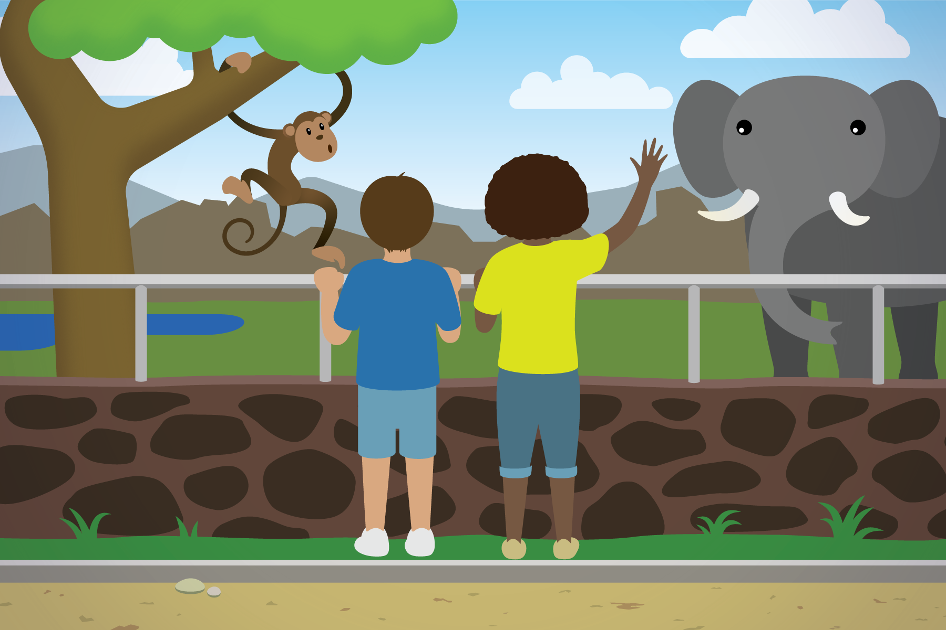

3.2: More Fun at the Zoo
Solve each story problem. Show your thinking.
- There were 65 students in the monkey house. 23 left to see the hippos. How many are still in the monkey house?
- 58 students went to see the bears. 27 students went to see the lions. How many more students went to see the bears than the lions?
- Some birds were in cages outside of the bird house. 34 birds were inside the bird house. In all, there were 88 birds. How many were in the cages outside?

Section Summary
Section Summary
In this section, we used addition and subtraction to compare and to find unknown values. We used different tools to show how to add and subtract two-digit numbers.
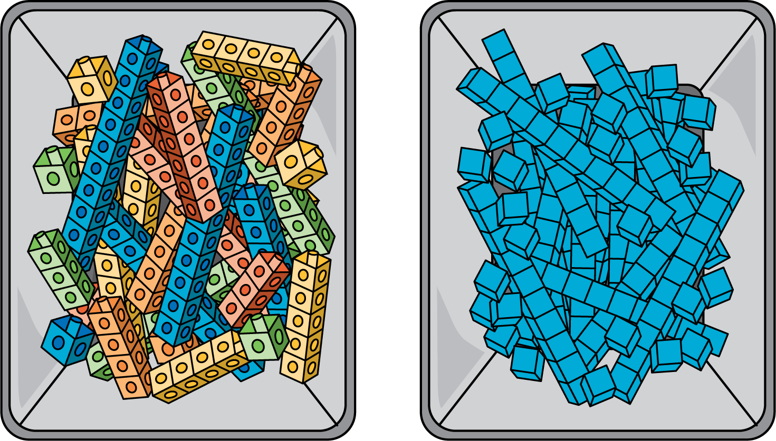
We learned that when you subtract 2 two-digit numbers you can think about subtracting tens from tens and ones from ones.
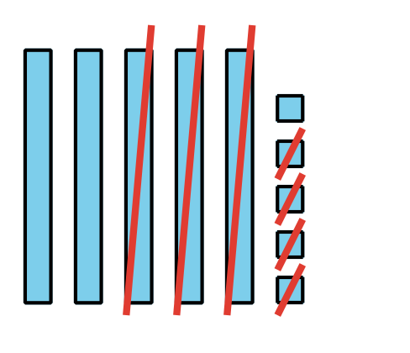
$50−30=20$
$5−4=1$
$20+1=21$
© CC BY 2021 Illustrative Mathematics®

