Unit 7 Lesson 7: Compose a Larger Unit

WU How Many Do You See: Are They the Same? (Warm up)

Student Task Statement
How many do you see? How do you see them?
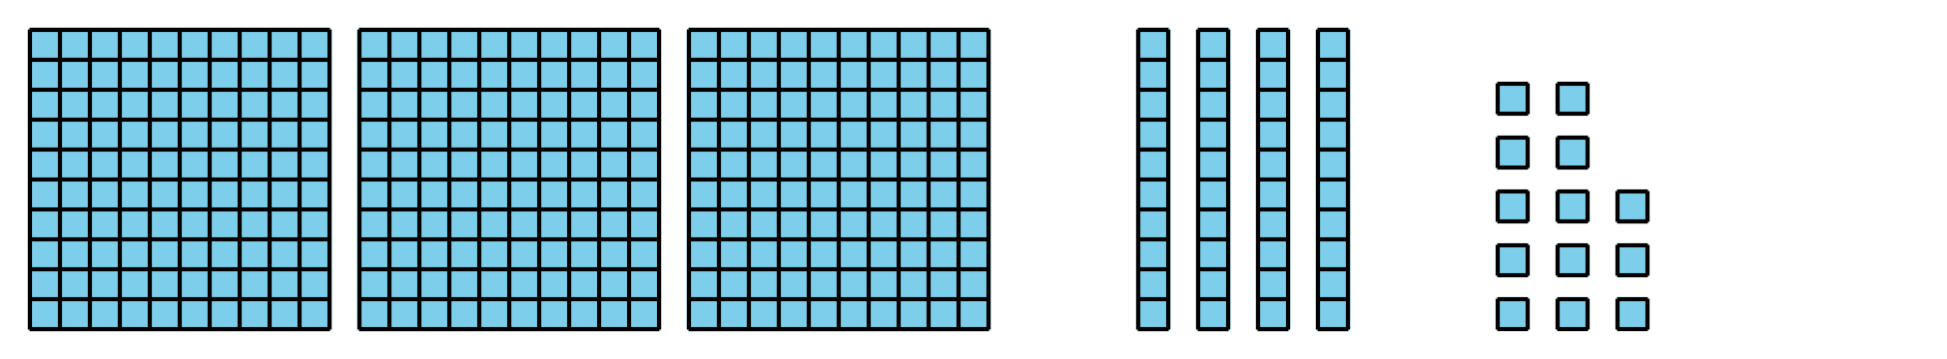
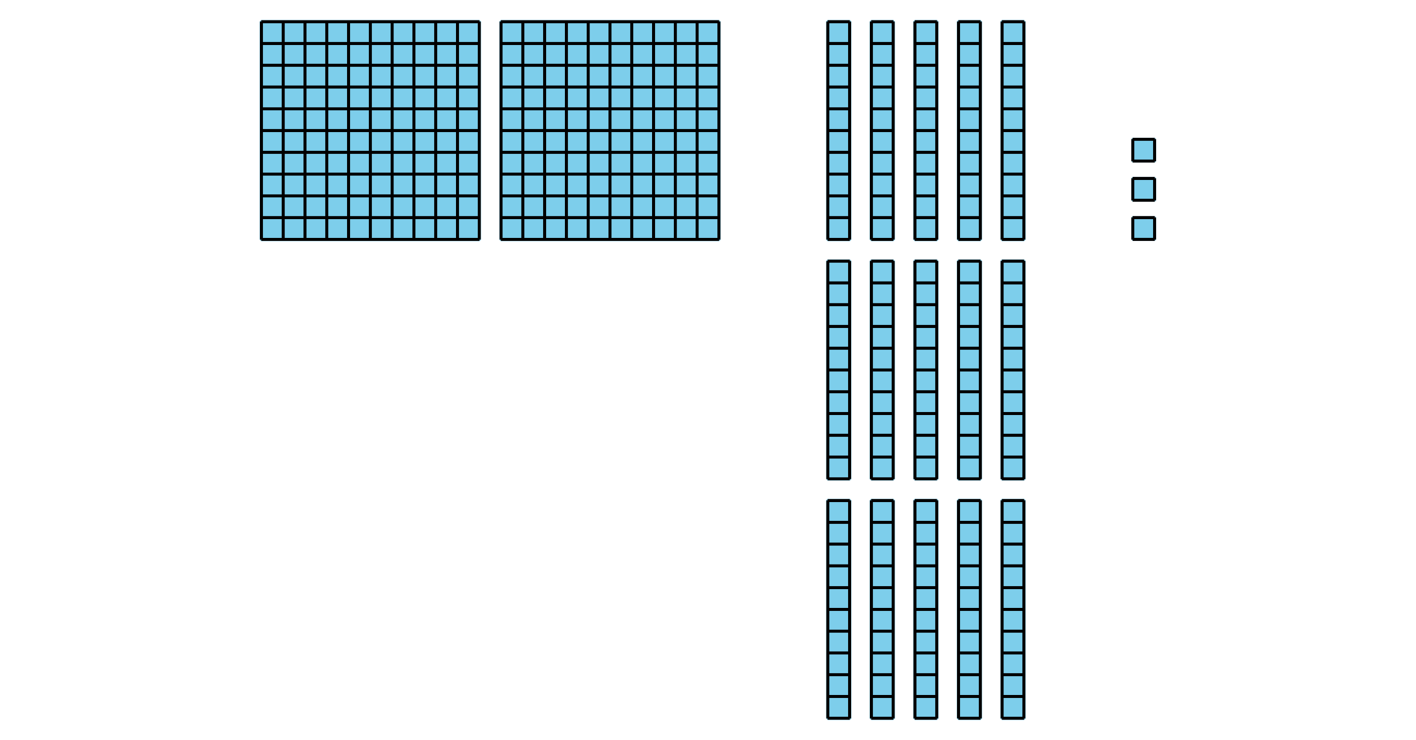

1 Compose a Ten or a Hundred

Student Task Statement
- Find the value of each expression. Show your thinking. Use base-ten blocks if it helps.
  - $364+28$
  - $364+82$
- Compare your thinking with your partner.

2 Walk About and Add

Student Task Statement
Directions:
- Find a partner and record your numbers to make an expression.
- Discuss if you think you would need to compose a ten or a hundred when adding your numbers.
- Find the value of the sum. Show your thinking.

  - ______________ + ______________
  - Will you need to compose a ten?
  - Yes or No
  - Will you need to compose a hundred?
  - Yes or No
  - Find the value of the sum. Show your thinking.
- 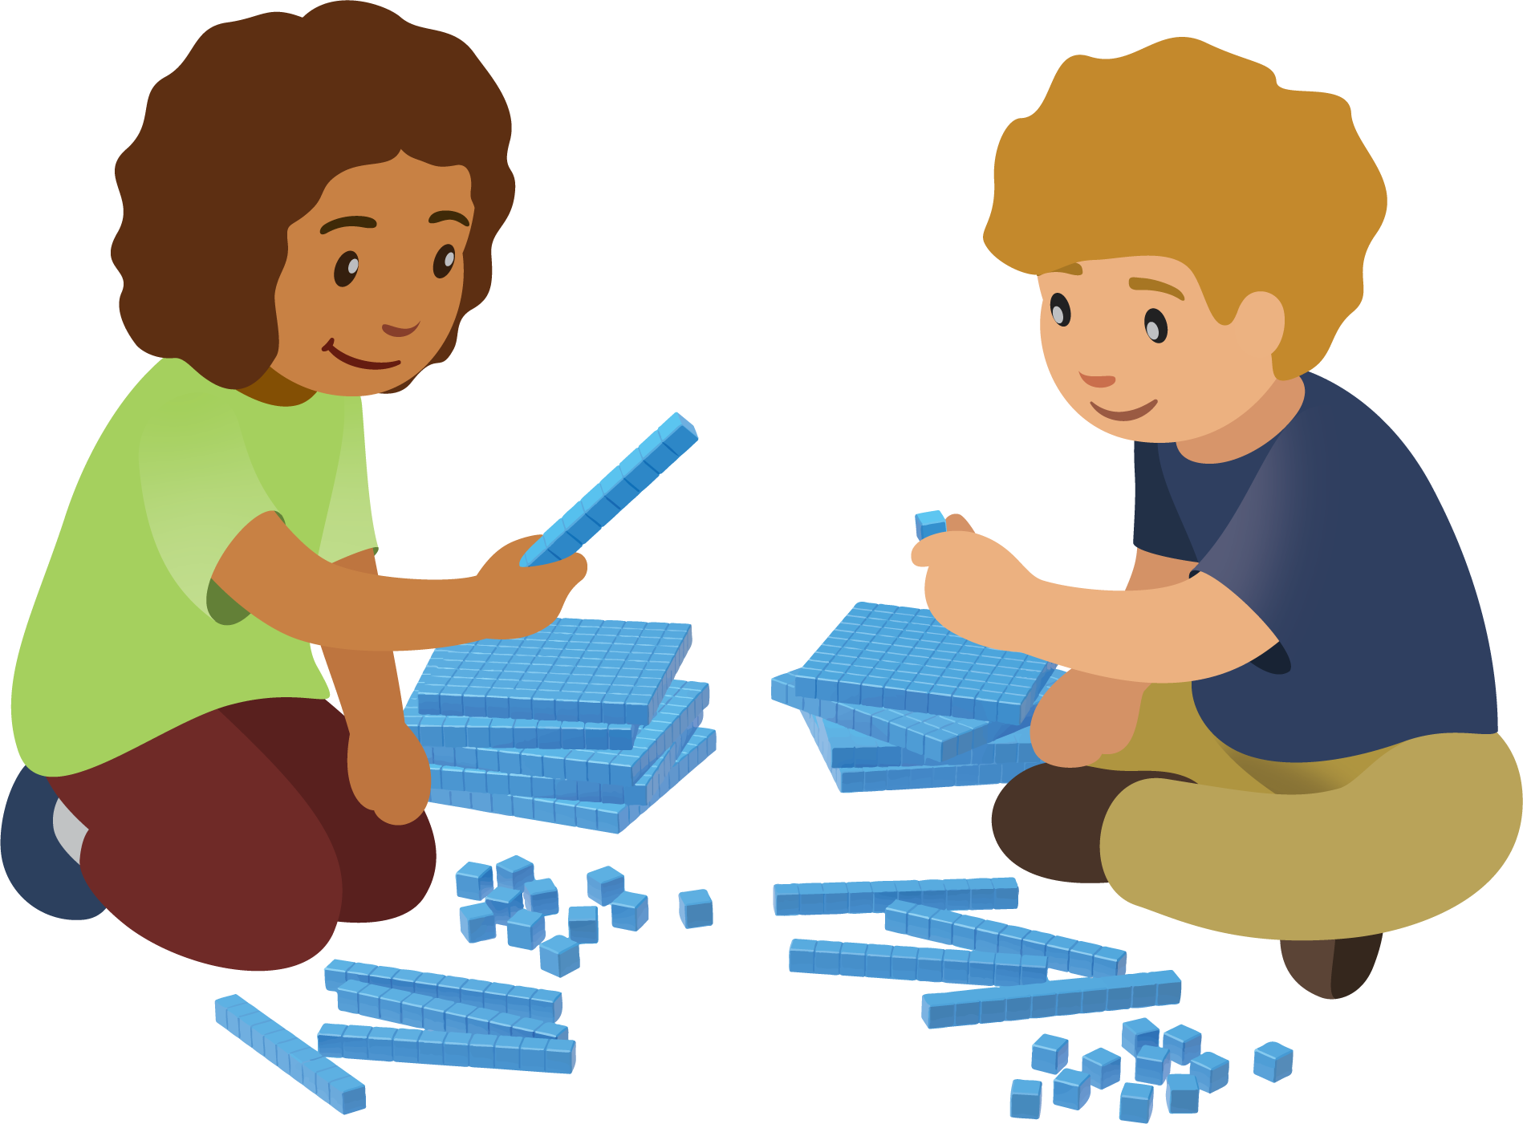

  - ______________+ _______________
  - Will you need to compose a ten?
  - Yes or No
  - Will you need to compose a hundred?
  - Yes or No
  - Find the value of the sum. Show your thinking.

  - _______________ + ______________
  - Will you need to compose a ten?
  - Yes or No
  - Will you need to compose a hundred?
  - Yes or No
  - Find the value of the sum. Show your thinking.
© CC BY 2021 Illustrative Mathematics®

