Lesson 7: The Size of Angles on a Clock

Standards Alignments
Addressing | 4.MD.C.5, 4.MD.C.5.a
Building Towards | 4.MD.C.5.a

Teacher-facing Learning Goals
- Describe the size of an angle as a turn of one ray from the other.
- Use the features of an analog clock to describe and compare the size of angles.

Student-facing Learning Goals
- Let’s describe angles using the hands of a clock.

Lesson Purpose
The purpose of this lesson is for students to describe the size of an angle as a turn of one ray to the other.
In this lesson, students use an analog clock as a tool to describe the size of angles. They begin by using the clock to help describe how to draw a given angle, which involves describing the positions of the two hands of the clock. This work encourages students to relate the turning of the hands in a circular arc to the turning of rays of an angle around their shared endpoint.
Students then use language that suggests rotational movement to describe and compare the size of angles on a clock. To describe whether an angle is greater or smaller than another, they reference the amount of turn made by one or both rays. Students will connect the ideas developed in this lesson to the standard measurement of an angle (in degrees) in subsequent lessons.

Instructional Routines
Notice and Wonder (Warm-up)

Materials to Gather
- Patty paper: Warm-up
- Rulers or straightedges: Activity 1

Lesson Timeline
Warm-up | 10 min
Activity 1 | 15 min
Activity 2 | 20 min
Lesson Synthesis | 10 min
Cool-down | 5 min

Teacher Reflection Question
What student questions about angles or angle measurement were addressed in this lesson? What can you do to help students refine their emerging understanding of angle measurement or resolve any questions that were not answered?

Cool-down
(to be completed at the end of the lesson) 5min
Which Angle is Larger? By How Much?

Student-facing Task Statement
The hands on each clock form an angle.
A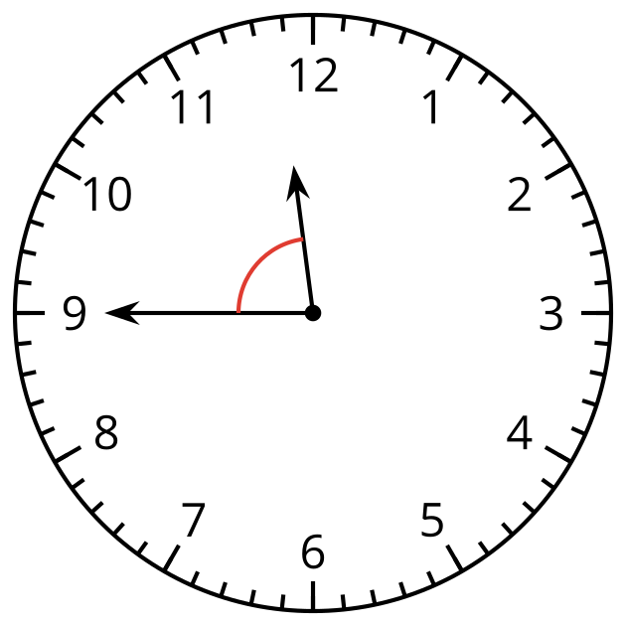
B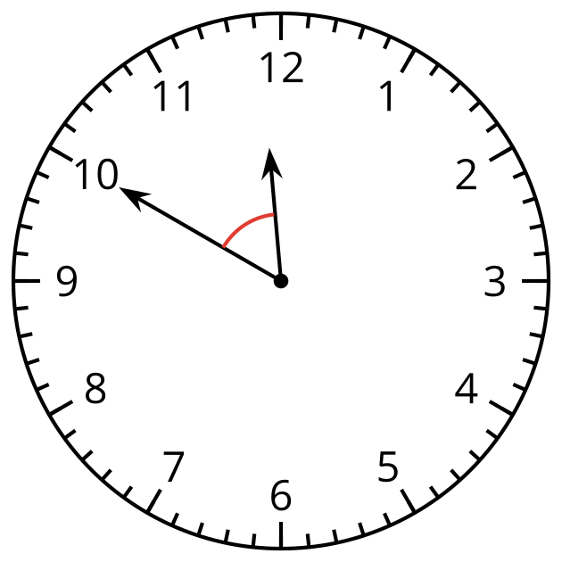
Which angle is larger? How much larger is it than the other angle? Explain how you know.

Student Responses
The angle on Clock A is larger by about 5 minutes. Sample response: In Clock A, the minute hand would have to turn 13 or 14 minutes to get to where the hour hand is. In Clock B, the minute hand would only have to turn 8 or 9 minutes.

