Unit 6 Lesson 6 Cumulative Practice Problems
- Which of these statements is true about the data in the scatter plot?
- 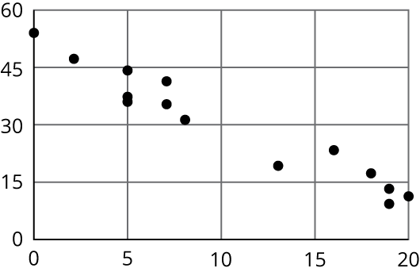
  - As $x$ increases, $y$ tends to increase.
  - As $x$ increases, $y$ tends to decrease.
  - As $x$ increases, $y$ tends to stay unchanged.
  - $x$ and $y$ are unrelated.
- Here is a scatter plot that compares hits to at bats for players on a baseball team.
- 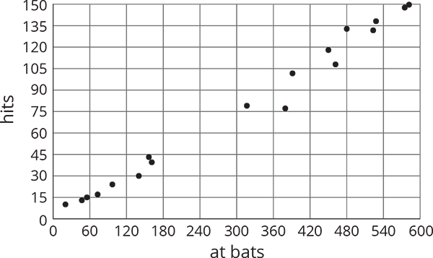
- Describe the relationship between the number of at bats and the number of hits using the data in the scatter plot.
- The linear model for some butterfly data is given by the equation $y=0.238x+4.642$. Which of the following best describes the slope of the model?
- 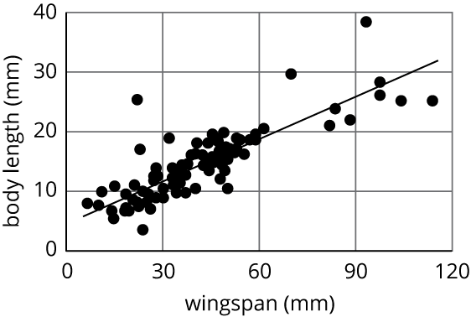
  - For every 1 mm the wingspan increases, the length of the butterfly increases 0.238 mm.
  - For every 1 mm the wingspan increases, the length of the butterfly increases 4.642 mm.
  - For every 1 mm the length of the butterfly increases, the wingspan increases 0.238 mm.
  - For every 1 mm the length of the butterfly increases, the wingspan increases 4.642 mm.
- Nonstop, one-way flight times from O’Hare Airport in Chicago and prices of a one-way ticket are shown in the scatter plot.
- 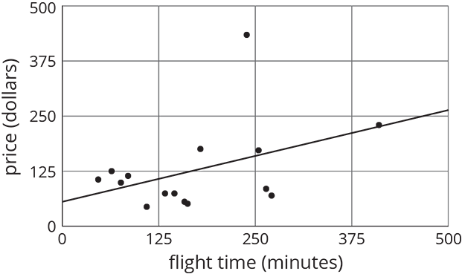
  - Circle any data that appear to be outliers.
  - Use the graph to estimate the difference between any outliers and their predicted values.
- (From Unit 6, Lesson 4.)
- Solve: $\left\{\begin{matrix}y=\text{-}3x+13 \\ y=\text{-}2x+1\end{matrix}\right.$
- (From Unit 4, Lesson 14.)
© CC BY Open Up Resources. Adaptations CC BY IM.

