Lesson 12 Practice Problems

  - Show that the two pentagons are congruent.
  - Find the side lengths of $ABCDE$ and the angle measures of $FGHIJ$.
- 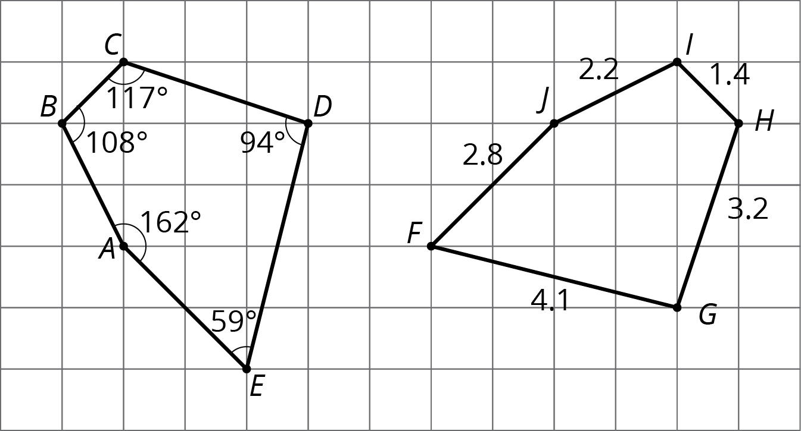
- For each pair of shapes, decide whether or not the two shapes are congruent. Explain your reasoning.

  - 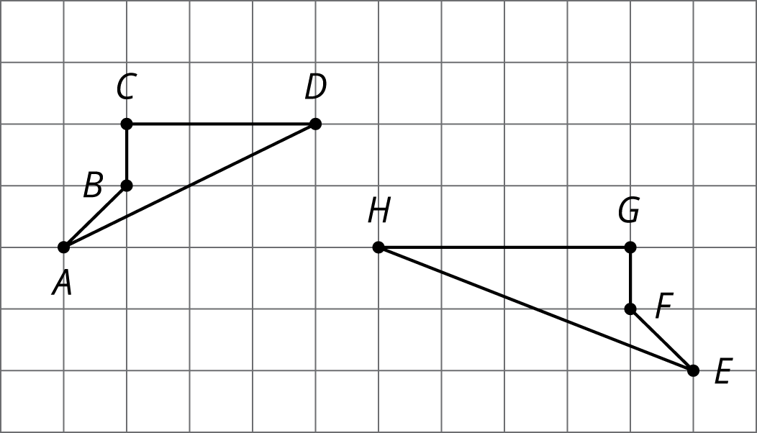

  - 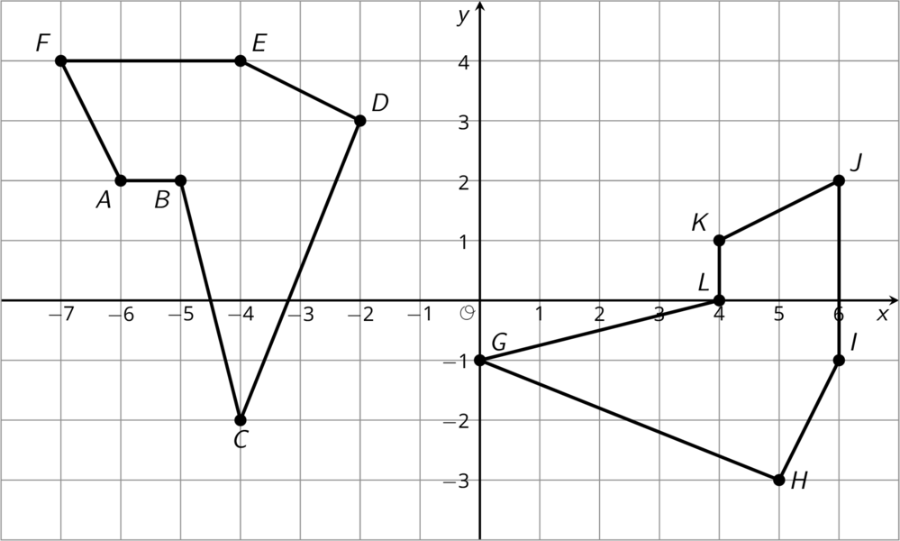

  - 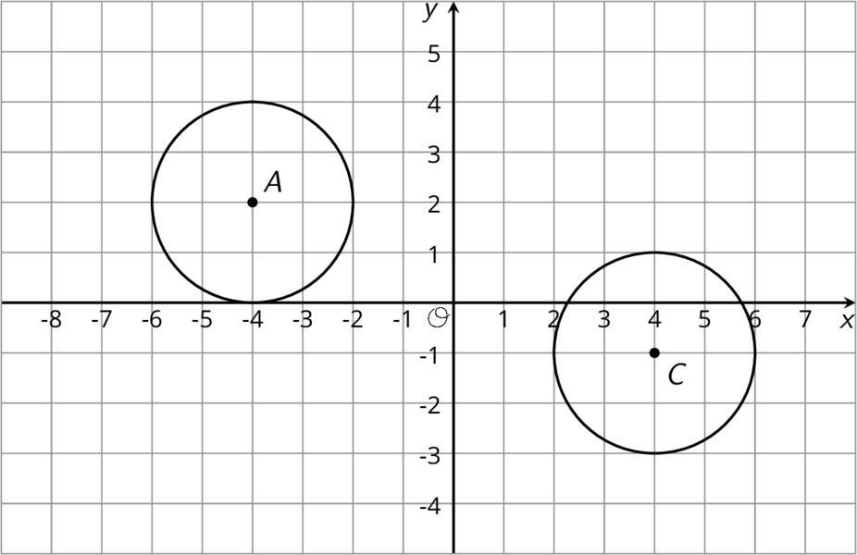

  - Draw segment $PQ$.
  - When $PQ$ is rotated ${180}^{∘}$ around point $R$, the resulting segment is the same as $PQ$. Where could point $R$ be located?
- (From Unit 1, Lesson 8.)
- Here is trapezoid $ABCD$.
- 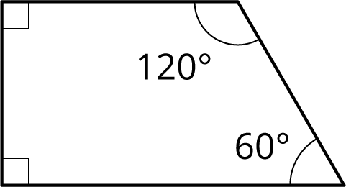

- Using rigid transformations on the trapezoid, build a pattern. Describe some of the rigid transformations you used.
- (From Unit 1, Lesson 10.)
© CC BY Open Up Resources. Adaptations CC BY IM.

