Lesson 9: Polygons
Let’s investigate polygons and their areas.

9.1: Which One Doesn’t Belong: Bases and Heights
Which one doesn't belong?
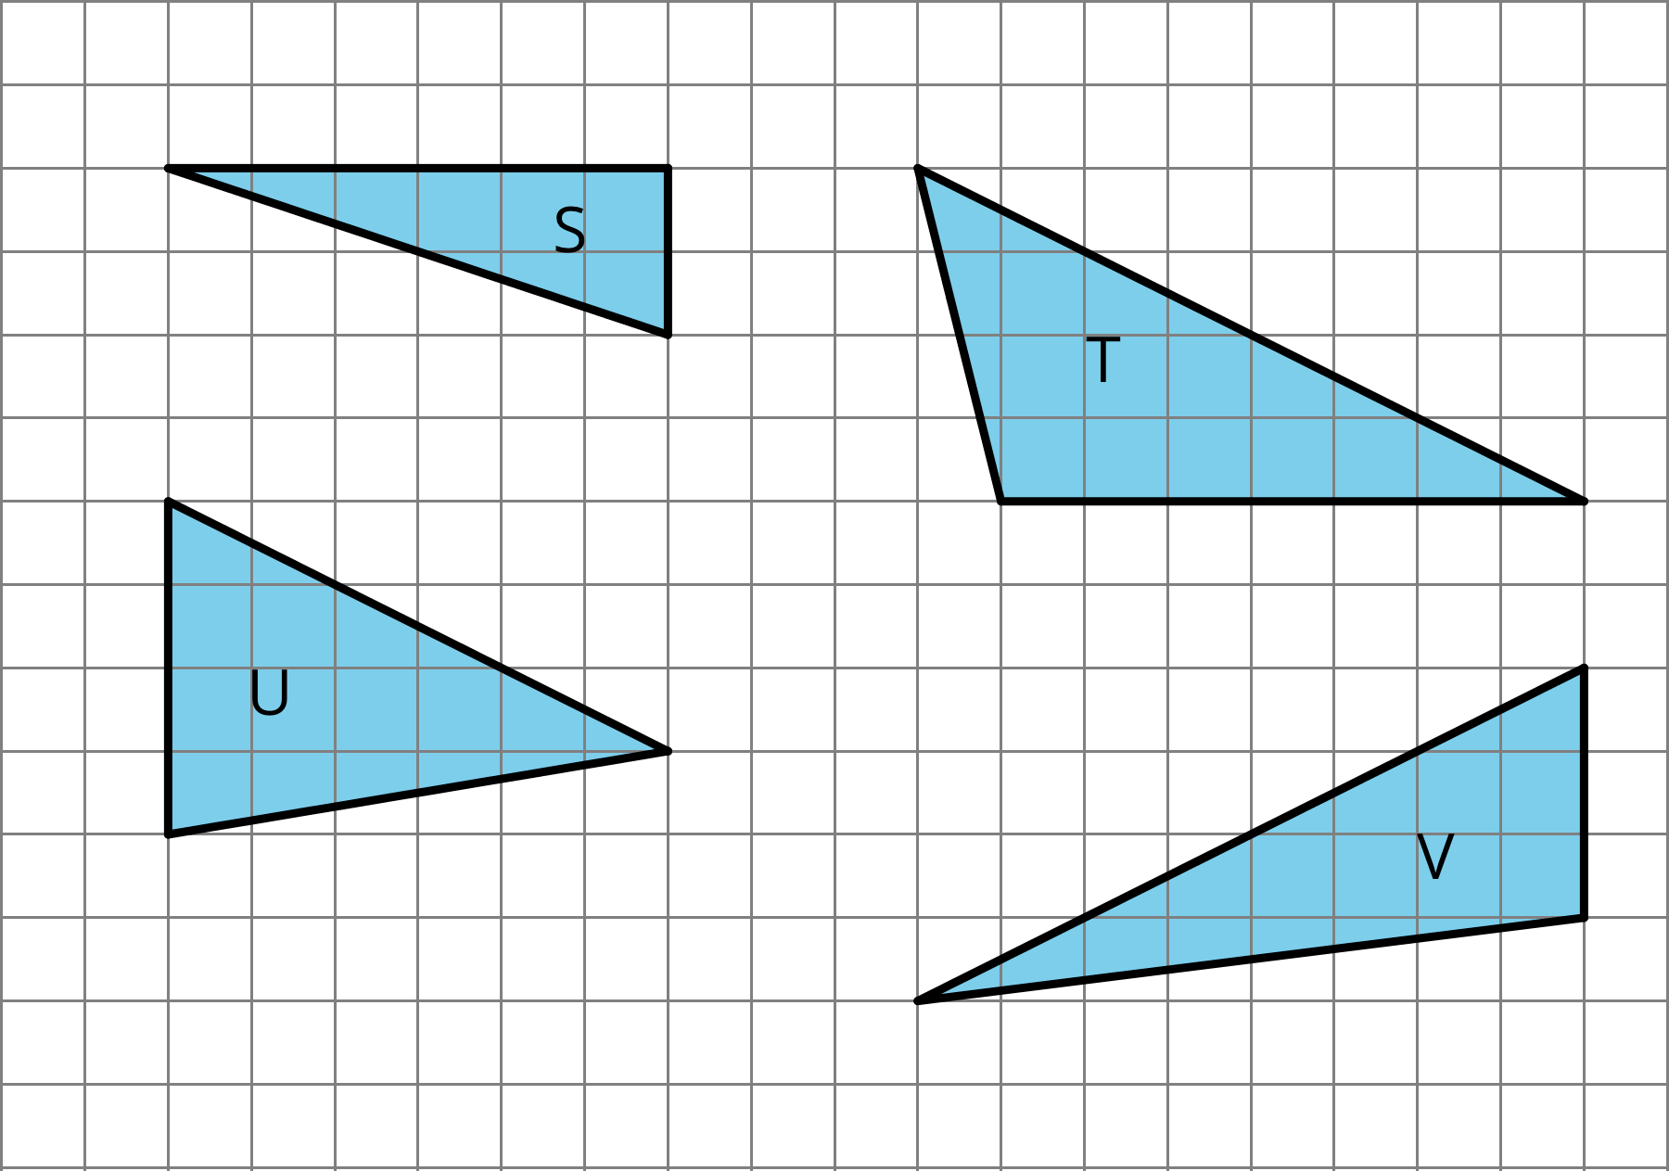

9.2: What Are Polygons?
Here are five polygons:
Here are six figures that are not polygons:
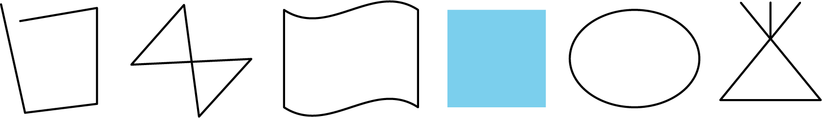

- Circle the figures that are polygons.
- 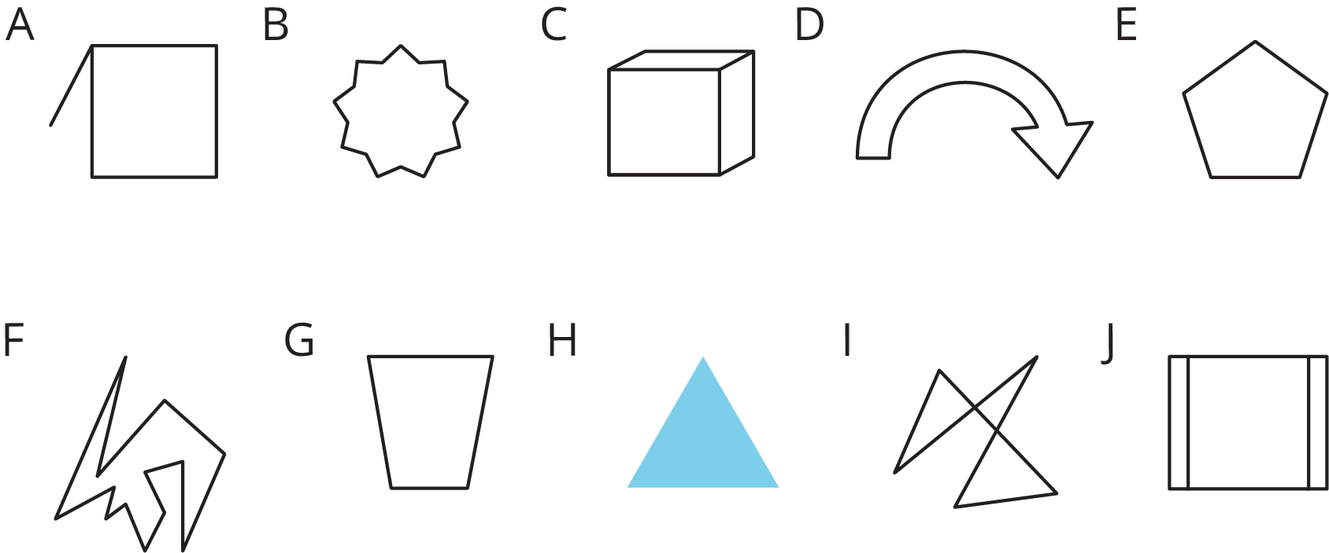
- What do the figures you circled have in common? What characteristics helped you decide whether a figure was a polygon?

9.3: Quadrilateral Strategies
Find the area of two quadrilaterals of your choice. Show your reasoning.
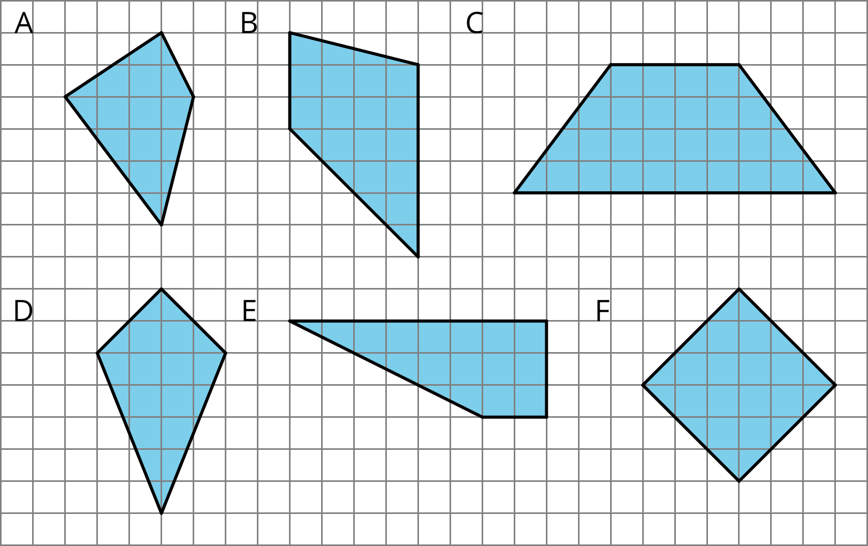

Are you ready for more?
Here is a trapezoid. $a$ and $b$ represent the lengths of its bottom and top sides. The segment labeled $h$ represents its height; it is perpendicular to both the top and bottom sides.
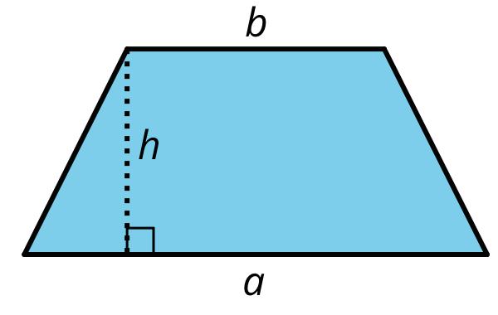
Apply area-reasoning strategies—decomposing, rearranging, duplicating, etc.—on the trapezoid so that you have one or more shapes with areas that you already know how to find. Use the shapes to help you write a formula for the area of a trapezoid. Show your reasoning.

9.4: Pinwheel
Find the area of the shaded region in square units. Show your reasoning.
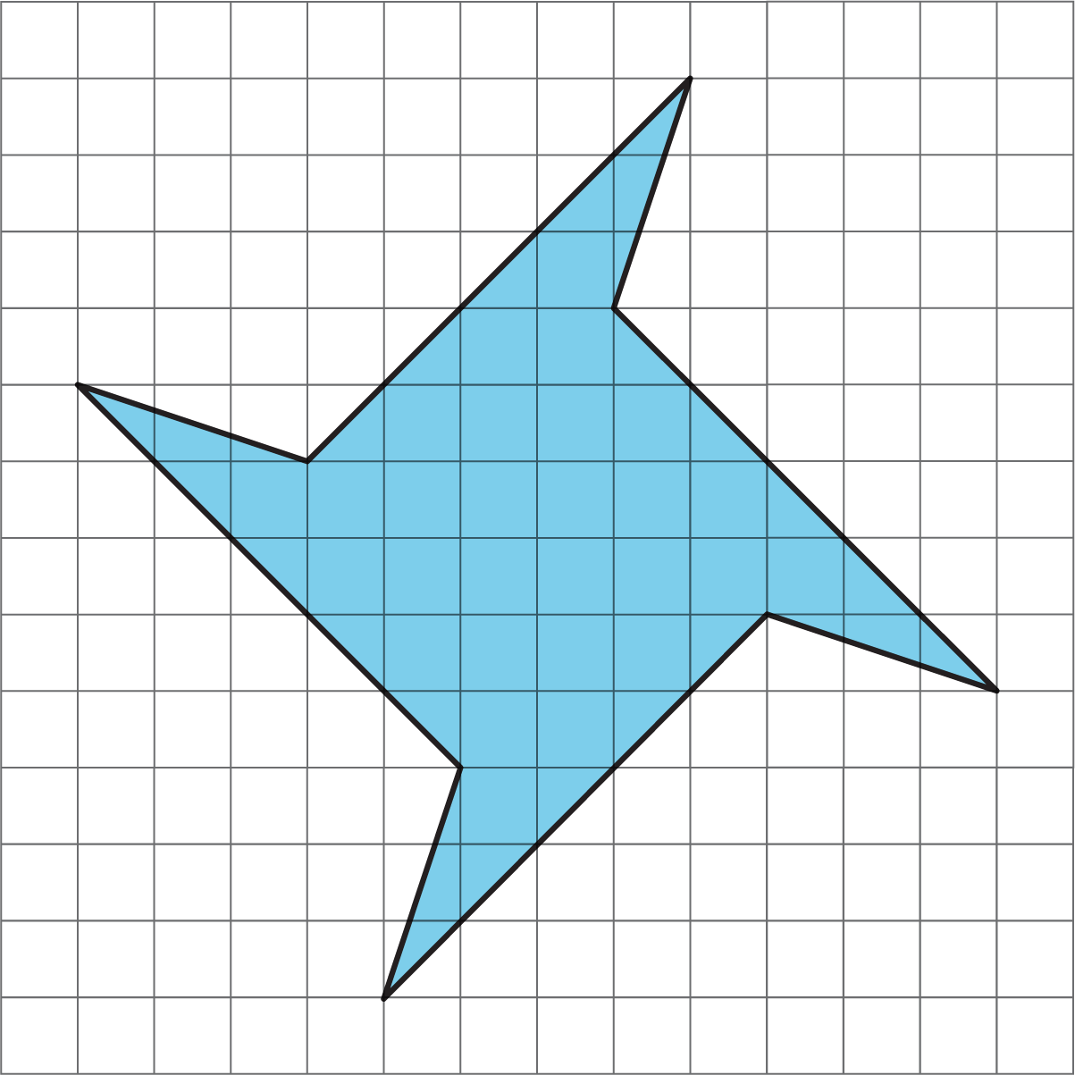

Lesson 9 Summary
A polygon is a two-dimensional figure composed of straight line segments.
- Each end of a line segment connects to one other line segment. The point where two segments connect is a vertex. The plural of vertex is vertices.
- The segments are called the edges or sides of the polygon. The sides never cross each other. There are always an equal number of vertices and sides.
Here is a polygon with 5 sides. The vertices are labeled $A,B,C,D$, and $E$.
A polygon encloses a region. To find the area of a polygon is to find the area of the region inside it.
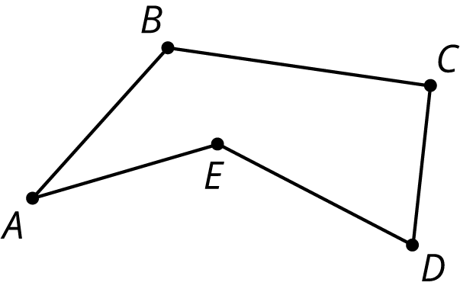
We can find the area of a polygon by decomposing the region inside it into triangles and rectangles.
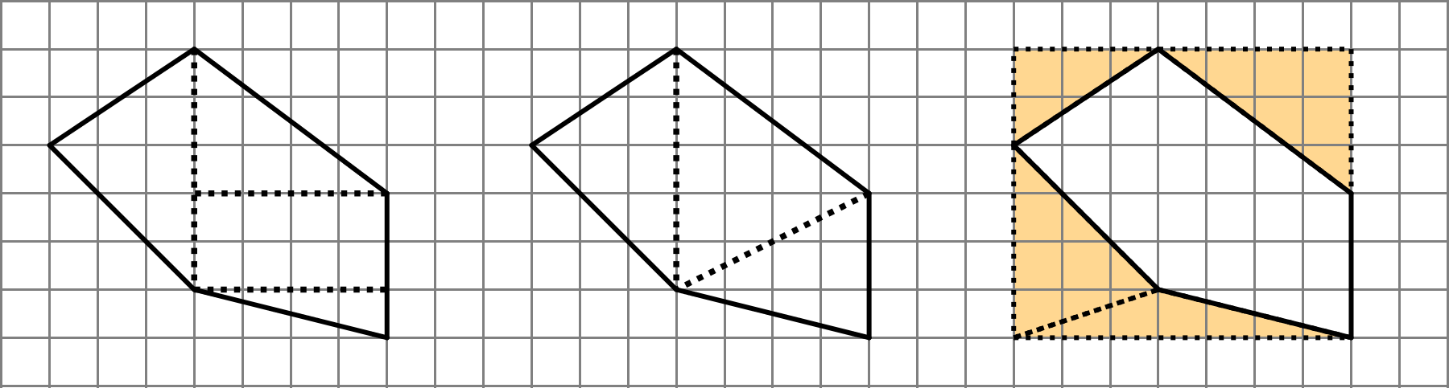
The first two diagrams show the polygon decomposed into triangles and rectangles; the sum of their areas is the area of the polygon. The last diagram shows the polygon enclosed with a rectangle; subtracting the areas of the triangles from the area of the rectangle gives us the area of the polygon.
© CC BY Open Up Resources. Adaptations CC BY IM.

