Lesson 12 Practice Problems
- A parking garage charges $5 for the first hour, $10 for up to two hours, and $12 for the entire day. Let $G$ be the dollar cost of parking for $t$ hours.
  - Complete the table.
  - Sketch a graph of $G$ for $0≤t≤12$.
  - 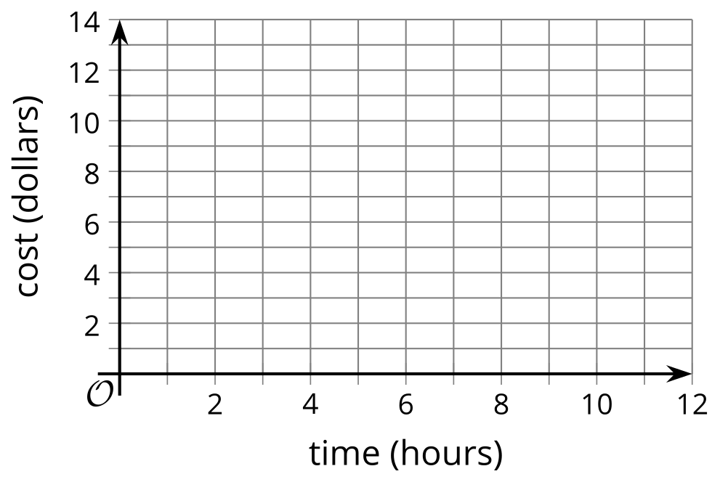
  - Is $G$ a function of $t$? Explain your reasoning.
  - Is $t$ a function of $G$? Explain your reasoning.
- $t$ (hours) | - $G$ (dollars)
- 0
- $\frac{1}{2}$
- 1
- $1\frac{3}{4}$
- 2
- 5
- Is this a graph of a function? Explain your reasoning.
- 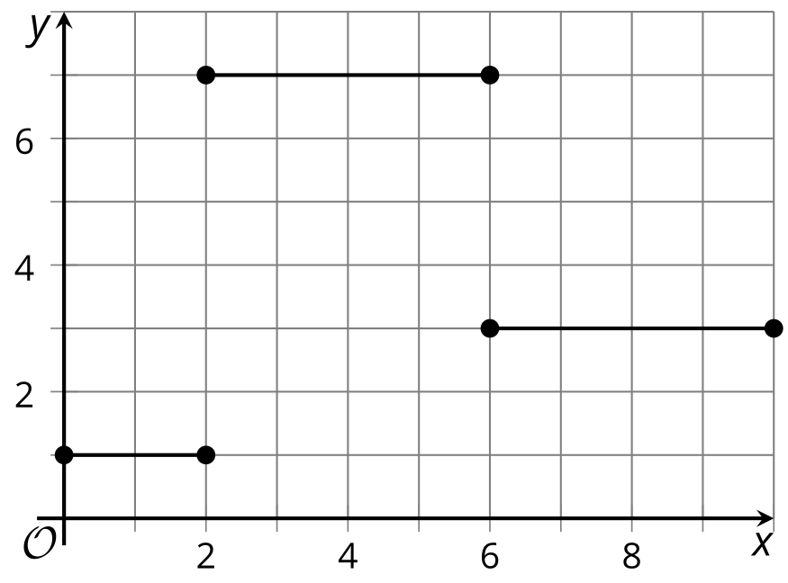
- Use the graph of function $g$ to answer these questions.
  - What are the values of $g\left(1\right)$, $g\left(\text{-}12\right)$, and $g\left(15\right)$?
  - For what $x$-values is $g\left(x\right)=\text{-}6$?
  - Complete the rule for $g\left(x\right)$ so that the graph represents it.
  - $g\left(x\right)= \left\{\begin{matrix}\text{-}10, & \text{-}15≤x<\text{-}10 \\ \underset{_}{}, & \text{-}10≤x<\text{-}8 \\ \text{-}6, & \underset{_}{}≤x<\text{-}1 \\ \underset{_}{}, & \text{-}1≤x<1 \\ 4, & \underset{_}{}≤x<\underset{_}{} \\ 8, & 10≤x<15\end{matrix}\right.$
  - 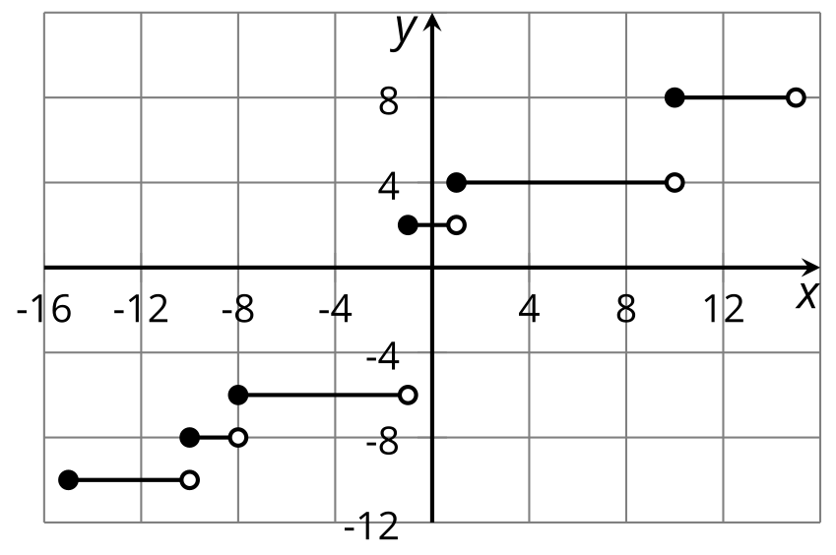
- This graph represents Andre’s distance from his bicycle as he walks in a park.
- 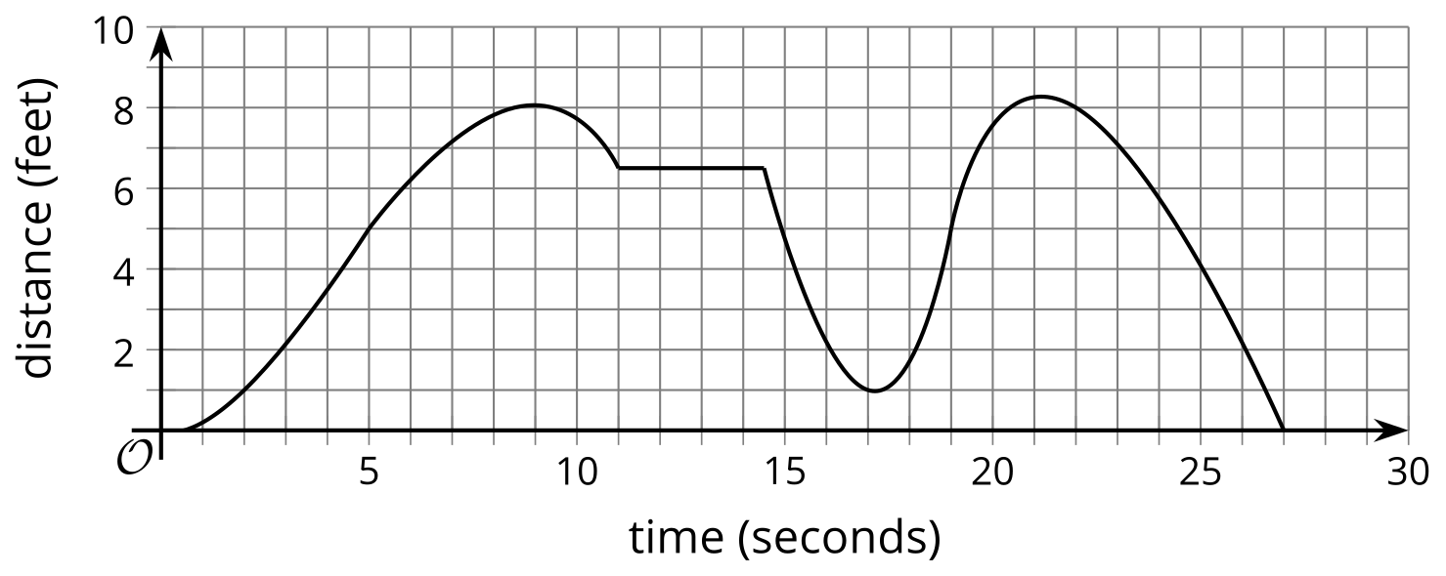
  - For which intervals of time is the value of the function decreasing?
  - For which intervals is it increasing?
  - Describe what Andre is doing during the time when the value of the function is increasing.
- (From Unit 4, Lesson 6.)
- The temperature was recorded at several times during the day. Function $T$ gives the temperature in degrees Fahrenheit, $n$ hours since midnight.
- Here is a graph for this function.
  - Describe the overall trend of temperature throughout the day.
  - 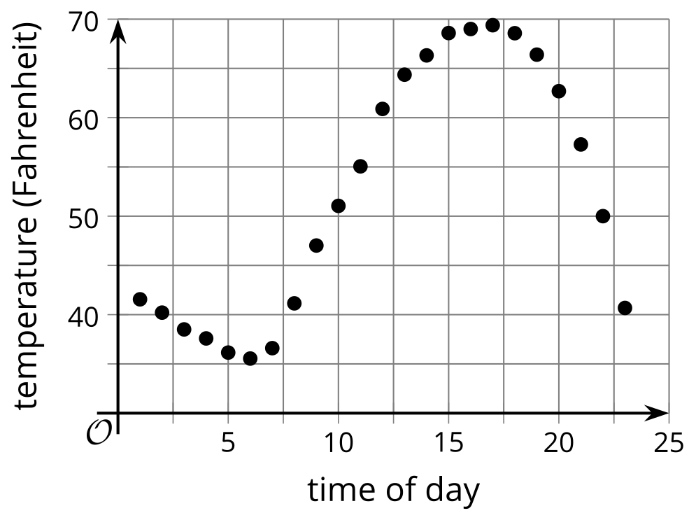
  - Based on the graph, did the temperature change more quickly between 10:00 a.m. and noon, or between 8:00 p.m. and 10:00 p.m.? Explain how you know.
- (From Unit 4, Lesson 7.)
- Explain why this graph does not represent a function.
- 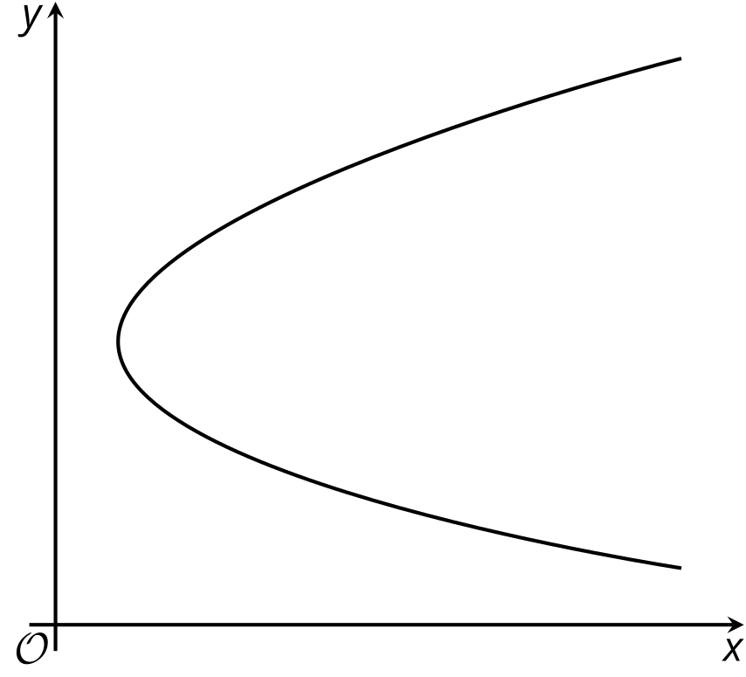
- (From Unit 4, Lesson 8.)
© CC BY 2019 by Illustrative Mathematics®

