Lesson 12: An Algorithm Using Partial Quotients

Standards Alignments
Addressing | 5.NBT.B.6

Teacher-facing Learning Goals
- Make sense of an algorithm using partial quotients.

Student-facing Learning Goals
- Let's make sense of an algorithm using partial quotients.

Lesson Purpose
The purpose of this lesson is for students to learn an algorithm using partial quotients to divide multi-digit numbers by two-digit numbers.
In previous lessons, students used estimation strategies, properties of operations, and the relationship between multiplication and division to divide multi-digit numbers by two-digit divisors. They analyzed different strategies for recording partial quotients.
In this lesson, students move from strategies to algorithms in which the connections to place value, properties of operations, and the relationship between multiplication and division are clear. Students interpret an algorithm using partial quotients with a two-digit divisor for the first time. They used this algorithm with one-digit divisors in grade 4. They practice using this algorithm with less and less scaffolding. Throughout the lesson, the emphasis is on making sense of each step and the different operations used in each step. Students also see that there are many different ways to correctly find a quotient with this algorithm and they are encouraged to find partial quotients that make sense to them.

Access for:

Students with Disabilities
- Representation (Activity 1)

Instructional Routines
MLR1 Stronger and Clearer Each Time (Activity 1), Notice and Wonder (Warm-up)

Lesson Timeline
Warm-up | 10 min
Activity 1 | 20 min
Activity 2 | 15 min
Lesson Synthesis | 10 min
Cool-down | 5 min

Teacher Reflection Question
Think about a recent time from class when your students were confused. What did you do to support them in reasoning about their confusion together as a community of learners?

Cool-down
(to be completed at the end of the lesson) 5min
What’s Next?

Standards Alignments
Addressing | 5.NBT.B.6

Student-facing Task Statement
Han started finding the value of a quotient.
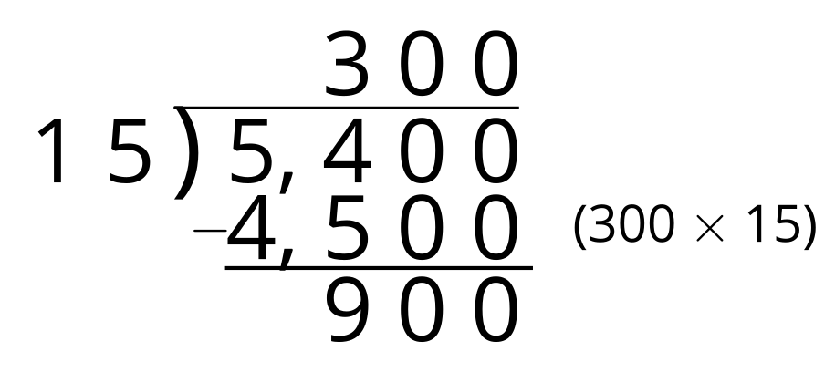
- Write the division expression that represents the quotient Han is finding.
- Complete the algorithm that Han started.

Student Responses
- $5,​400÷15$
- 