Unit 8 Lesson 5: Order Numbers 1-20

WU Choral Count: Count Backward (Warm up)

Student Task Statement

1 Order Numbers

Student Task Statement
Write the numbers in order.
_________
_________
_________
_________
_________
_________
_________
_________
_________
_________
_________
_________
_________
_________
_________
_________
_________
_________
_________
_________

2 Number Clues

Student Task Statement

3 Centers: Choice Time

Student Task Statement
Choose a center.
Less, Same, More
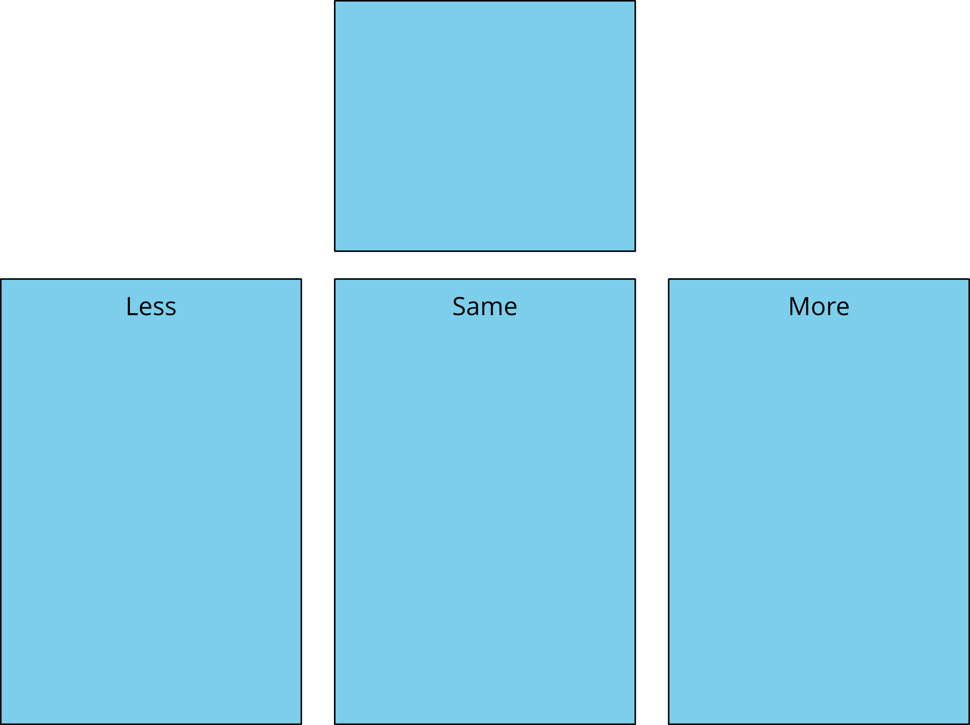
Math Fingers
Tower Build
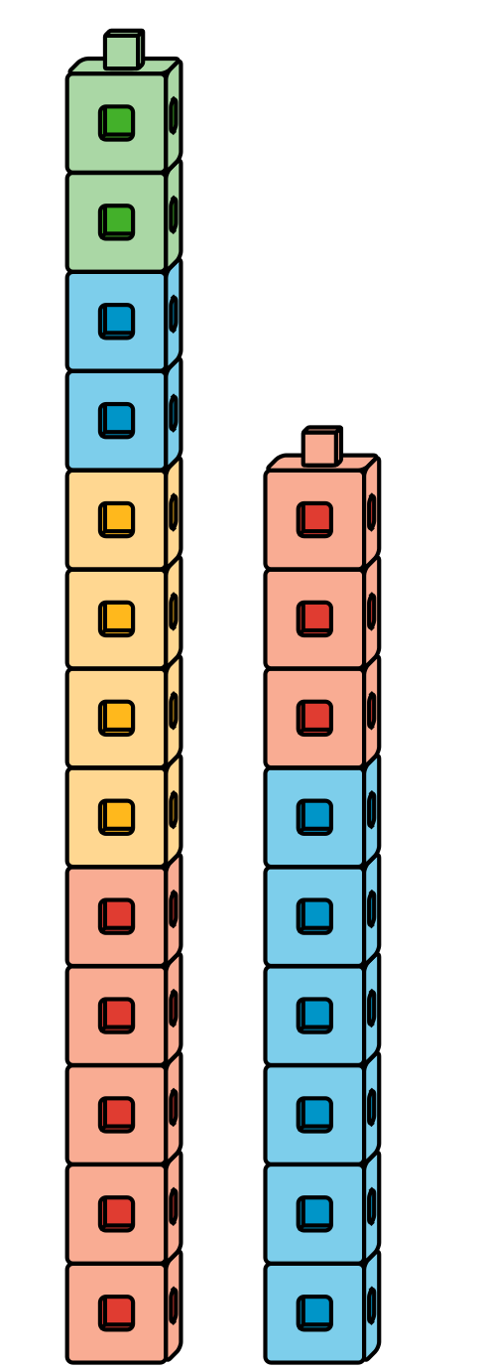
Math Stories
Which One
© CC BY 2021 Illustrative Mathematics®

