Lesson 13: Represent Story Problems
- Let’s compare representations and solve problems.

Warm-up: Notice and Wonder: Compare Representations
What do you notice? What do you wonder?
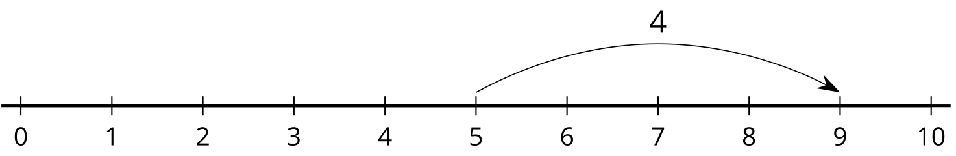
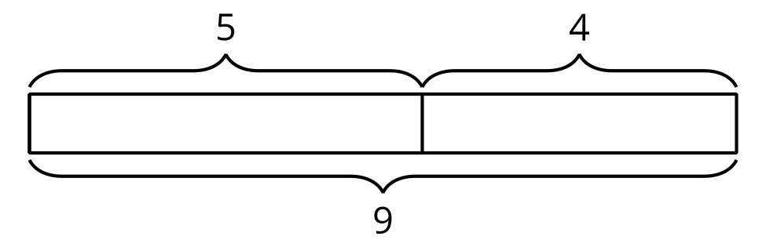

13.2: All Kinds of Representations
Solve each problem. Show your thinking. Use a number line or diagram if it helps.
- Clare started with 24 cubes and added on some more. Clare made a train with 42 cubes. How many cubes did Clare add on?
- 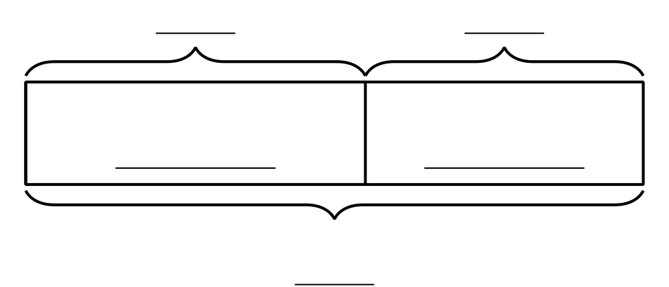
- Andre had 37 cubes. Then he added 39 more to make the train longer. How many cubes did Andre use?
- Mai wanted her train to be 55 cubes long. So far she has 47. How many more cubes does Mai need?

Section Summary
Section Summary In this unit, we have solved all types of problems and represented them in different ways. We represented addition and subtraction on the number line and made connections to equations and strategies. When adding and subtracting within 100, we can use diagrams, base-ten blocks, number lines, and equations to make sense of stories and situations and to show our thinking. They are all connected.
.
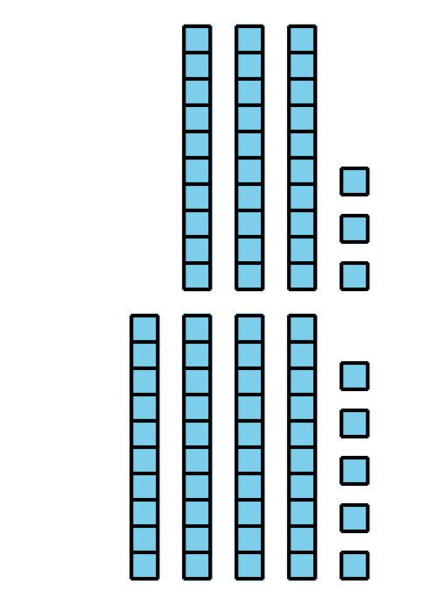
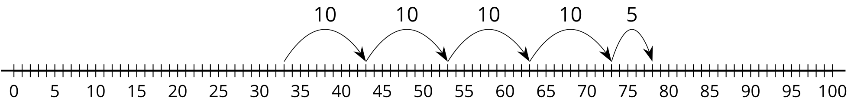
© CC BY 2021 Illustrative Mathematics®

