Lesson 2: Draw Shapes
- Let’s recognize and draw triangles, quadrilaterals, pentagons, and hexagons.

Warm-up: Which One Doesn’t Belong: Five-sided Shapes
Which one doesn’t belong?
A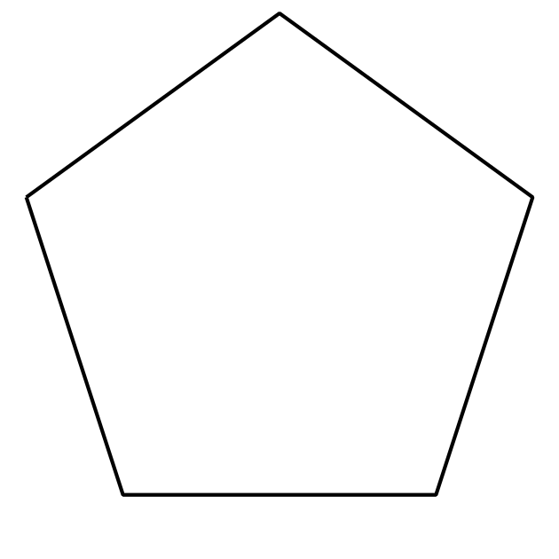
B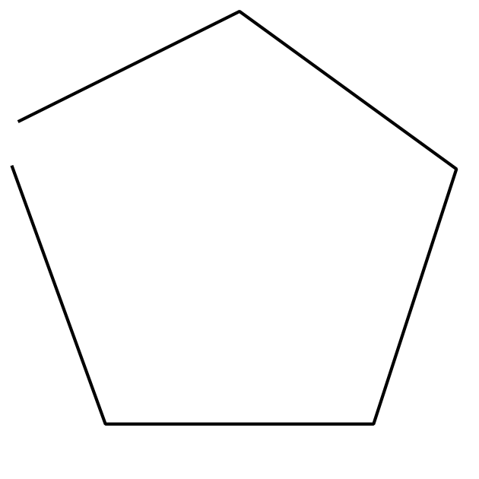
C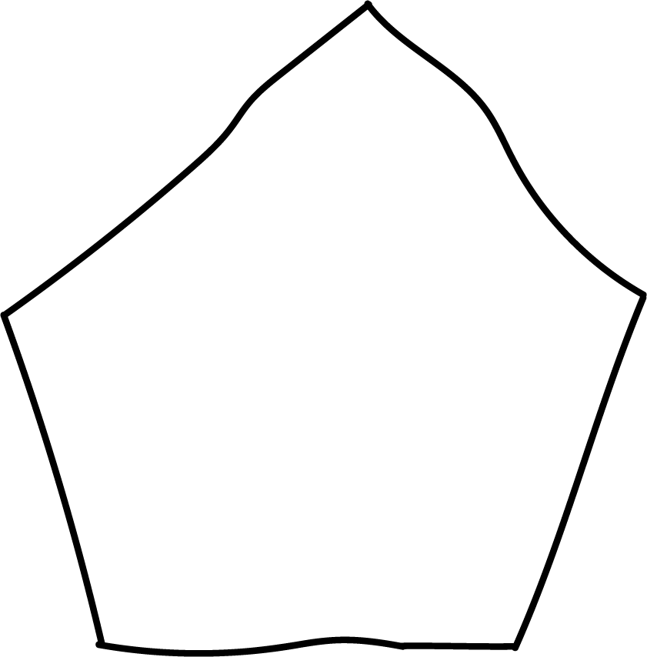
D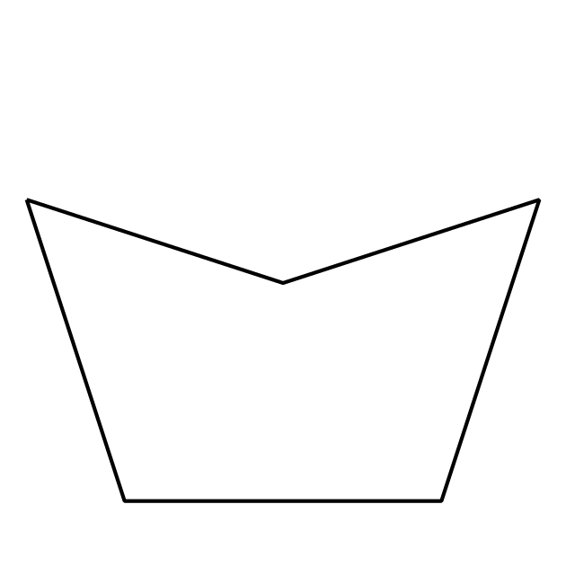

2.1: Draw Shapes
- Complete the shape to make a quadrilateral. Then draw a different four-sided shape.
- 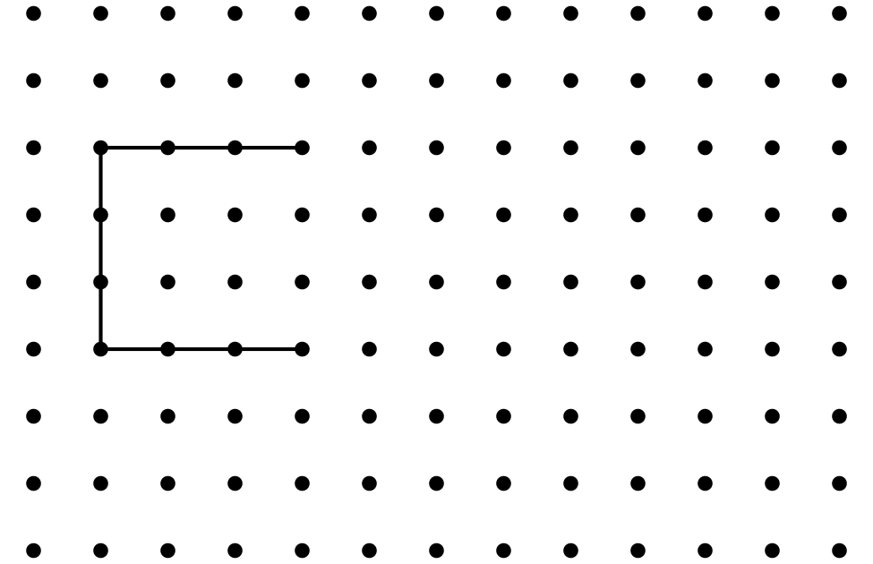
- Complete the shape to make a pentagon. Then draw a different five-sided shape.
- Complete the shape to make a hexagon. Then draw a different six-sided shape.
- Compare your shapes with your partner’s shapes. Find one way your shapes are the same and one way they are different.

2.2: What Shape Could It Be?
- Clare drew a shape that has fewer than 5 sides. Circle shapes that could be Clare’s shape.
- 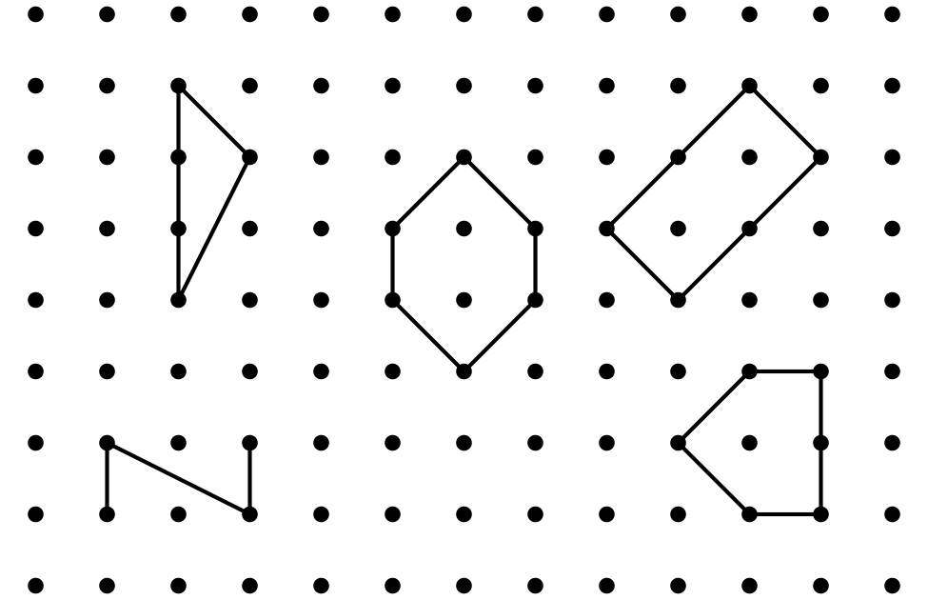
- Draw a different shape that could be Clare’s shape.
- Andre drew a shape that has 4 corners. Circle shapes that could be Andre’s shape.
- 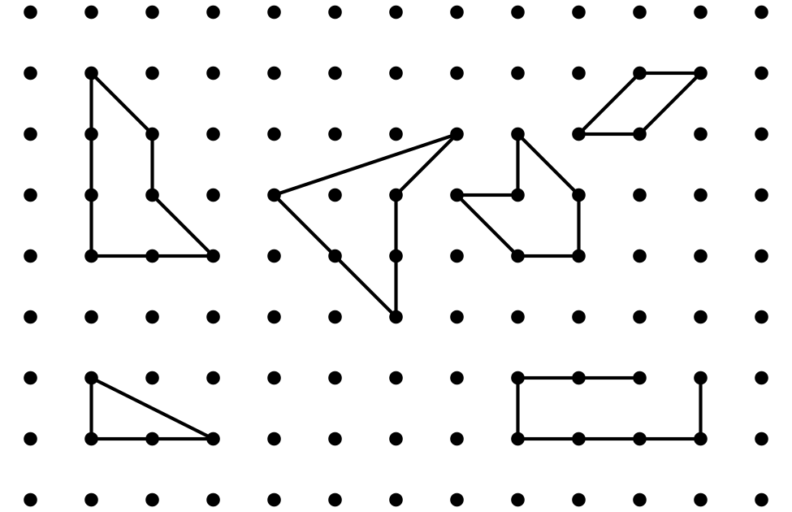
- Draw a different shape that could be Andre’s shape.
- Han drew a shape that has more corners than Andre’s shape. Draw two shapes that could be Han’s shape.
© CC BY 2021 Illustrative Mathematics®

