Lesson 15: Different Types of Story Problems
- Let’s solve story problems and write equations to match.

Warm-up: Which One Doesn’t Belong: Equations
Which one doesn’t belong?
- $7=\boxed{7}$
- $\boxed{7}=3+4$
- $4+3=\boxed{8}$
- $7−3=\boxed{4}$

15.1: What Questions Can We Ask?
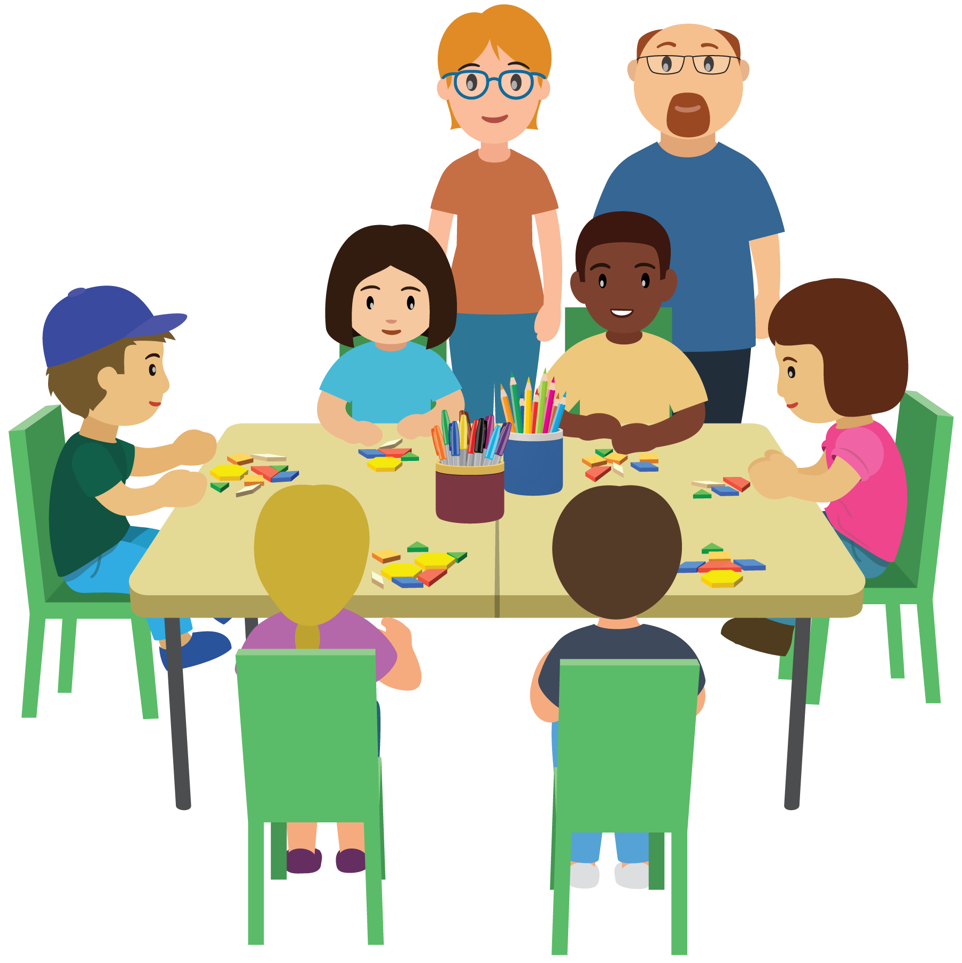
What mathematical questions can you ask about this image?

15.2: Different Types of Problems
- There are 8 people at the table.
6 of the people are students.
How many are teachers?
Show your thinking using drawings, numbers, or words.
- Equation: ________________________________
- Equation: ________________________________
- Elena has 4 pattern blocks.
Tyler has 6 pattern blocks.
How many fewer pattern blocks does Elena have than Tyler?
Show your thinking using drawings, numbers, or words.
- Equation: ________________________________
- Equation: ________________________________
- Tyler has 6 pattern blocks.
Elena has 4 patterns blocks.
How many pattern blocks do they have altogether?
Show your thinking using drawings, numbers, or words.
- Equation: ________________________________
- Equation: ________________________________
- Priya has 7 triangles and 3 squares.
How many more triangles than squares does Priya have?
Show your thinking using drawings, numbers, or words.
- Equation: ________________________________
- Equation: ________________________________

15.3: Centers: Choice Time
Choose a center.
Capture Squares
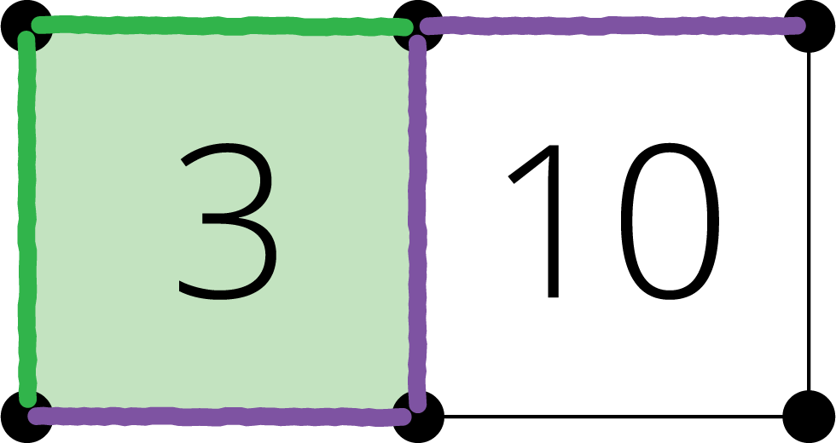
Shake and Spill
What's Behind My Back
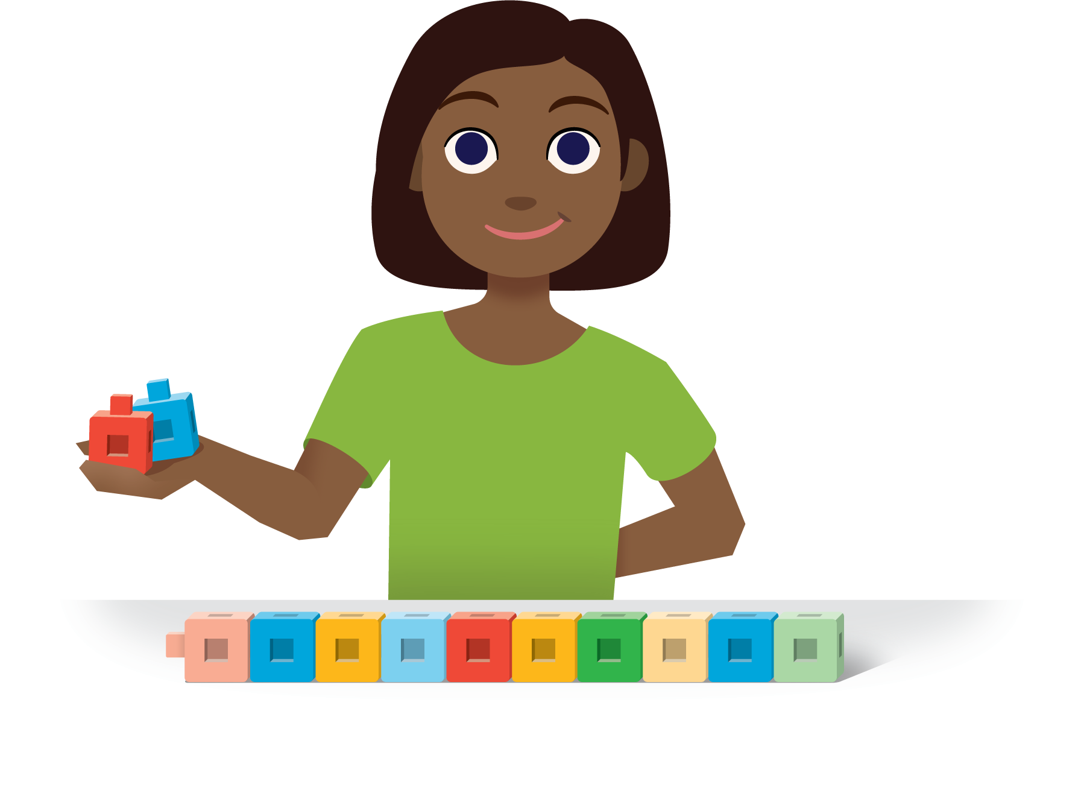

Section Summary
Section Summary
- We made cube towers that have the same number of cubes.
- 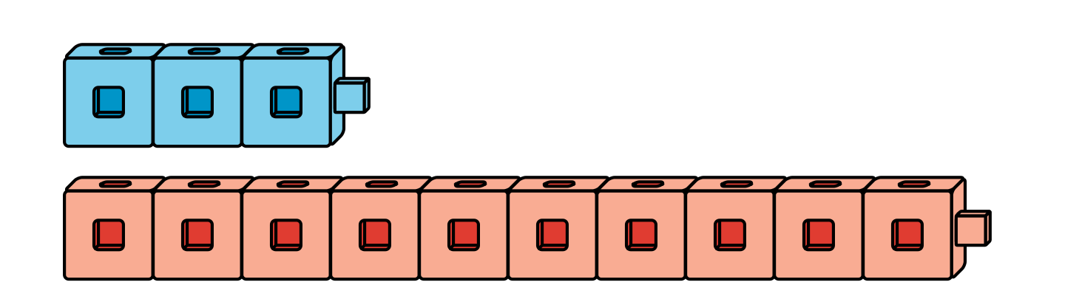
- We can add 7 more blue cubes.
We can take off 7 red cubes.
- We solved story problems about “how many more” and “how many fewer.”
- Elena has 4 pattern blocks.
Tyler has 6 pattern blocks.
How many fewer pattern blocks does Elena have than Tyler?
- $4+\boxed{2}=6$
- or
- $6−4=\boxed{2}$
- We learned that these problems can be solved with addition or subtraction.
© CC BY 2021 Illustrative Mathematics®

