Unit 7 Lesson 9: Add Three-digit Numbers

WU Number Talk: Ten and Some More (Warm up)

Student Task Statement
Find the value of each expression mentally.
- $528+2$
- $528+7$
- $487+3$
- $487+8$

1 How Did You Add Three-digit Numbers?

Student Task Statement
Find the value of each expression. Show your thinking.
- $384+409$
- $757+152$
- $262+438$
- $575+166$

2 Analyze and Add

Student Task Statement
Noah and Kiran showed how they found the value of $267+338$.
Noah's work
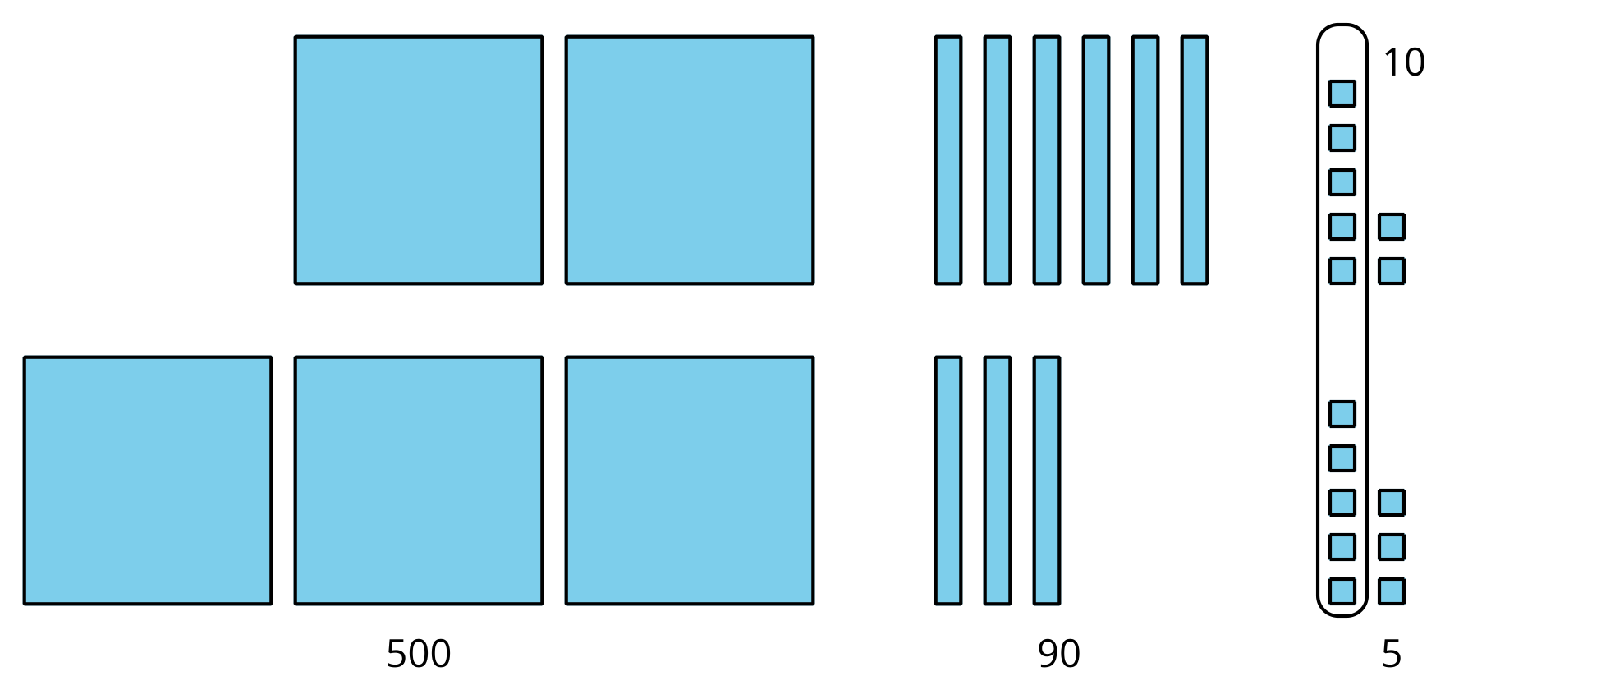
Kiran's work
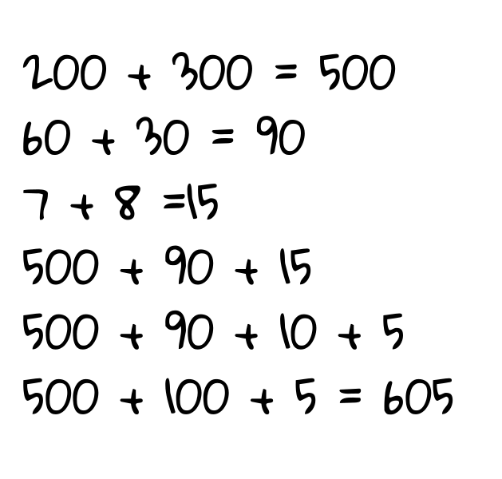
- How is Noah and Kiran’s work the same? How is it different?
- Which student found the correct value? Explain or show your thinking.
© CC BY 2021 Illustrative Mathematics®

