Unit 9 Lesson 2: Costs of Running a Restaurant

1 Introducing Spreadsheets (Optional)

Images for Launch
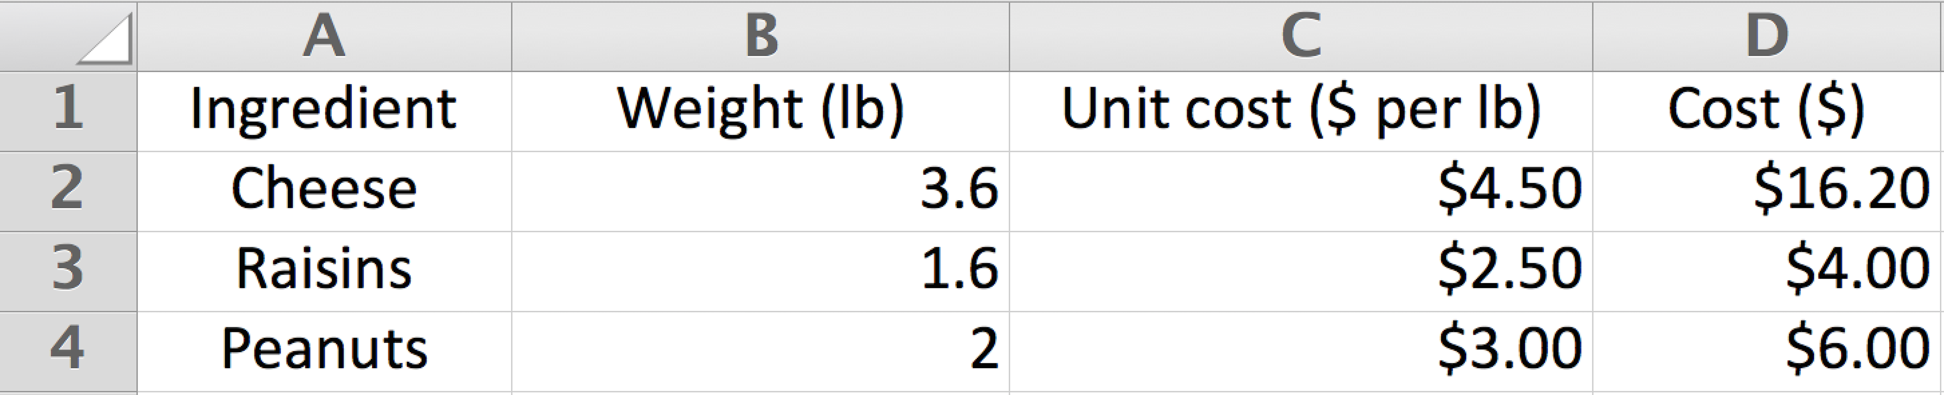
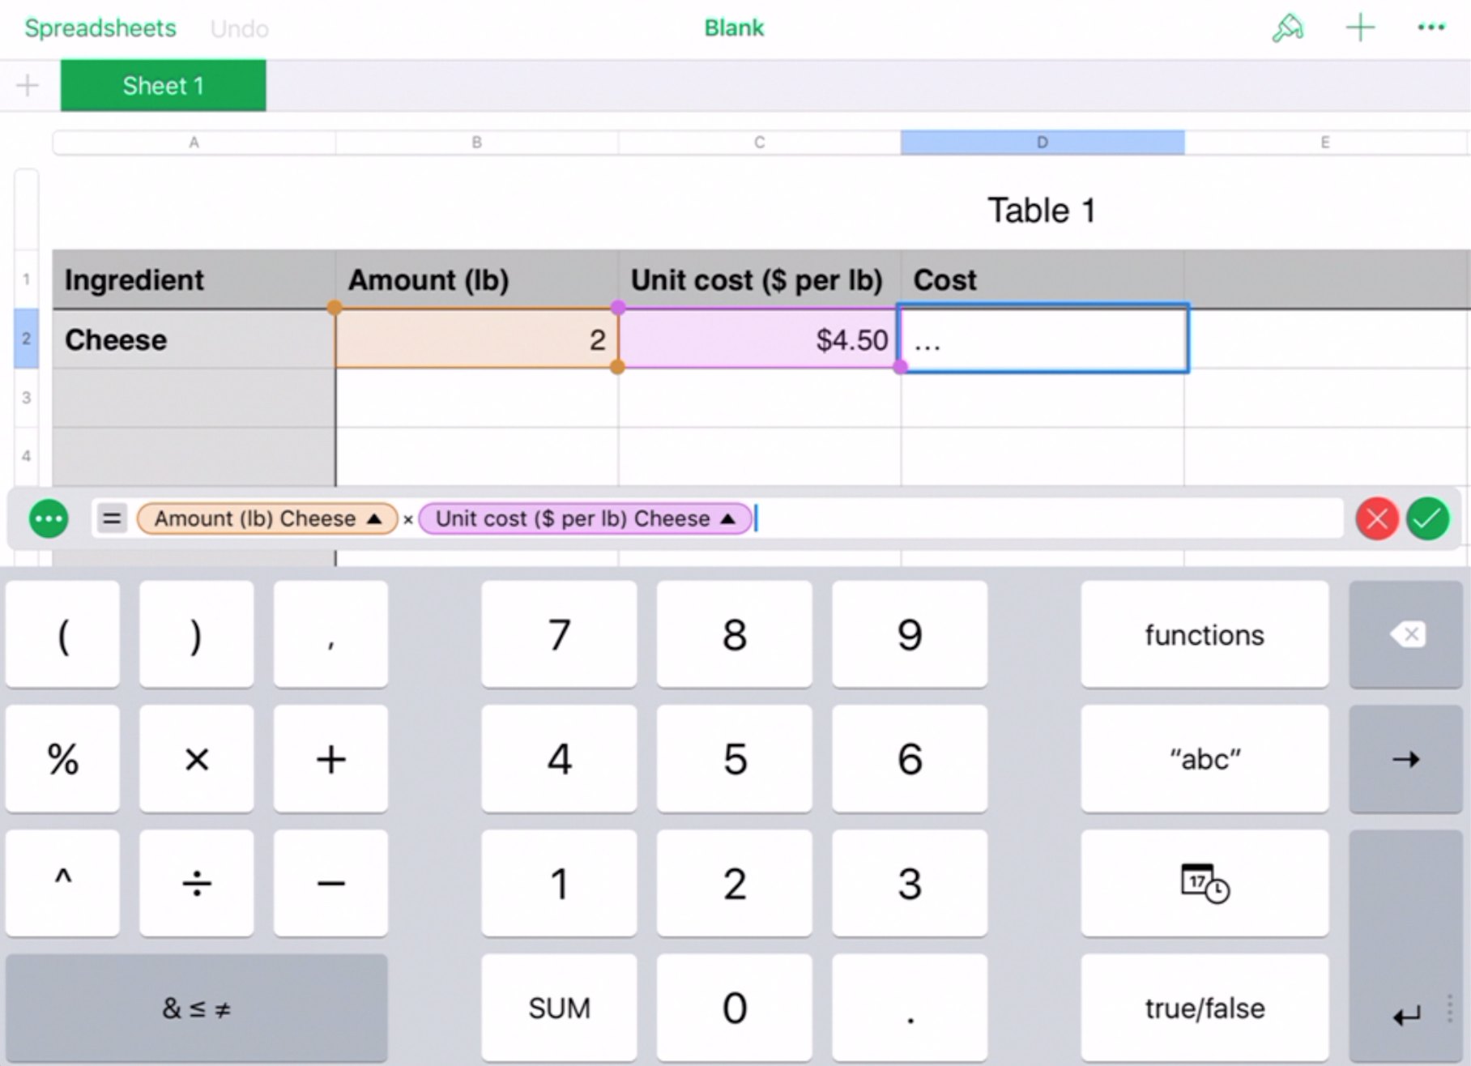

Student Task Statement
- Type each formula into the cells of a spreadsheet program and press enter. Record what the cell displays. Make sure to type each formula exactly as it is written here.
 | - A | - B | - C | - D
- 1 | - =40-32 | - =1.5+3.6 | - =14/7 | - =0.5*6

  - Predict what will happen if you type the formula =A1*C1 into cell C2 of your spreadsheet.
  - Type in the formula, and press enter to check your prediction.

  - Predict what will happen next if you delete the formula in cell A1 and replace it with the number 100.
  - Replace the formula with the number, and press enter to check your prediction.

  - Predict what will happen if you copy cell C2 and paste it into cell D2 of your spreadsheet.
  - Copy and paste the formula to check your prediction.

2 Cost per Serving (Optional)

Student Task Statement
- Set up a spreadsheet with these column labels in the first row.
 | - A | - B | - C | - D
- 1 | - ingredient | - unit  in recipe | - amount  in recipe | - amount  per serving
- 2
  - Type the information about the ingredients in your recipe into the first 3 columns of the spreadsheet.
  - Type a formula into cell D2 to automatically calculate the amount per serving for your first ingredient.
  - Copy cell D2 and paste it into the cells beneath it to calculate the amount per serving for the rest of your ingredients. Pause here so your teacher can review your work.
- Add these column labels to your spreadsheet.
- E | - F | - G | - H
- purchase price | - purchase  amount | - purchase  unit | - cost per  purchase unit
  - Research the cost of each ingredient in your meal, and record the information in columns E, F, and G.
  - Type a formula into cell H2 to automatically calculate the cost per purchase unit for your first ingredient.
  - Copy cell H2, and paste it into the cells beneath it to calculate the cost per purchase unit for the rest of your ingredients.
- Add these column labels to your spreadsheet.
- I | - J | - K
- conversion from  purchase units  to recipe units | - cost per  recipe unit | - cost  per serving
  - Complete column I with how many of your recipe unit are in 1 of your purchase unit for each ingredient. For example, if your recipe unit was cups and your purchase unit was gallons, then your conversion would be 16 because there are 16 cups in 1 gallon.
  - Type a formula into cell J2 to calculate the cost per recipe unit for your first ingredient.
  - Type a formula into cell K2 to calculate the cost per serving for your first ingredient.
  - Compare formulas with your partner. Discuss your thinking. If you disagree, work to reach an agreement.
  - Copy cells J2 and K2, and paste them into the cells beneath them to calculate the cost per recipe unit and cost per serving for the rest of your ingredients.
- Type a formula into the first empty cell below your last ingredient in column K to calculate the total cost per serving for all of the ingredients in your recipe. Record the answer here.
© CC BY Open Up Resources. Adaptations CC BY IM.

