Unit 4 Lesson 8: Equal and Equivalent

1 Algebra Talk: Solving Equations by Seeing Structure (Warm up)

Student Task Statement
Find a solution to each equation mentally.
$3+x=8$
$10=12−x$
$x^{2}=49$
$\frac{1}{3}x=6$

2 Using Diagrams to Show That Expressions are Equivalent

Images for Launch
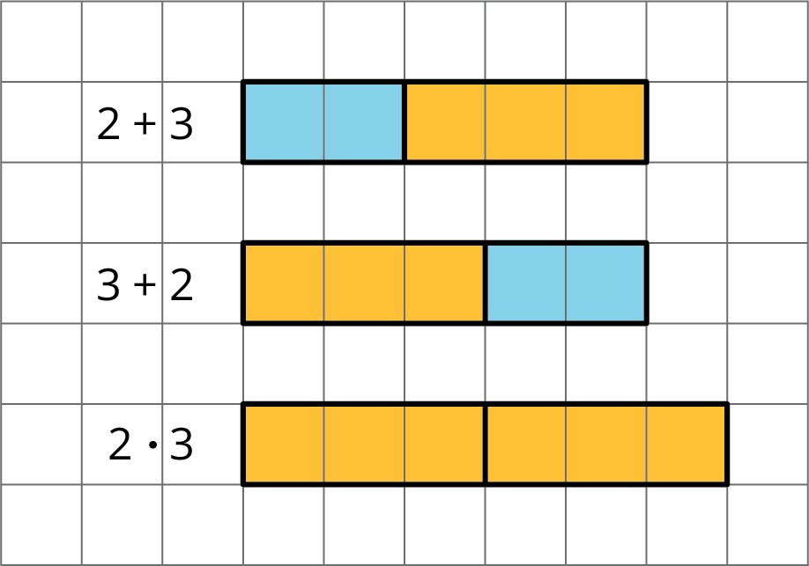

Student Task Statement
Here is a diagram of $x+2$ and $3x$ when $x$ is 4. Notice that the two diagrams are lined up on their left sides.
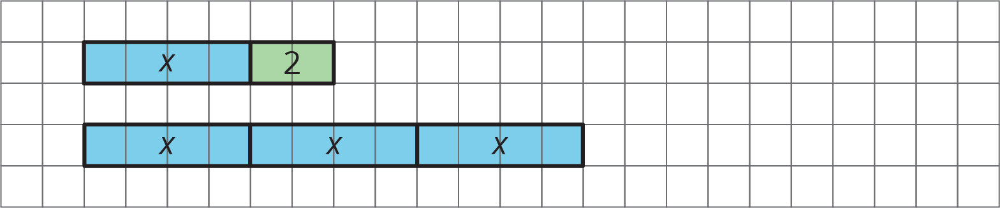
In each of your drawings below, line up the diagrams on one side.
- Draw a diagram of $x+2$, and a separate diagram of $3x$, when $x$ is 3.
- Draw a diagram of $x+2$, and a separate diagram of $3x$, when $x$ is 2.
- Draw a diagram of $x+2$, and a separate diagram of $3x$, when $x$ is 1.
- Draw a diagram of $x+2$, and a separate diagram of $3x$, when $x$ is 0.
- When are $x+2$ and $3x$ equal? When are they not equal? Use your diagrams to explain.
- Draw a diagram of $x+3$, and a separate diagram of $3+x$.
- When are $x+3$ and $3+x$ equal? When are they not equal? Use your diagrams to explain.

3 Identifying Equivalent Expressions

Student Task Statement
Here is a list of expressions. Find any pairs of expressions that are equivalent. If you get stuck, try reasoning with diagrams.
$a+3$
$a+a+a$
$a÷\frac{1}{3}$
$a⋅3$
$\frac{1}{3}a$
$3a$
$\frac{a}{3}$
$1a$
$a$
$3+a$

© CC BY Open Up Resources. Adaptations CC BY IM.

