Unit 8 Lesson 7: Box Plots and Interquartile Range

1 Notice and Wonder: Two Parties (Warm up)

Student Task Statement
Here are dot plots that show the ages of people at two different parties. The mean of each distribution is marked with a triangle.
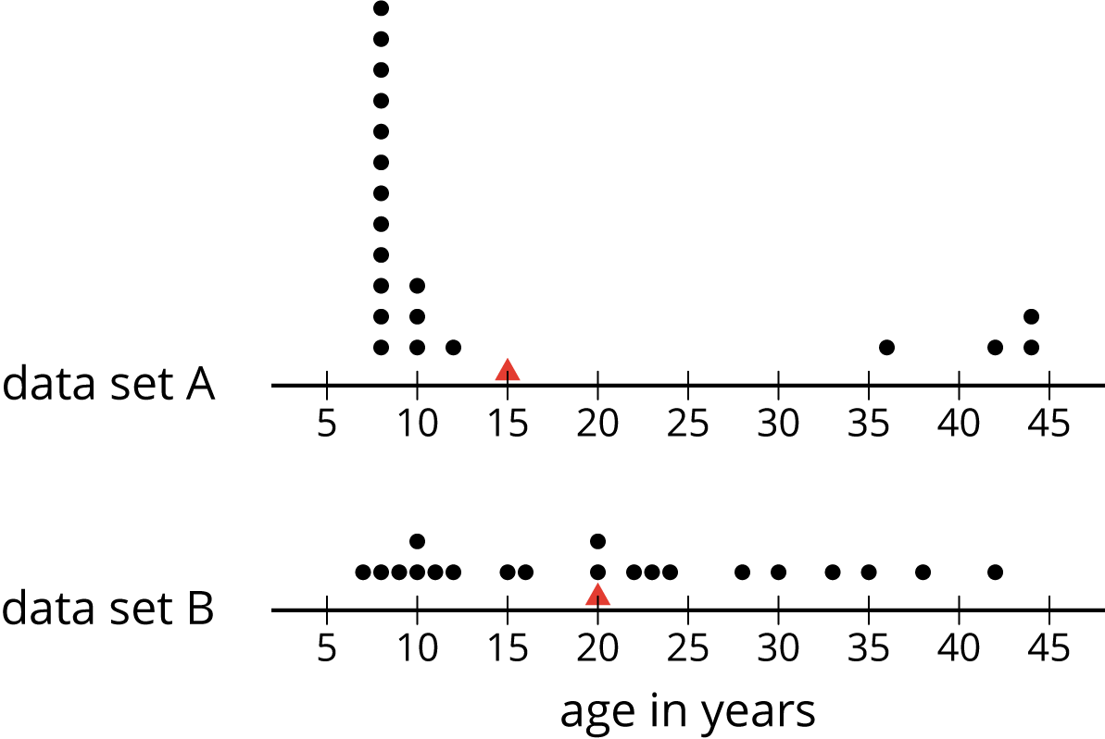
What do you notice and what do you wonder about the distributions in the two dot plots?

2 The Five-Number Summary

Student Task Statement
Here are the ages of the people at one party, listed from least to greatest.
7 | 8 | 9 | 10 | 10 | 11 | 12 | 15
16 | 20 | 20 | 22 | 23 | 24 | 28 | 30
33 | 35 | 38 | 42

  - Find the median of the data set and label it “50th percentile.” This splits the data into an upper half and a lower half.
  - Find the middle value of the lower half of the data, without including the median. Label this value “25th percentile.”
  - Find the middle value of the upper half of the data, without including the median. Label this value “75th percentile.”
- You have split the data set into four pieces. Each of the three values that split the data is called a quartile.
  - We call the 25th percentile the first quartile. Write “Q1” next to that number.
  - The median can be called the second quartile. Write “Q2” next to that number.
  - We call the 75th percentile the third quartile. Write “Q3” next to that number.
- Label the lowest value in the set “minimum” and the greatest value “maximum.”
- The values you have identified make up the five-number summary for the data set. Record them here.
- minimum: _____ Q1: _____ Q2: _____ Q3: _____ maximum: _____
- The median of this data set is 20. This tells us that half of the people at the party were 20 years old or younger, and the other half were 20 or older. What do each of these other values tell us about the ages of the people at the party?
  - the third quartile
  - the minimum
  - the maximum

Activity Synthesis
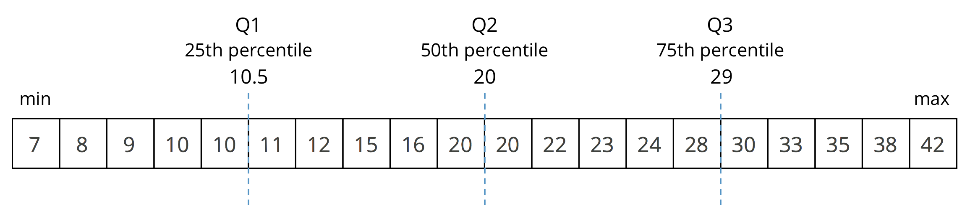

3 Human Box Plot

Images for Launch
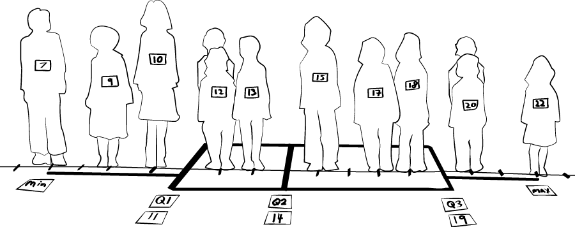

Student Task Statement
Your teacher will give you the data on the lengths of names of students in your class. Write the five-number summary by finding the data set's minimum, Q1, Q2, Q3, and the maximum.
Pause for additional instructions from your teacher.

4 Studying Blinks

Images for Launch
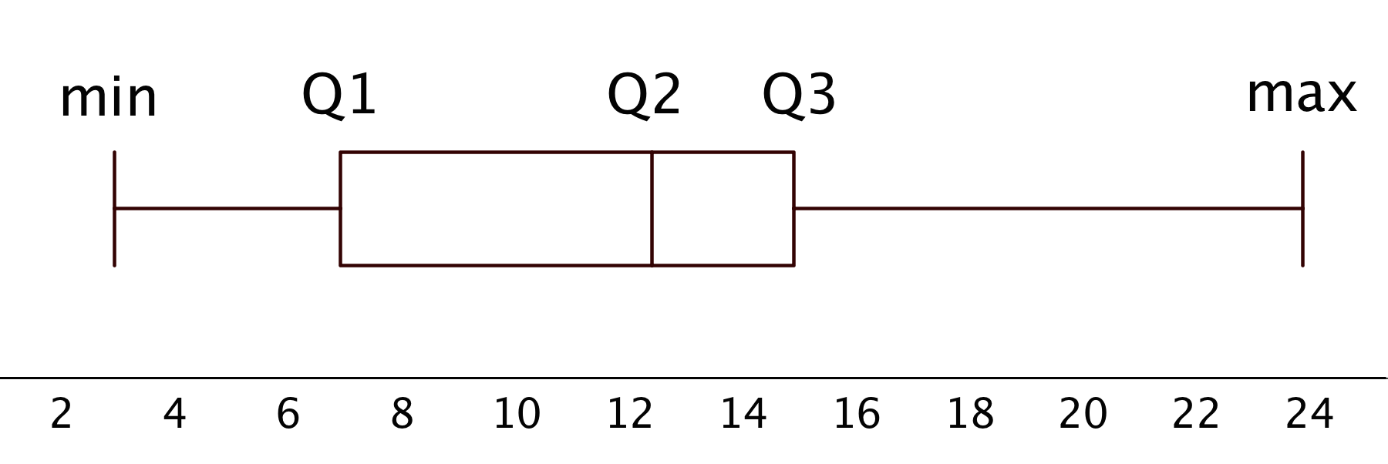

Student Task Statement
Twenty people participated in a study about blinking. The number of times each person blinked while watching a video for one minute was recorded. The data values are shown here, in order from smallest to largest.
3 | 6 | 8 | 11 | 11 | 13 | 14 | 14
14 | 14 | 16 | 18 | 20 | 20 | 20 | 22
24 | 32 | 36 | 51

  - Use the grid and axis to make a dot plot of this data set.
  - 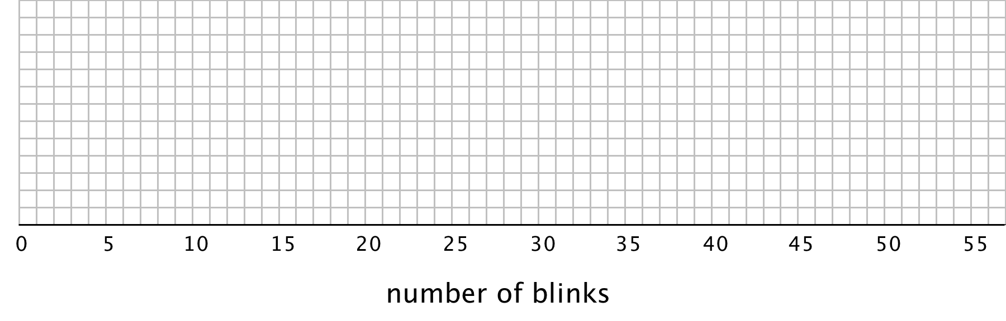
  - Find the median (Q2) and mark its location on the dot plot.
  - Find the first quartile (Q1) and the third quartile (Q3). Mark their locations on the dot plot.
  - What are the minimum and maximum values?
- A box plot can be used to represent the five-number summary graphically. Let’s draw a box plot for the number-of-blinks data. On the grid, above the dot plot:
  - Draw a box that extends from the first quartile (Q1) to the third quartile (Q3). Label the quartiles.
  - At the median (Q2), draw a vertical line from the top of the box to the bottom of the box. Label the median.
  - From the left side of the box (Q1), draw a horizontal line (a whisker) that extends to the minimum of the data set. On the right side of the box (Q3), draw a similar line that extends to the maximum of the data set.
- You have now created a box plot to represent the number of blinks data. What fraction of the data values are represented by each of these elements of the box plot?
  - The left whisker
  - The box
  - The right whisker

Activity Synthesis
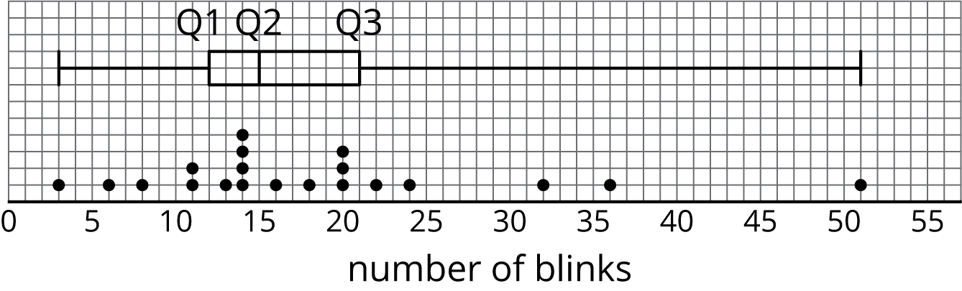
© CC BY Open Up Resources. Adaptations CC BY IM.

