Lesson 13: Encontremos medidas de ángulos

Standards Alignments
Addressing | 4.MD.C.7

Teacher-facing Learning Goals
- Compose and decompose angles to determine their measurements.

Student-facing Learning Goals
- Compongamos y descompongamos ángulos para encontrar sus medidas.

Lesson Purpose
The purpose of this lesson is for students to find unknown angle measurements by composing or decomposing known measurements, and to see that an angle is not determined by the length of the segments that form it.
In this lesson, students use tactile tools to find angle measurements and observe more clearly that angles are additive. They compose and decompose angles by arranging paper cutouts, by folding paper or tracing, and by drawing diagrams. Students arrange smaller angles whose sizes are unknown into larger angles with familiar sizes and features (${90}^{∘}$, ${180}^{∘}$, and ${360}^{∘}$). Once the measurement of an angle is known, they use it to find those of other angles. For example, if two copies of angle $x$ form a right angle, angle $x$ must be ${45}^{∘}$. If another angle, $z$, can be decomposed into three of these ${45}^{∘}$ angles, then $z$ must be ${135}^{∘}$.
Encourage students to continue to collect, define, and illustrate new terms to support communication and reasoning at the end of each lesson.

Access for:

Students with Disabilities
- Representation (Activity 2)

Instructional Routines
MLR5 Co-craft Questions (Activity 1), Notice and Wonder (Warm-up)

Materials to Gather
- Origami paper: Activity 2
- Patty paper: Activity 1

Materials to Copy
- How Big Are These Angles? (groups of 2): Activity 1

Required Preparation

Lesson Timeline
Warm-up | 10 min
Activity 1 | 25 min
Activity 2 | 10 min
Lesson Synthesis | 10 min
Cool-down | 5 min

Teacher Reflection Question
The work of finding angle measurements in this lesson offered opportunities to reason about equal groups. Did you hear students use this type of reasoning? What were some other ways students reasoned about the angle sizes?

Cool-down
(to be completed at the end of the lesson) 5min
Grupos de tres ángulos

Standards Alignments
Addressing | 4.MD.C.7

Student-facing Task Statement
Noah recorta 3 copias del ángulo $p$ y 3 copias del ángulo $q$. Él las organiza una al lado de la otra.
- Tres copias del ángulo $p$ forman una línea recta. ¿Cuántos grados mide el ángulo $p$? Explica o muestra cómo razonaste.
- 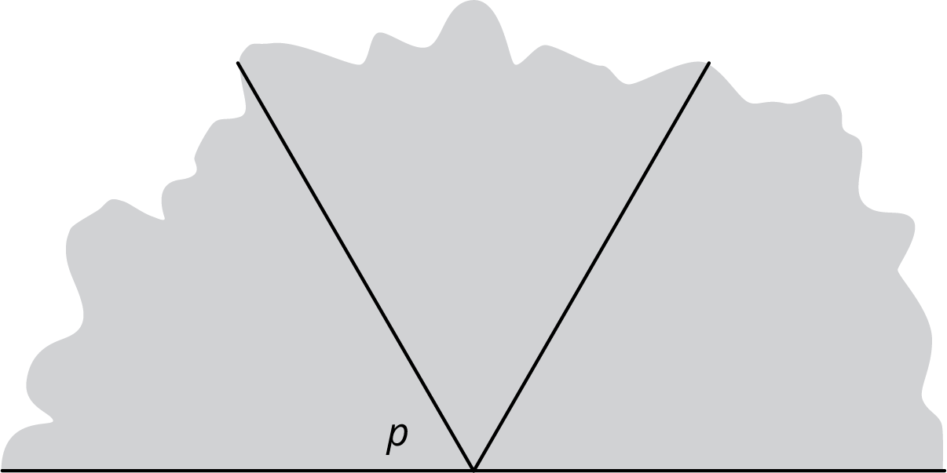
- ​​​​​
- Tres copias del ángulo $q$ forman un ángulo recto. ¿Cuántos grados mide el ángulo $q$? Explica o muestra cómo razonaste.
- 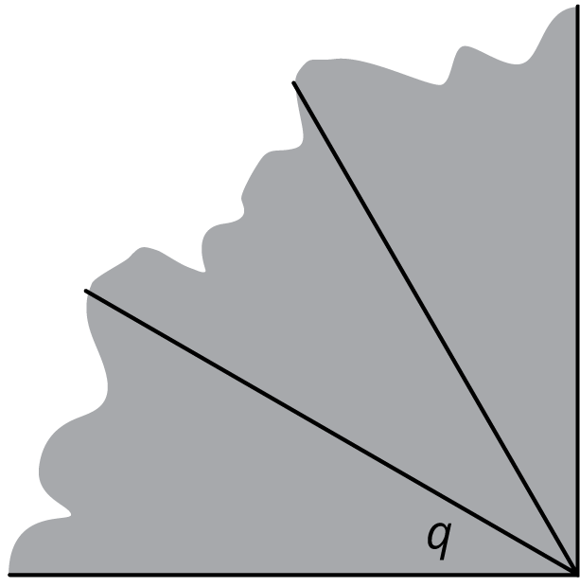
- ​​​​
- Noah pone el ángulo $p$ junto al ángulo $q$. ¿Cuántos grados mide el ángulo que se forma? Explica o muestra cómo razonaste.
- 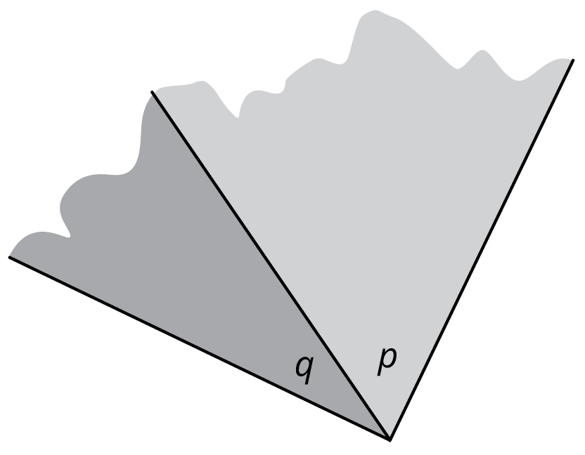

Student Responses
- ${60}^{∘}$.Sample response: Three times the measure of $p$ is ${180}^{∘}$, so $p$ must measure ${60}^{∘}$.
- ${30}^{∘}$. Sample response: $90÷3=30$.
- ${90}^{∘}$. Sample response: $60+30=90$.

