Lesson 11: Polyhedra and Nets
Let's use nets to find the surface area of polyhedra.

11.1: What are Polyhedra?
Here are pictures that represent polyhedra:
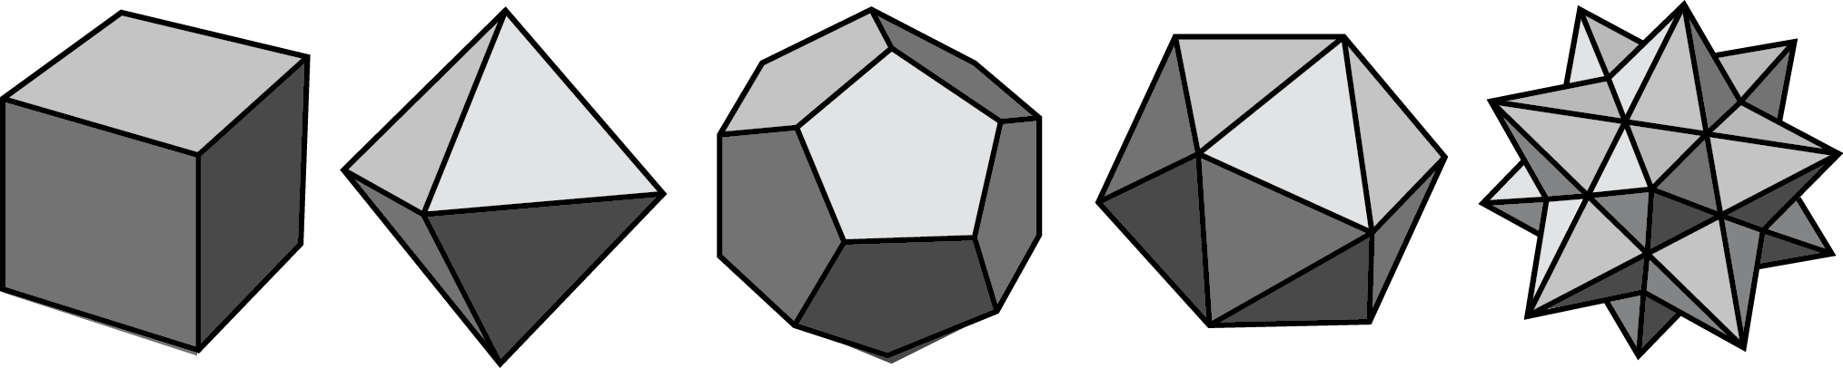
Here are pictures that do not represent polyhedra:
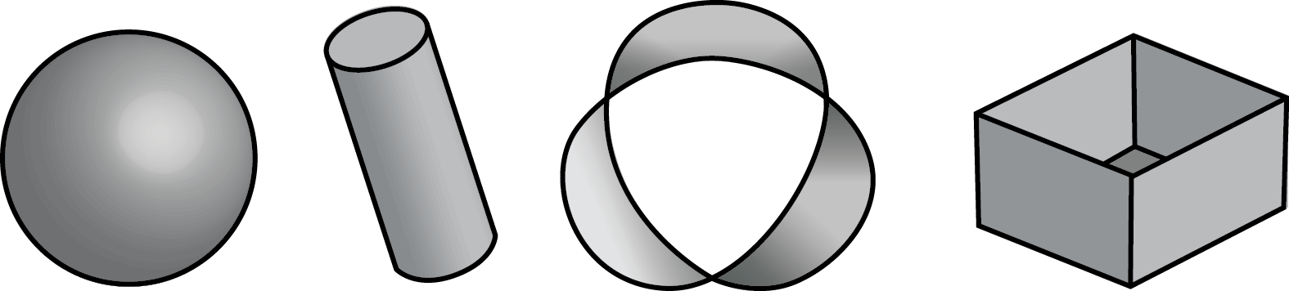

- Your teacher will give you some figures or objects. Sort them into polyhedra and non-polyhedra.
- What features helped you distinguish the polyhedra from the other figures?

11.2: Prisms and Pyramids
- Here are some polyhedra called prisms.
- 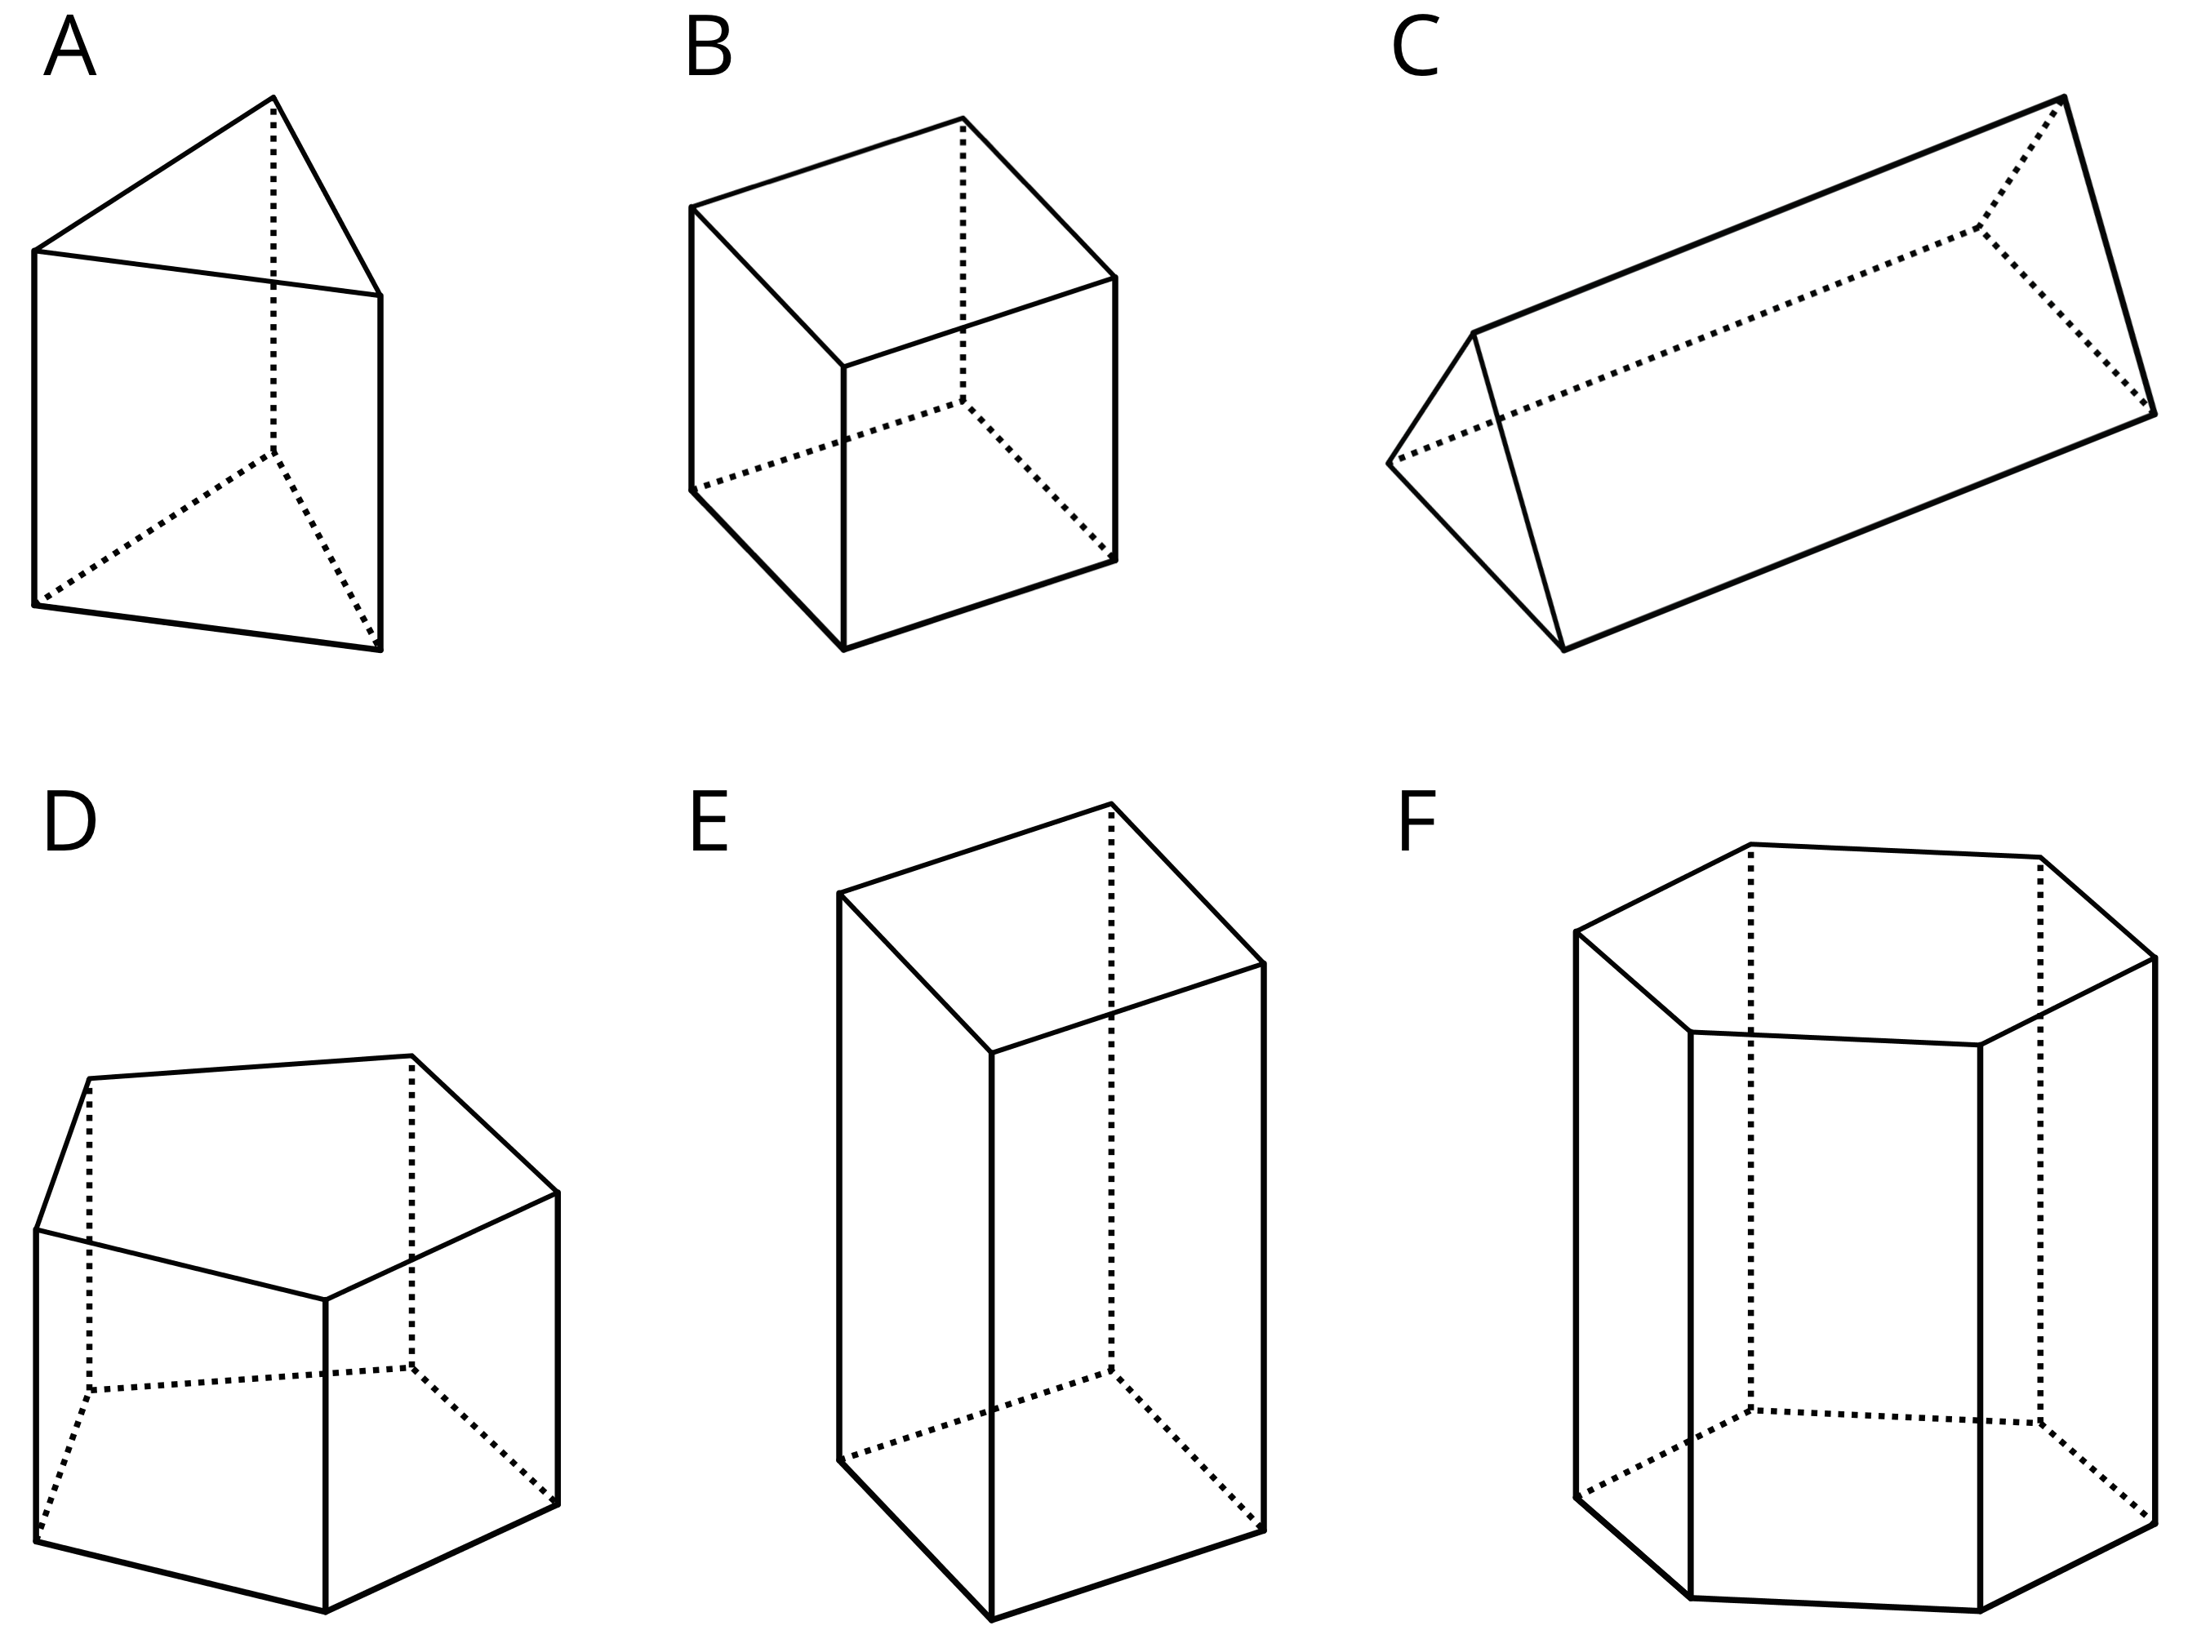
- Here are some polyhedra called pyramids.
- 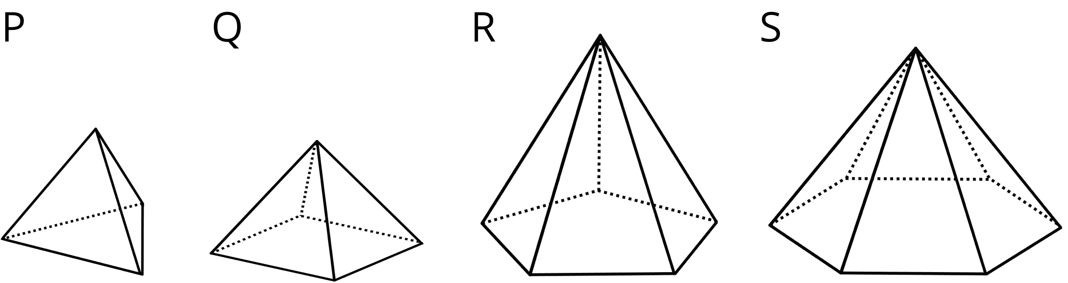
  - Look at the prisms. What are their characteristics or features?
  - Look at the pyramids. What are their characteristics or features?
- Which of these nets can be folded into Pyramid P? Select all that apply.
- 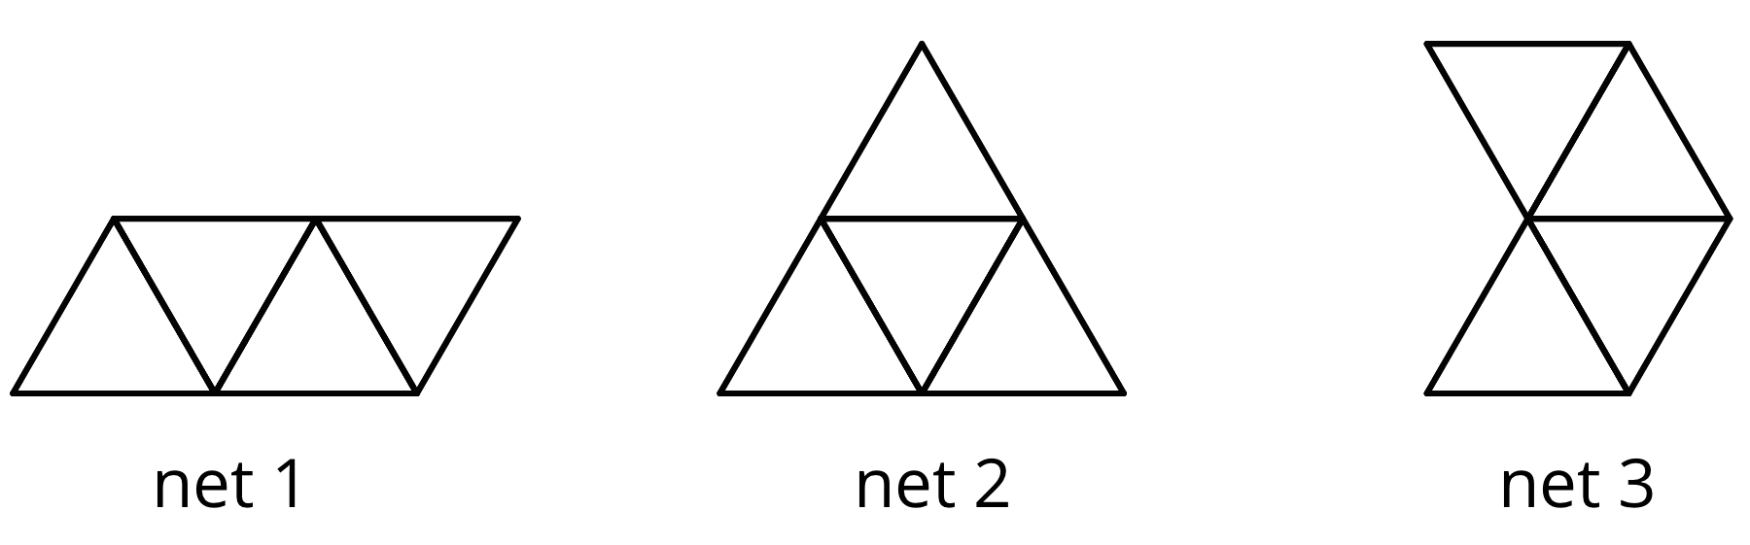
- Your teacher will give your group a set of polygons and assign a polyhedron.
  - Decide which polygons are needed to compose your assigned polyhedron. List the polygons and how many of each are needed.
  - Arrange the cut-outs into a net that, if taped and folded, can be assembled into the polyhedron. Sketch the net. If possible, find more than one way to arrange the polygons (show a different net for the same polyhedron).

Are you ready for more?
What is the smallest number of faces a polyhedron can possibly have? Explain how you know.

11.3: Using Nets to Find Surface Area
- Name the polyhedron that each net would form when assembled.
- 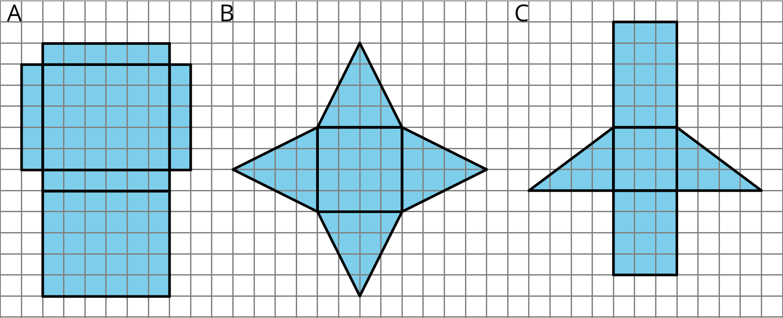
- Your teacher will give you the nets of three polyhedra. Cut out the nets and assemble the three-dimensional shapes.
- Find the surface area of each polyhedron. Explain your reasoning clearly.

Are you ready for more?
- For each net, decide if it can be assembled into a rectangular prism.
- 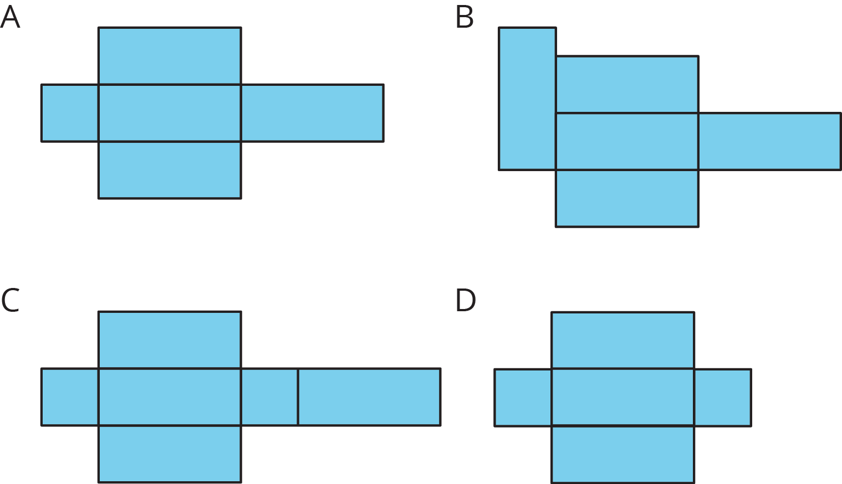
- For each net, decide if it can be folded into a triangular prism.
- 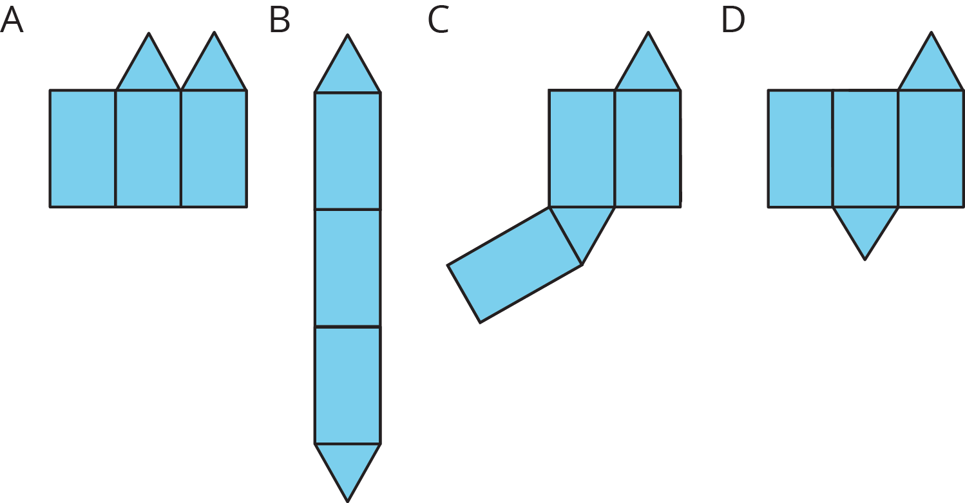

Lesson 11 Summary
A polyhedron is a three-dimensional figure composed of faces. Each face is a filled-in polygon and meets only one other face along a complete edge. The ends of the edges meet at points that are called vertices.
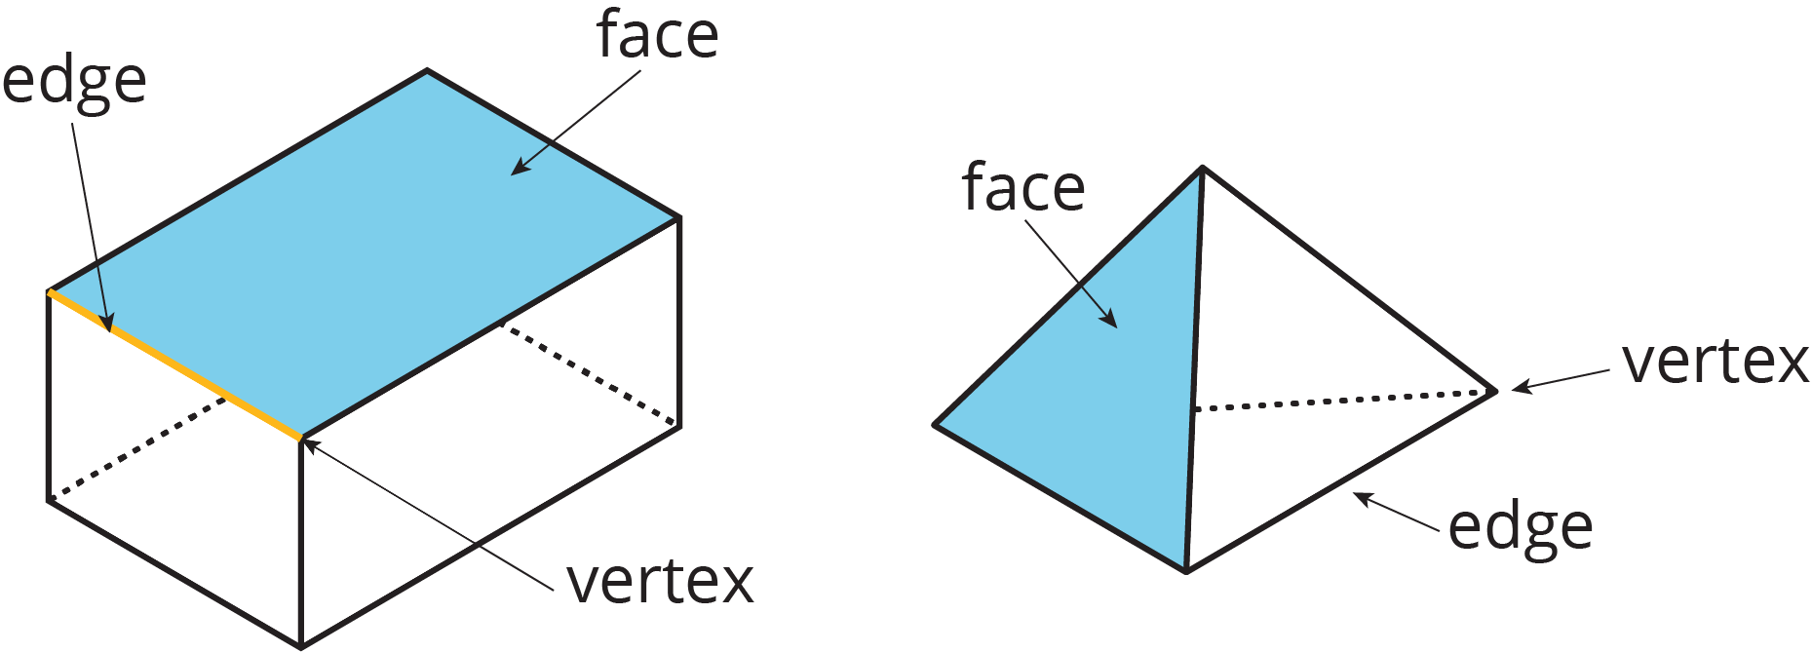
A prism is a type of polyhedron with two identical faces that are parallel to each other and that are called bases. The bases are connected by a set of rectangles (or sometimes parallelograms). A prism is named for the shape of its bases. For example, if the base is a pentagon, then it is called a “pentagonal prism.”
A net is a two-dimensional representation of a polyhedron. It is composed of polygons that form the faces of a polyhedron. A net of a prism has two copies of the polygon that is the base. The rest of the polygons are rectangles. A pentagonal prism and its net are shown here.
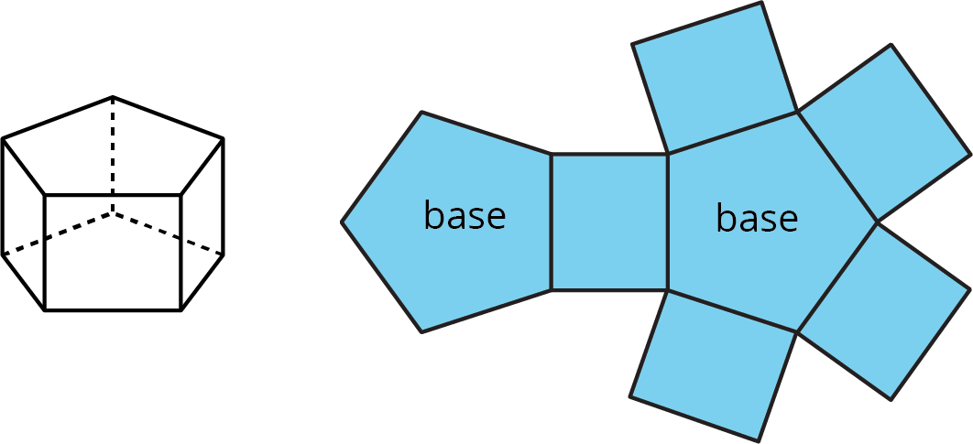
A pyramid is a type of polyhedron that has one special face called the base. All of the other faces are triangles that all meet at a single vertex. A pyramid is named for the shape of its base. For example, if the base is a pentagon, then it is called a “pentagonal pyramid.”
A net of a pyramid has one polygon that is the base. The rest of the polygons are triangles. A pentagonal pyramid and its net are shown here.
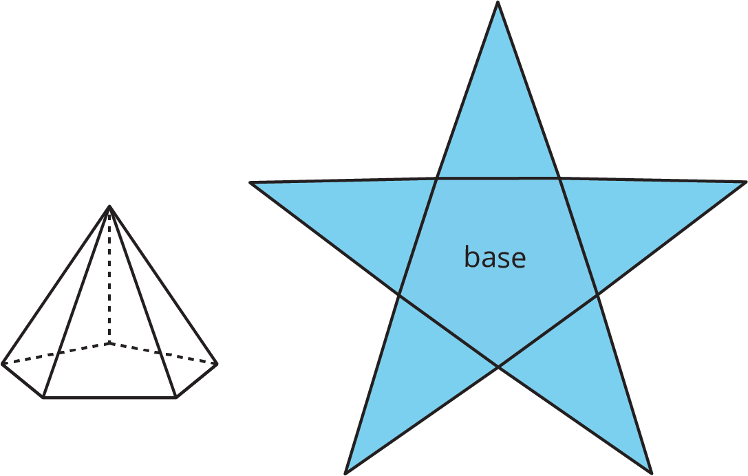
Because a net shows all the faces of a polyhedron, we can use it to find its surface area. For instance, the net of a rectangular prism shows three pairs of rectangles: 4 units by 2 units, 3 units by 2 units, and 4 units by 3 units.
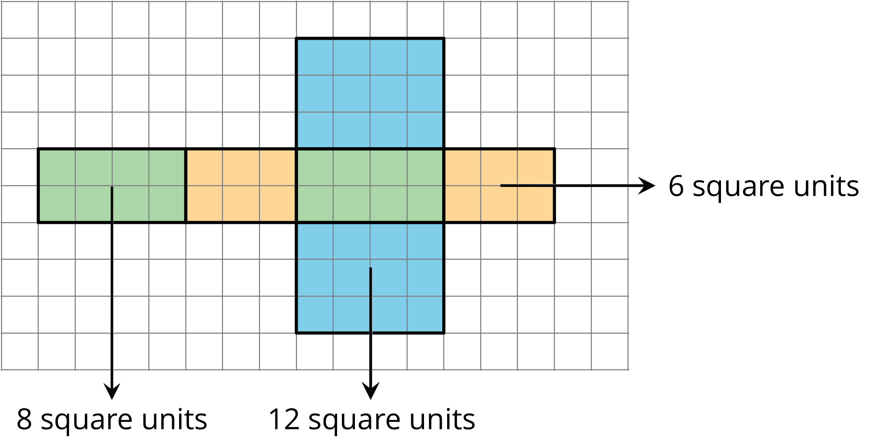
The surface area of the rectangular prism is 52 square units because $8+8+6+6+12+12=52$.
© CC BY Open Up Resources. Adaptations CC BY IM.

