Unit 1 Lesson 4 Cumulative Practice Problems
- For each pair of polygons, describe a sequence of translations, rotations, and reflections that takes Polygon P to Polygon Q.
  - 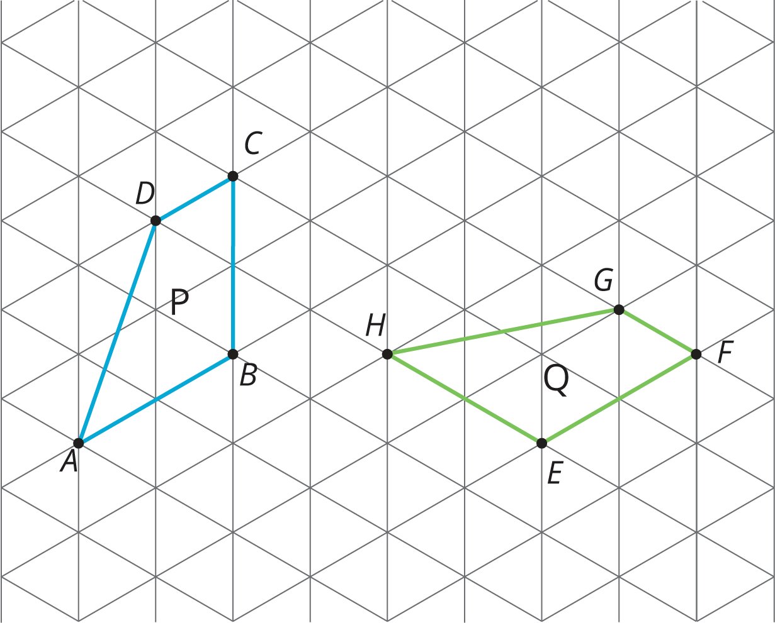
  - 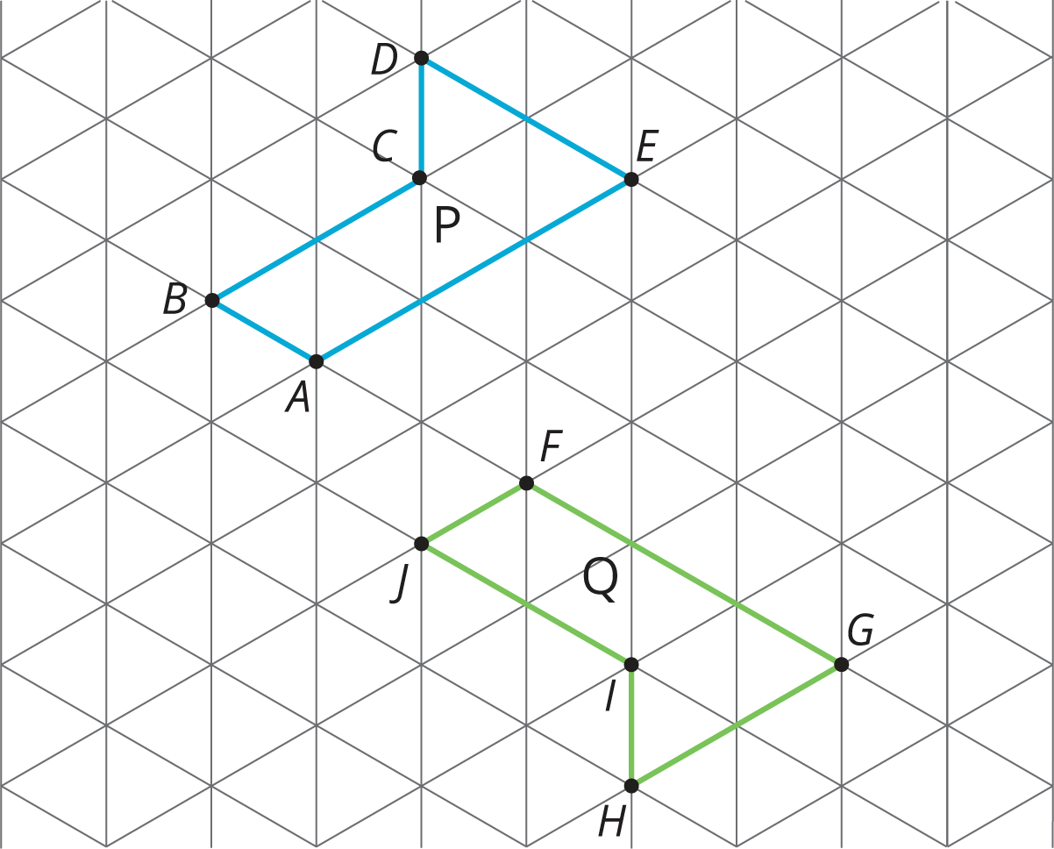
  - 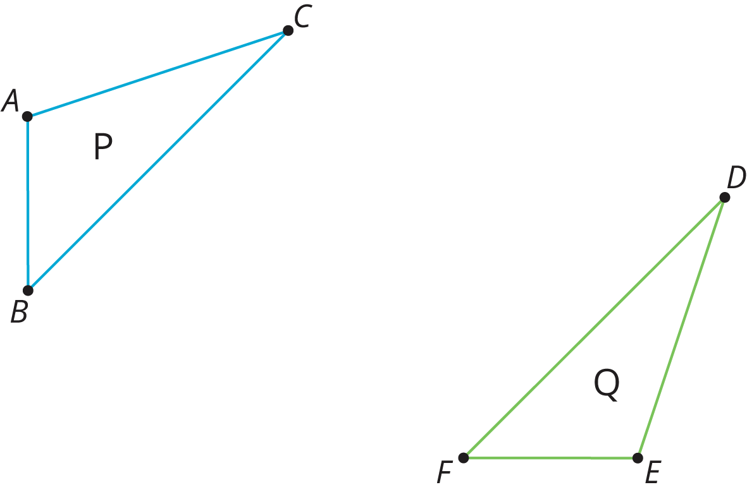
- Here is quadrilateral $ABCD$ and line $ℓ$.
- 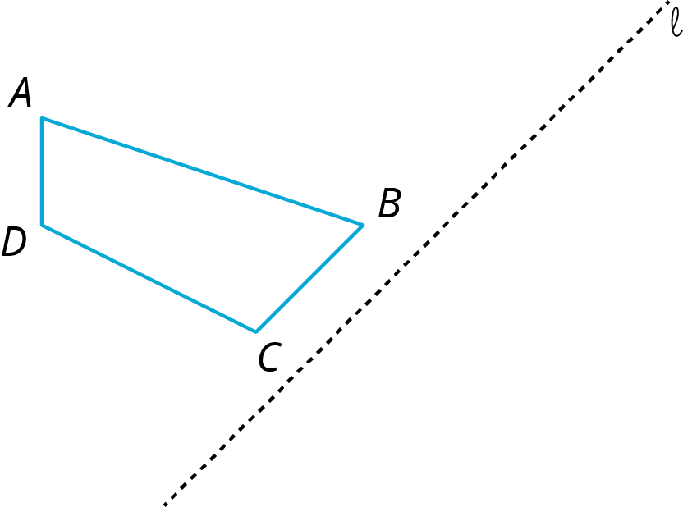
- Draw the image of quadrilateral $ABCD$ after reflecting it across line $ℓ$.
- (From Unit 1, Lesson 2.)
- Here is quadrilateral $ABCD$.

- 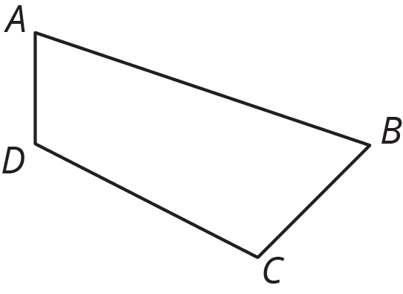

- Draw the image of quadrilateral $ABCD$ after each rotation using $B$ as center.
  - 90 degrees clockwise
  - 120 degrees clockwise
  - 30 degrees counterclockwise
- (From Unit 1, Lesson 2.)
© CC BY Open Up Resources. Adaptations CC BY IM.

