Lesson 20: Products in the Hundredths Place

Standards Alignments
Addressing | 5.NBT.B.7, 5.NF.B.4
Building Towards | 5.NF.B.7

Teacher-facing Learning Goals
- Use diagrams and place value reasoning to interpret and evaluate products of two decimal numbers.

Student-facing Learning Goals
- Let’s multiply tenths by tenths.

Lesson Purpose
The purpose of this lesson is for students to find products of tenths and tenths.
The purpose of this lesson is for students to find products of two decimal numbers where each decimal represents a number of tenths, using the place value reasoning and diagrams that were also useful for finding the product of a whole number and a decimal. Students explain why $0.1×0.1=0.01$ in the warm-up and this opens up one strategy for finding products like $1.5×0.7$. In particular, this can be rewritten as
$\left(15×0.1\right)×\left(7×0.1\right)=\left(15×7\right)×\left(0.1×0.1\right)$.
So the value of $1.5×0.7$ is 105 hundredths or 1.05. A second approach uses area diagrams which students are familiar with from earlier lessons in this unit and from when they used them to find products of fractions. Decimals are an example of fractions and these diagrams are useful in this situation as well.

Access for:

Students with Disabilities
- Representation (Activity 1)

English Learners
- MLR8 (Activity 1)

Instructional Routines
What Do You Know About _____? (Warm-up)

Materials to Copy
- Small Grids (groups of 1): Activity 1
- Small Grids (groups of 1): Activity 2

Lesson Timeline
Warm-up | 10 min
Activity 1 | 15 min
Activity 2 | 20 min
Lesson Synthesis | 10 min
Cool-down | 5 min

Teacher Reflection Question
What do you love most about math? How are you sharing that joy with your students and encouraging them to think about what they love about math?

Cool-down
(to be completed at the end of the lesson) 5min
Tenths

Standards Alignments
Addressing | 5.NBT.B.7

Student-facing Task Statement
Find the value of each expression. Use the diagrams if they are helpful.
- $0.3×0.6$
- $1.3×0.6$
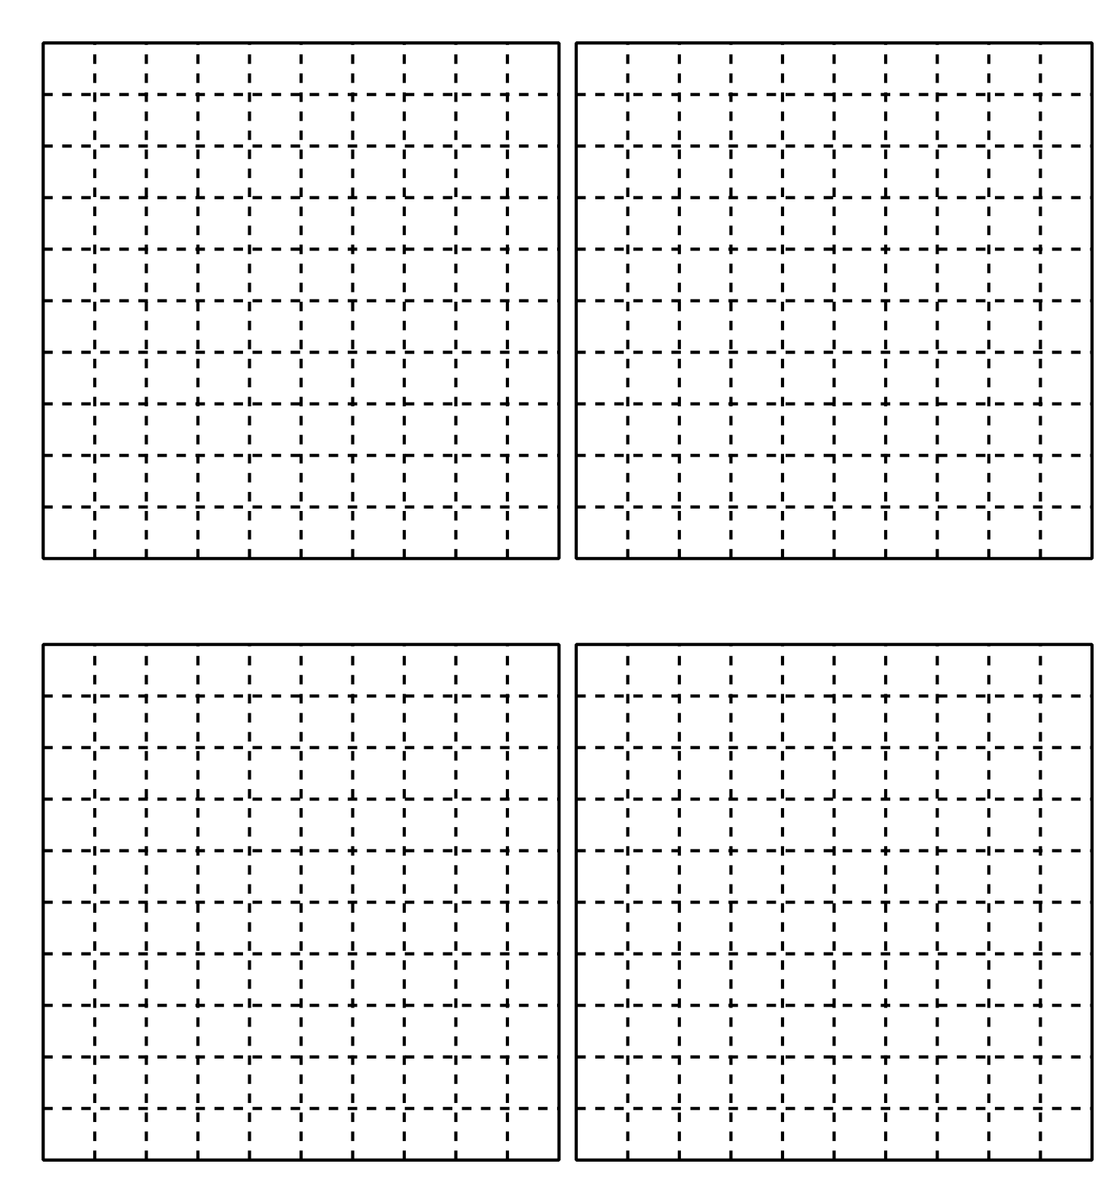

Student Responses
- $0.18$ or equivalent
- $0.78$ or equivalent

