Unit 7 Lesson 9: Variability in Samples

1 Selecting Samples (Warm up)

Student Task Statement
Coins are usually stamped with the year and location of the mint where they were made. D represents the mint in Denver, Colorado, and a blank or P represents the mint in Philadelphia, Pennsylvania.
Diego has a jar containing 36 coins. Select a sample of 5 coins by rolling your number cube once to represent the row and rolling again to find the column. For example, rolling a 3 and then a 5 would represent selecting the coin marked 2000 P. Repeat this process to collect a sample of 5 coins.

coin 1
coin 2
coin 3
coin 4
coin 5
sample mean year
sample proportion minted in Denver
sample 1

sample 2

sample 3

- Find the mean for the sample of 5 coins.
- Find the proportion of the sample of 5 coins that were minted in Denver.
- Repeat the process to find 2 more samples of 5 coins, then compute the mean and proportion that were minted in Denver.

2 Examining Sample Statistics

Student Task Statement
Use the data from the warm-up to answer the questions.
- Not all the samples have the same mean and proportion. Why not?
- Examine the histogram for the mean year of coins from the samples. What do you notice?
- Based on the mean years from the samples, estimate the mean year for all the coins in Diego’s jar. Explain your reasoning.
- Examine the histogram of the proportion of coins in each sample that were minted in Denver. What do you notice?
- Based on the sample proportions found by the class, estimate the proportion of coins minted in Denver for all the coins in Diego’s jar. Explain your reasoning.

3 Variability of Sample Estimates

Student Task Statement
A political campaign sends volunteers out into the various parts of the state to get a sense of how well their candidate will do in an upcoming election. Thirty volunteers each get a random sample of 10 people in the state and find the proportion of people who are expecting to vote for their candidate. The sample proportions are summarized in the histogram.
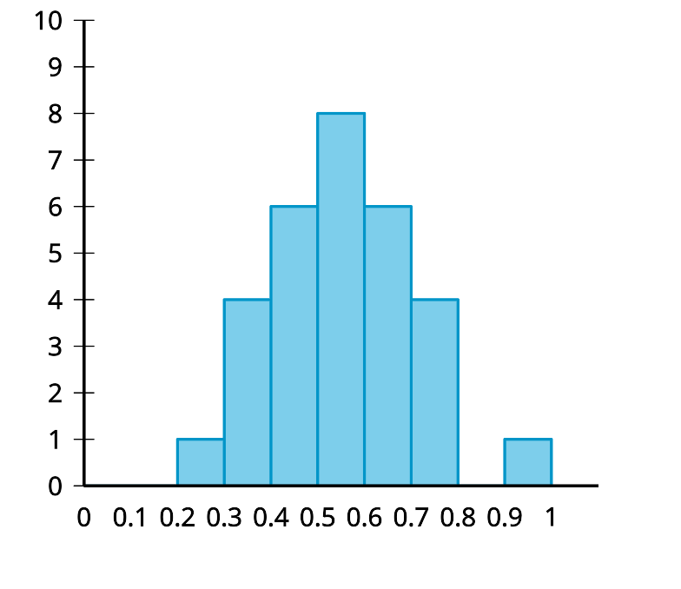
The mean of these sample proportions is 0.55, and the standard deviation is 0.15.
- Recall that, for normally distributed data, about 95% of the data is within 2 standard deviations of the mean. What percentage of sample proportions are within 2 standard deviations of the mean for these data? Does this match what we expect from approximately normally distributed data? Explain or show your reasoning.
- Estimates for population characteristics are usually given along with a margin of error. The margin of error is the maximum expected difference between the estimate of the population characteristic and the actual population characteristic. Each of the sample proportions are good estimates of the population proportion, so we should give a margin of error that contains about 95% of the sample proportions to be reasonably sure that the actual population proportion is in the range between the mean minus the margin of error to the mean plus the margin of error. What margin of error should be given along with the estimate of 0.55 for the population proportion? Explain or show your reasoning.
© CC BY 2019 by Illustrative Mathematics

