Lesson 14: Center Day 2
- Let’s practice adding and subtracting and using the number line.

Warm-up: True or False: Is This 50?
Decide if each statement is true or false. Be prepared to explain your reasoning.
- $28+2+20=50$
- $16+3+30=50$
- $36+4+20=50$

14.2: Centers: Choice Time
Choose a center.
Jump the Line
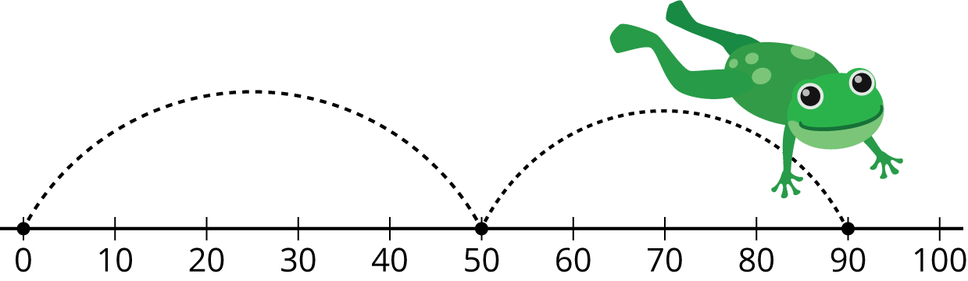
Number Line Scoot
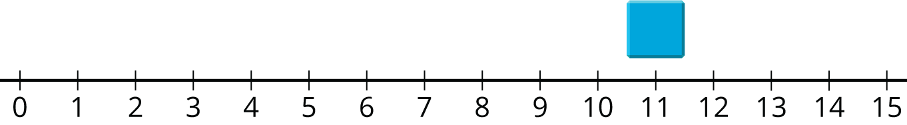
How Close?
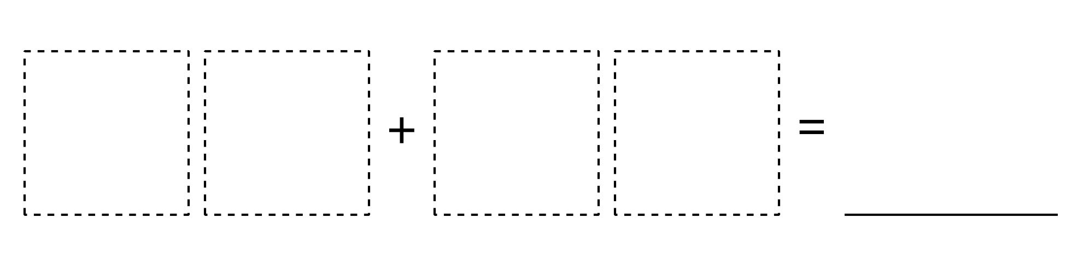
© CC BY 2021 Illustrative Mathematics®

