Lesson 6: Distance Around Shapes

Standards Alignments
Addressing | 3.MD.D, 3.MD.D.8
Building Towards | 3.MD.D.8

Teacher-facing Learning Goals
- Describe perimeter as the length of the boundary of a flat shape.
- Find the perimeter of two-dimensional shapes.

Student-facing Learning Goals
- Let’s find the distance around shapes.

Lesson Purpose
The purpose of this lesson is for students to understand perimeter and find the perimeter of shapes by counting to determine the side lengths.
In previous lessons, students reasoned about shapes and their attributes. In this lesson, students determine how many paper clips it takes to build a given shape to introduce perimeter as the boundary of a flat shape. Then, they find the distance around shapes with marked side lengths and consider different strategies for finding the total length of the sides. In the lesson synthesis, students have the opportunity to share familiar situations that could involve perimeter.

Access for:

Students with Disabilities
- Action and Expression (Activity 2)

English Learners
- MLR8 (Activity 2)

Instructional Routines
Notice and Wonder (Warm-up)

Materials to Gather
- Paper clips: Activity 1

Materials to Copy
- What Does It Take to Build the Shapes? (groups of 4): Activity 1

Lesson Timeline
Warm-up | 10 min
Activity 1 | 15 min
Activity 2 | 20 min
Lesson Synthesis | 10 min
Cool-down | 5 min

Teacher Reflection Question
Reflect on how comfortable your students are asking questions of you and of each other. What can you do to encourage students to ask questions?

Cool-down
(to be completed at the end of the lesson) 5min
What is the Perimeter?

Standards Alignments
Addressing | 3.MD.D.8

Student-facing Task Statement
Find the perimeter of this shape. Explain or show your reasoning.
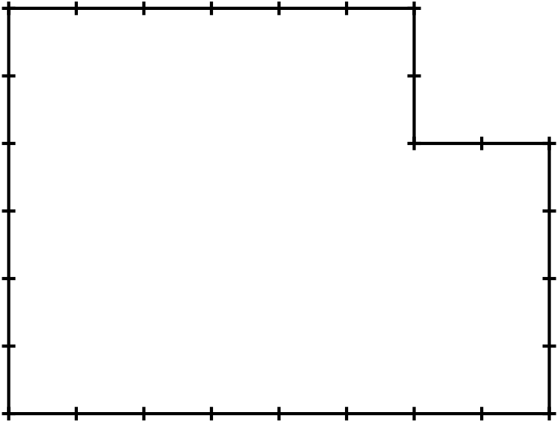

Student Responses
28 units. Sample response: There are 2 sides that are 2 units each, and 2 sides that are 6 units each, so that's $\left(2×2\right)+\left(2×6\right)$ or $4+12$, which is 16. There are 2 other sides that are 8 units and 4 units, so that’s 12 more. $16+12=28$

