Lesson 16: Center Day 3
- Let’s play games to practice adding and subtracting.

Warm-up: Number Talk: Subtraction
Find the value of each expression mentally.
- $9−7$
- $9−2$
- $8−6$
- $8−2$

16.2: Centers: Choice Time
Choose a center.
Math Stories
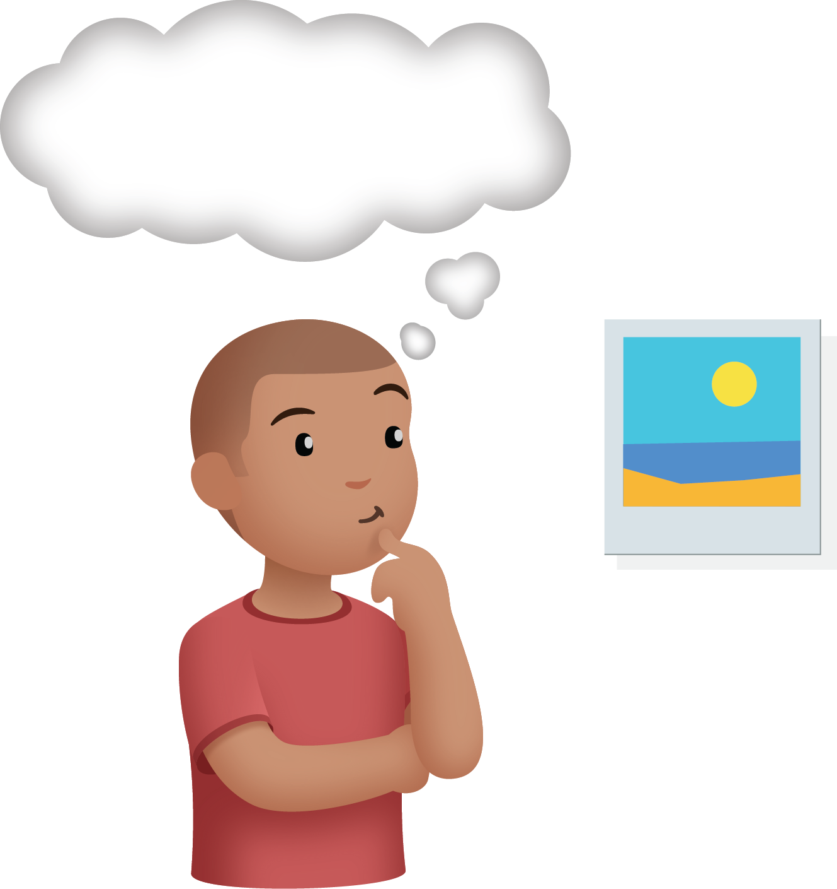
Shake and Spill
What's Behind My Back
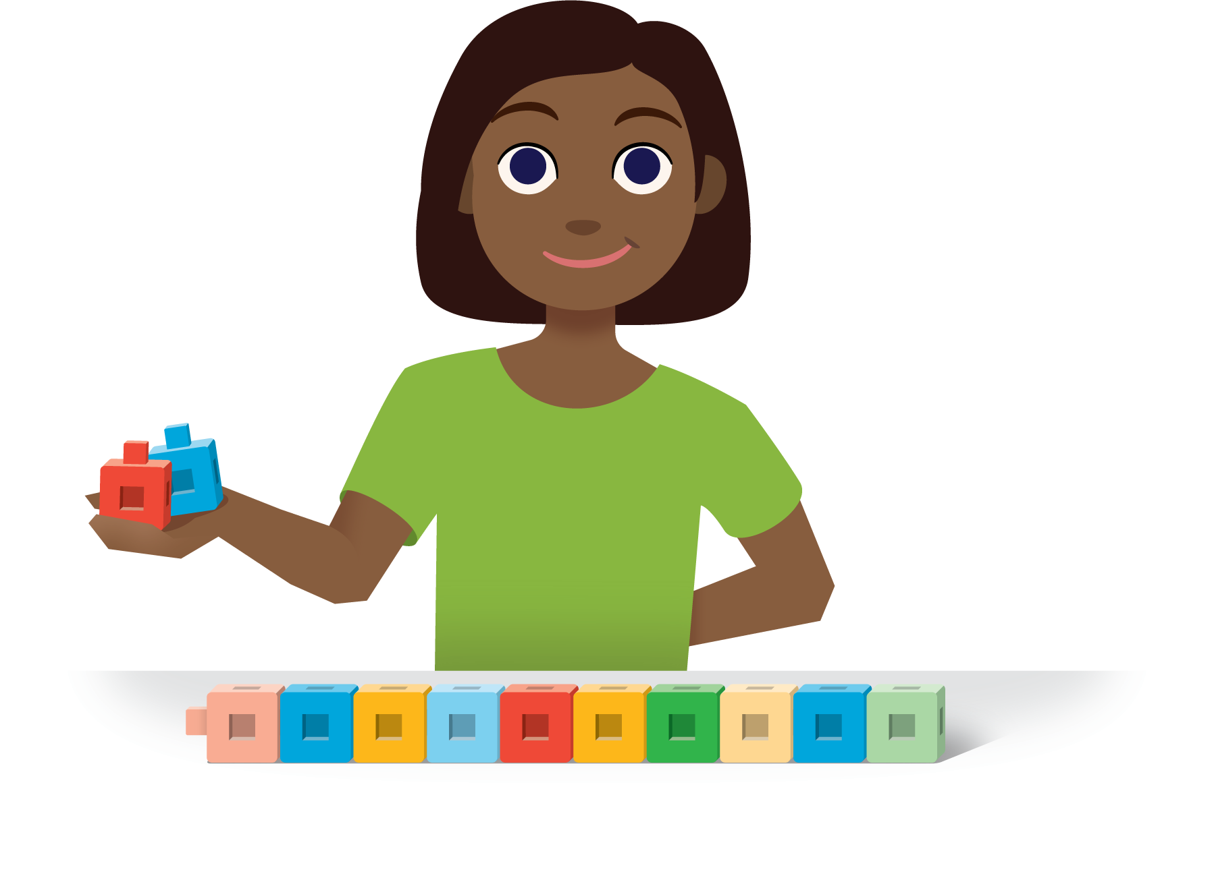
© CC BY 2021 Illustrative Mathematics®

