Lesson 10: Angle Measurement and Perpendicular Lines

Standards Alignments
Addressing | 4.G.A.1, 4.MD.C.5.b, 4.MD.C.6, 4.NBT.B.6

Teacher-facing Learning Goals
- Recognize that perpendicular lines meet or cross at a right angle.
- Use a protractor to measure angles.

Student-facing Learning Goals
- Let’s measure all kinds of angles.

Lesson Purpose
The purpose of this lesson is for students to practice using a protractor to measure angles and to learn that lines that intersect at a right angle are perpendicular lines.
In a previous lesson, students learned that a 1-degree angle measures a turn through ​$\frac{1}{360}$​ of a circle and that a protractor could be used to measure angles in degrees.
In this lesson, students practice using a protractor to measure a variety of angles—angles formed by rays or line segments and those that are in other two-dimensional figures. Students consider how to position the tool, which set of numbers to use, and whether their measurements make sense.
Next, students are prompted to fold paper to create two lines that form right angles. They learn that intersecting lines that form ${90}^{∘}$ angles are perpendicular. They then practice identifying perpendicular lines and segments.

Access for:

Students with Disabilities
- Representation (Activity 2)

English Learners
- MLR8 (Activity 1)

Instructional Routines
MLR2 Collect and Display (Activity 2), Number Talk (Warm-up)

Materials to Gather
- Colored pencils: Activity 2
- Paper: Activity 2
- Protractors: Activity 1
- Rulers or straightedges: Activity 1, Activity 2

Lesson Timeline
Warm-up | 10 min
Activity 1 | 15 min
Activity 2 | 20 min
Lesson Synthesis | 10 min
Cool-down | 5 min

Teacher Reflection Question
In the past few lessons, students may have made assumptions (correct or incorrect) about angle sizes based on their appearance. In this lesson, they may have done the same when looking for perpendicularity. What questions can you ask, or what instructional moves can you consider, to encourage students to check their assumptions?

Cool-down
(to be completed at the end of the lesson) 5min
Size Up Angles

Standards Alignments
Addressing | 4.G.A.1, 4.MD.C.5.b, 4.MD.C.6

Student-facing Task Statement
- Which figures show perpendicular lines or rays?
- 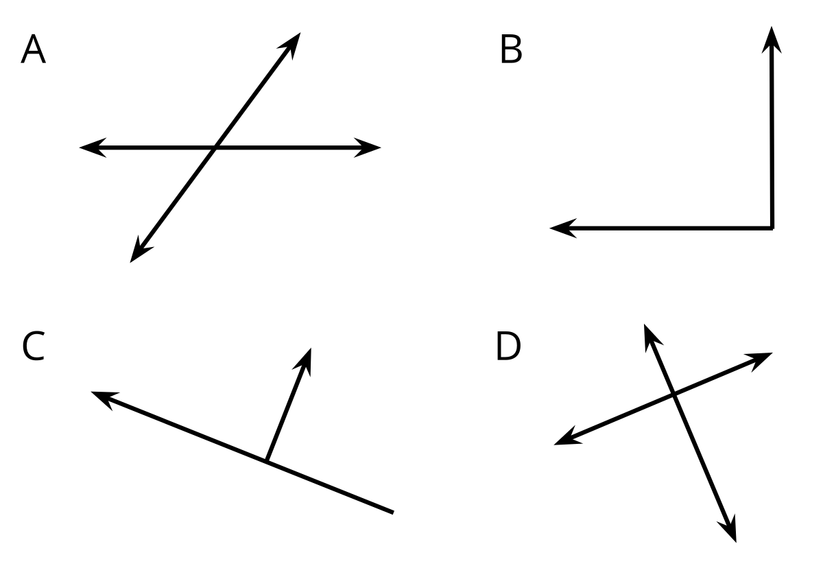
- Use a protractor to measure the labeled angles in the figure.
- 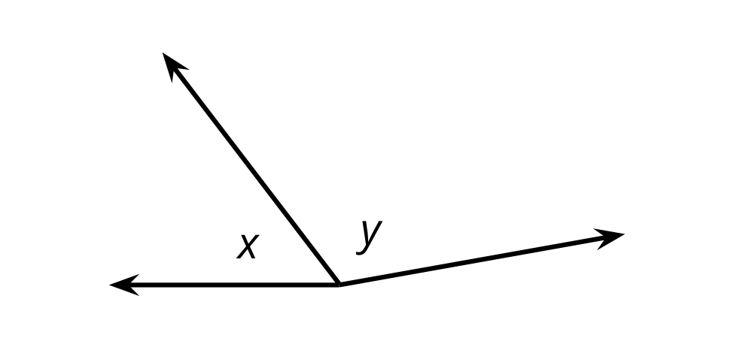

Student Responses
- B, C, and D
- Angle $x$ is ${53}^{∘}$. Angle $y$ is ${117}^{∘}$.

