Lesson 8: Scaling the Outputs
- Let’s stretch and squash some graphs.

8.1: Notice and Wonder: Arch You Glad to See Me?
What do you notice? What do you wonder?
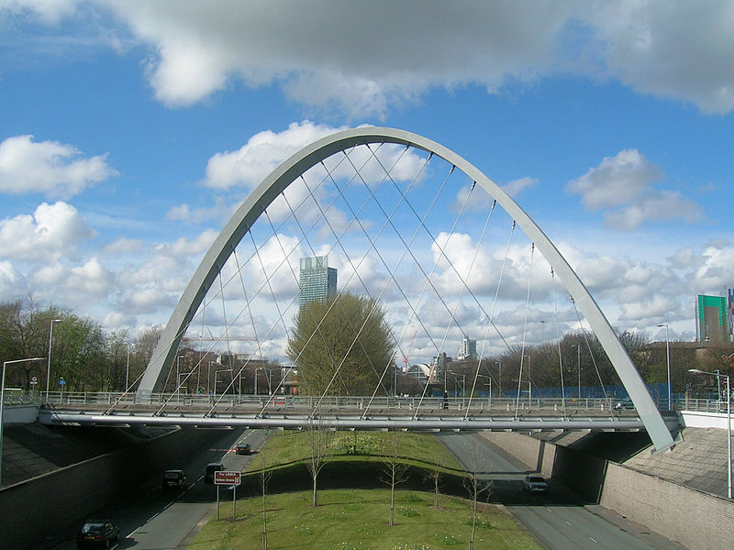

8.2: The Hulme Arch Bridge
The Hulme Arch Bridge in Manchester, England is shaped like a parabola. The ends of the arch are 52 meters apart, and it is 25 meters high.
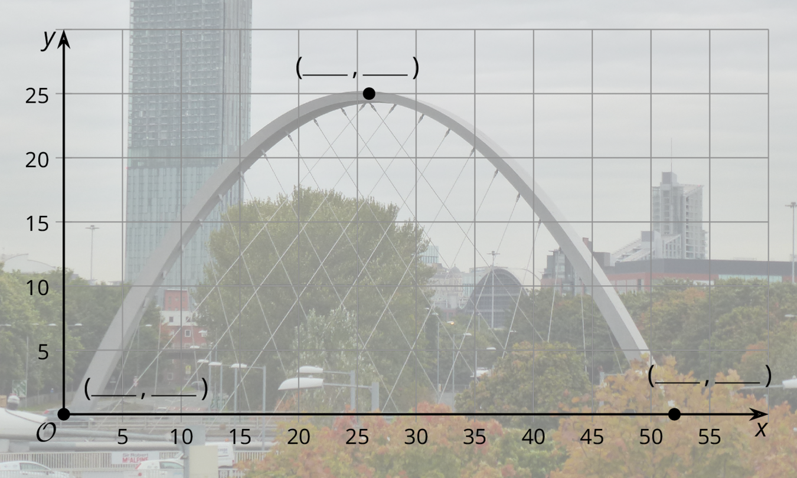
- Use the description to help you label the 3 coordinates on the graph.
- Han wants to model the shape of the arch with the graph of a function, and he chooses $H(x)=x(52−x)$, where $H(x)$ is the height in meters above a point $x$ meters along the base of the arch from the left end.
  - For the $x$-coordinates of the three points, what are the corresponding points on the graph of $H$?
  - What aspects of the shape does Han’s function model well, and what parts does it not model well?
  - Compare the height of Han’s graph with the height of the Hulme Arch Bridge. How can you change the outputs of $H$ to make it fit better? What would the revised version of $H(x)$ be?

8.3: Feed the Dog
A certain brand of dog food gives the minimum daily amount of food a dog needs depending on its weight. We want to model the relationship between the amount of food and the dog’s weight with a function $F$, where $F(w)$ is the amount of food, in grams, needed by a dog weighing $w$ pounds.
weight (pounds) | food (grams)
5 | 50
10 | 75
20 | 130
40 | 230
60 | 305
80 | 375
100 | 435
- Use graphing technology to find a linear function, $F(w)=mw+b$, that fits the data.
- What aspects of the data does your function model well and what aspects does it not model well?
- The graph of $f(w)=w^{\frac{2}{3}}$ has a general shape that fits the data. Use graphing technology to find a scale factor $k$ so that $F(w)=kf(w)$ fits the data.

Are you ready for more?
- How do the graphs of $a(w)=42w^{\frac{1}{2}}$, $b(w)=20w^{\frac{2}{3}}$, and $c(w)=14w^{\frac{3}{4}}$ compare?
- Which one do you think can be used to produce the best model of the amount of food needed? Explain your reasoning.

Lesson 8 Summary
Sometimes when we want to model data, we can look at the context and the shape of the data to help us figure out what type of function to use. Once we have the same general shape, we can translate a function up, down, left, or right or reflect a function to make it fit the data better. But sometimes these types of transformations are not enough.
For example, the towers of the Golden Gate bridge in San Francisco are 1280 meters apart, and the tops of the towers are 152 meters above the roadway. If we place the $x$-axis at the top of the towers, we can model the parabolic shape representing the suspension cable between them using a quadratic function with zeros at 0 and 1280, given by $f(x)=x(x−1280)$. Unfortunately, the model should have a value of -152 at $x=640$, which is halfway between the towers, and instead we have
$f(640)=640(640−1280)=\text{-}{640}^{2}=\text{-}409,​600.$
No number of translations or reflections of the current model will make a graph that matches the shape of the suspension cables and also keeps the zeros at 0 and 1280. So instead of adding to or subtracting from the output, we're going to multiply the output by a scale factor, $k$. Using multiplication means we keep the zeros where they are while scaling all the other output values. To make -409,600 be -152, we are going to have to squash the graph using a very small scale factor. If we choose a scale factor $k=\frac{152}{409,600}=0.000371$, then the graph of $y=kf(x)=0.000371x(x−1280)$ has the same shape as the bridge.
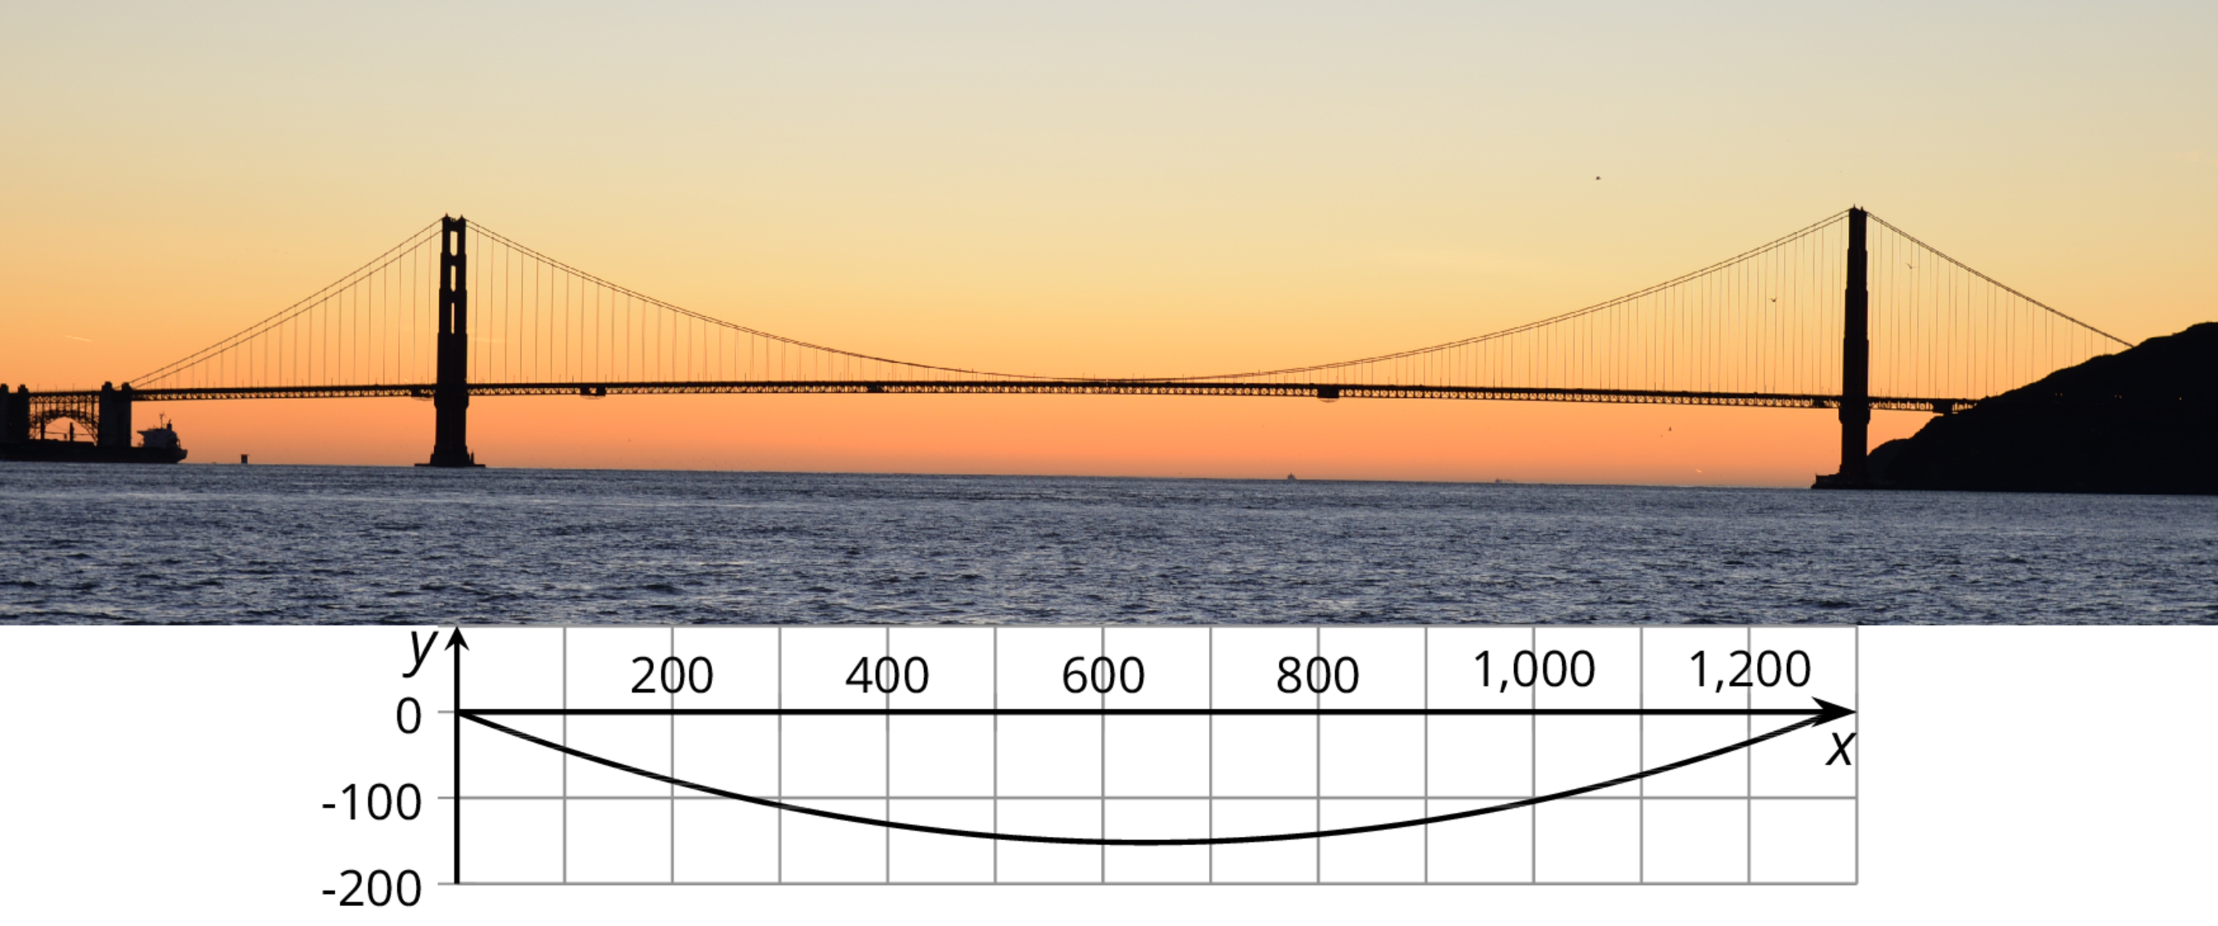
Multiplying by a scale factor less than 1 squashes the graph vertically. This is also called compressing the graph vertically. Sometimes we want to stretch the graph. In that case, we would use a scale factor greater than 1.
© CC BY 2019 by Illustrative Mathematics®

