Lesson 15 Practice Problems
- In triangle $ABC$, the measure of angle $A$ is ${40}^{∘}$.
  - Give possible measures for angles $B$ and $C$ if triangle $ABC$ is isosceles.
  - Give possible measures for angles $B$ and $C$ if triangle $ABC$ is right.
- For each set of angles, decide if there is a triangle whose angles have these measures in degrees:
  - 60, 60, 60
  - 90, 90, 45
  - 30, 40, 50
  - 90, 45, 45
  - 120, 30, 30
- If you get stuck, consider making a line segment. Then use a protractor to measure angles with the first two angle measures.
- Angle $A$ in triangle $ABC$ is obtuse. Can angle $B$ or angle $C$ be obtuse? Explain your reasoning.
- For each pair of polygons, describe the transformation that could be applied to Polygon A to get Polygon B.
  - 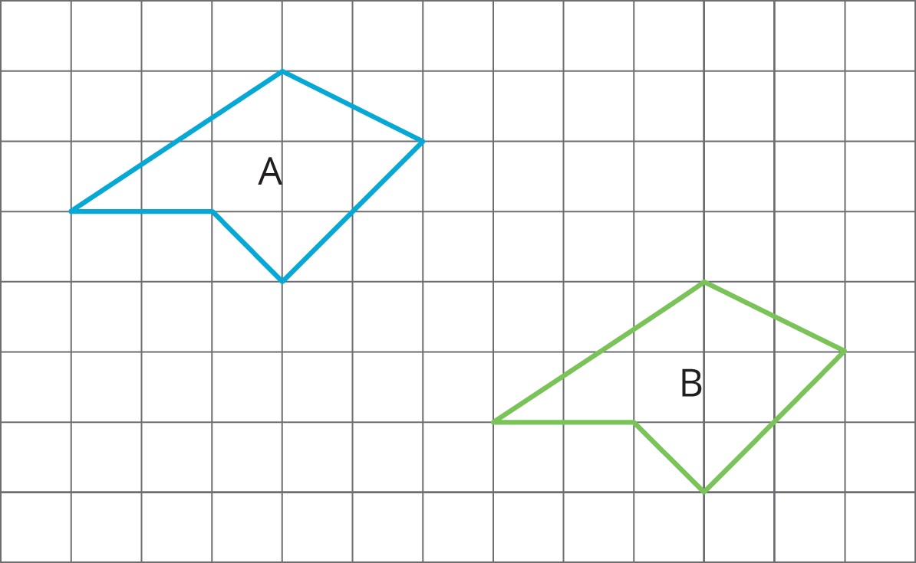
  - 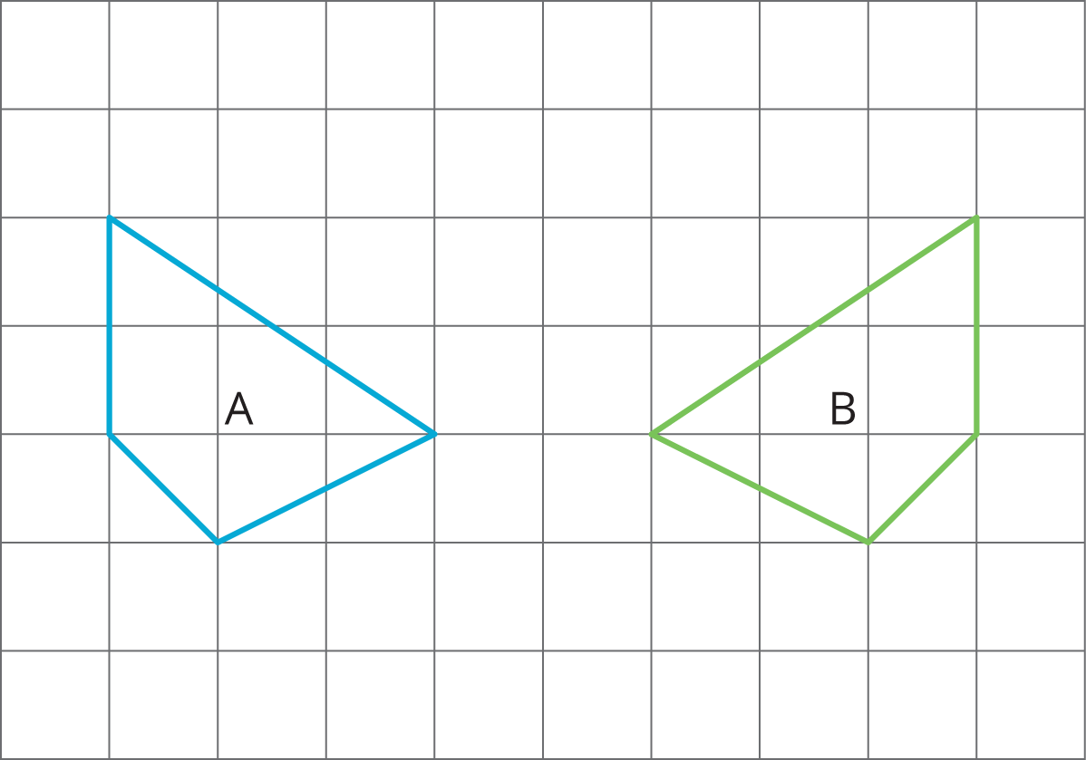
  - 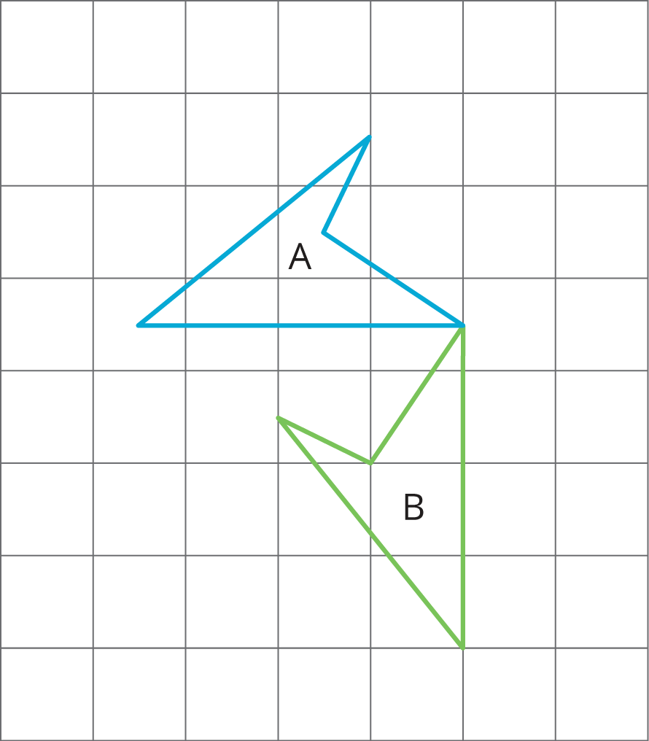
- (From Unit 1, Lesson 3.)
- On the grid, draw a scaled copy of quadrilateral $ABCD$ using a scale factor of $\frac{1}{2}$.
- 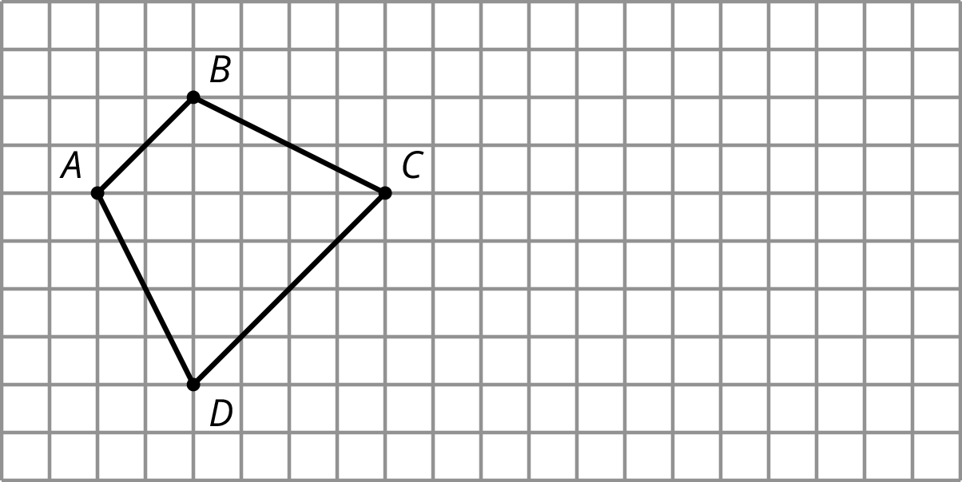
- (From Unit 1, Lesson 14.)
© CC BY Open Up Resources. Adaptations CC BY IM.

