Lesson 14: Razonemos sobre ángulos (parte 1)

Standards Alignments
Building On | 4.G.A.1
Addressing | 4.MD.C.6, 4.MD.C.7

Teacher-facing Learning Goals
- Draw angles of given measurements.
- Reason about angle measurements within a circle.

Student-facing Learning Goals
- Encontremos el tamaño de algunos ángulos que están en el reloj.

Lesson Purpose
The purpose of this lesson is twofold: for students to use known angles to reason about unknown angles on a clock, and for them to practice drawing angles of given measurements.
Angles are ever present on an analog clock. In this lesson, students investigate and solve problems about the angles formed by a clock’s hour and minute hands. Students reason about the number of degrees between the two hands or the number of degrees the minute hand has turned over some specified time. To do so, students rely on their understanding of fractional parts (for example, a round clock can be divided into 12 and 60 equal parts), their ability to tell time and elapsed time, and their knowledge of angle types and measurements.

Access for:

Students with Disabilities
- Engagement (Activity 2)

English Learners
- MLR8 (Activity 1)

Instructional Routines
MLR1 Stronger and Clearer Each Time (Activity 2), Which One Doesn’t Belong? (Warm-up)

Materials to Gather
- Protractors: Activity 1, Activity 2
- Rulers or straightedges: Activity 1

Lesson Timeline
Warm-up | 10 min
Activity 1 | 15 min
Activity 2 | 20 min
Lesson Synthesis | 10 min
Cool-down | 5 min

Teacher Reflection Question
How did students’ understandings about time—how to tell time and find elapsed time—help their work with angles on the clock?

Cool-down
(to be completed at the end of the lesson) 5min
Un ángulo para cada hora

Standards Alignments
Addressing | 4.MD.C.6, 4.MD.C.7

Student-facing Task Statement
¿Cuántos grados mide cada uno de los ángulos que están marcados en el reloj? Explica o muestra cómo razonaste.
A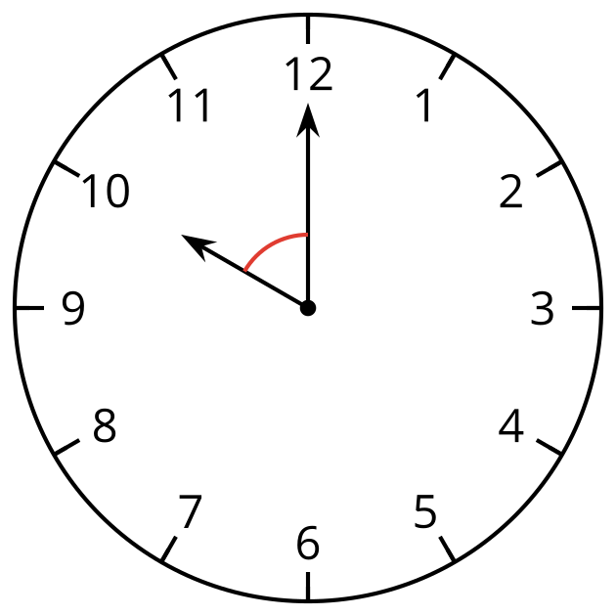
B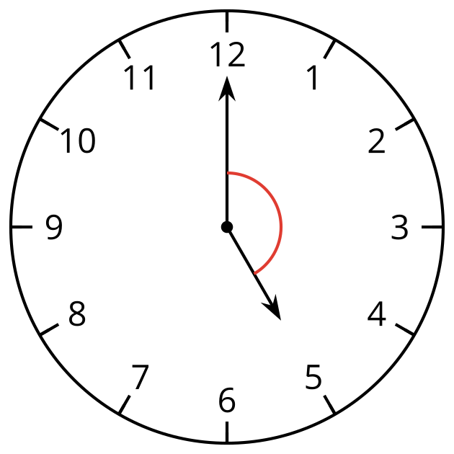

Student Responses
- ${60}^{∘}$. Sample response: Every time the minute hand moves from one number to the next, it turns ${30}^{∘}$. The angle between the hands is 2 numbers apart, so it is $2×30$, which is 60.
- ${150}^{∘}$. Sample responses:
  - $5×30=150$
  - If it was 6 o'clock, the angle would be ${180}^{∘}$. The angle for 5 o'clock is ${30}^{∘}$ less than ${180}^{∘}$.

