Unit 1 Lesson 10: What Is the Same?

1 Find the Right Hands (Warm up)

Images for Launch
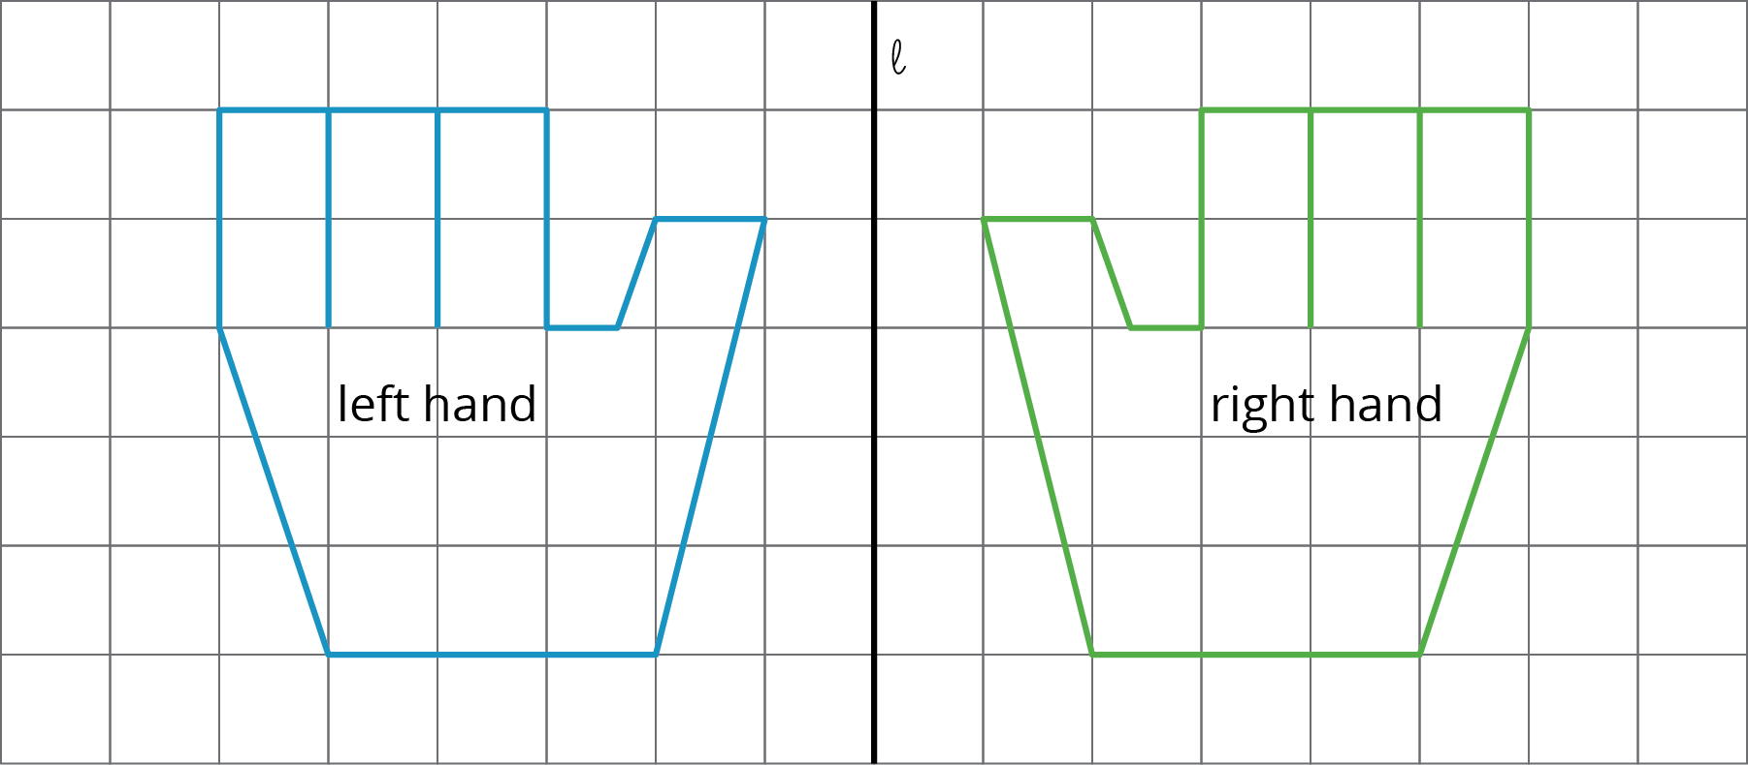

Student Task Statement
A person’s hands are mirror images of each other. In the diagram, a left hand is labeled. Shade all of the right hands.
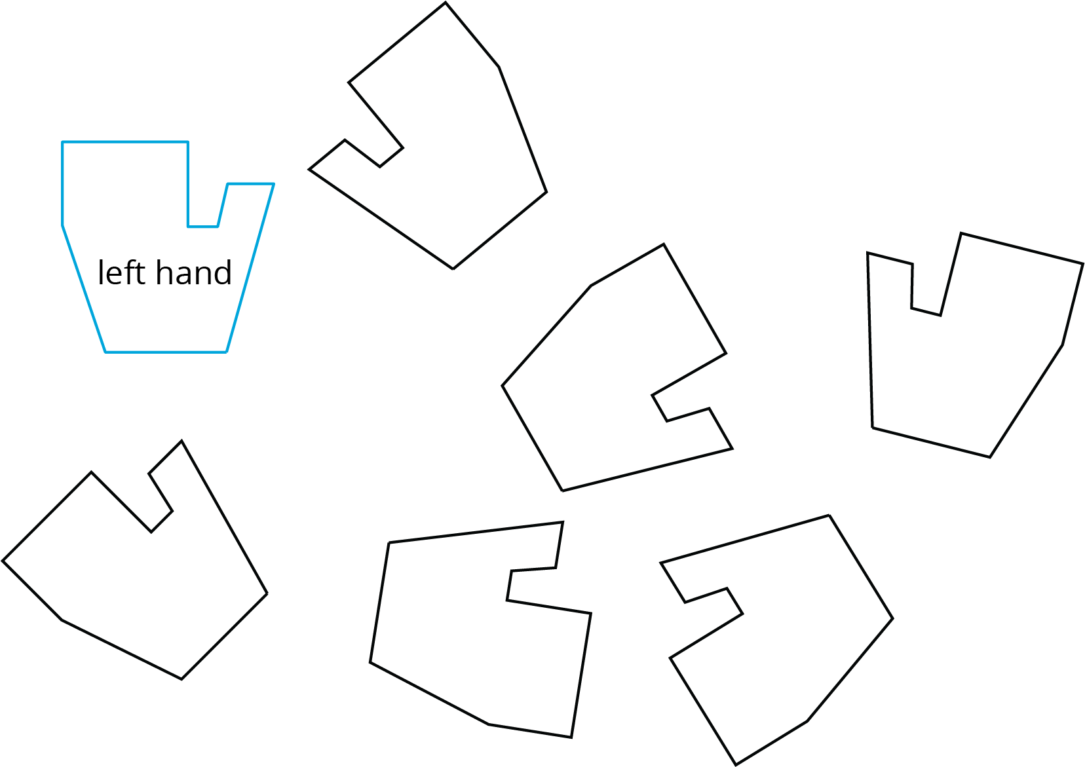

2 Are They the Same?

Student Task Statement
For each pair of shapes, decide whether or not they are the same.
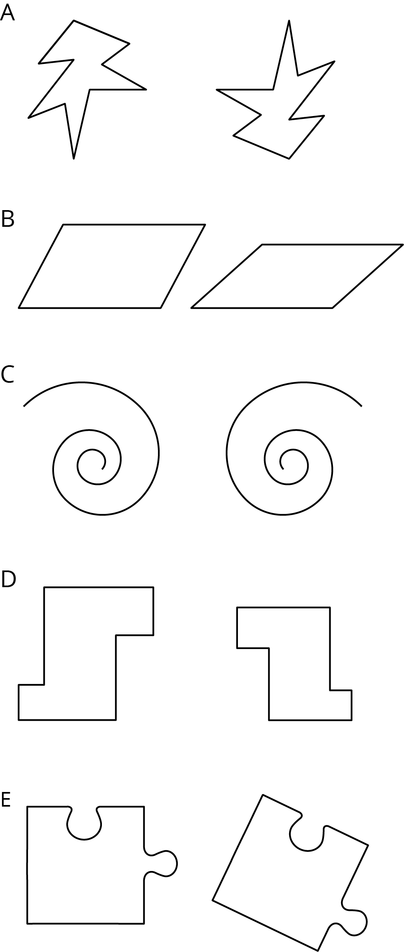

3 Area, Perimeter, and Congruence

Images for Launch
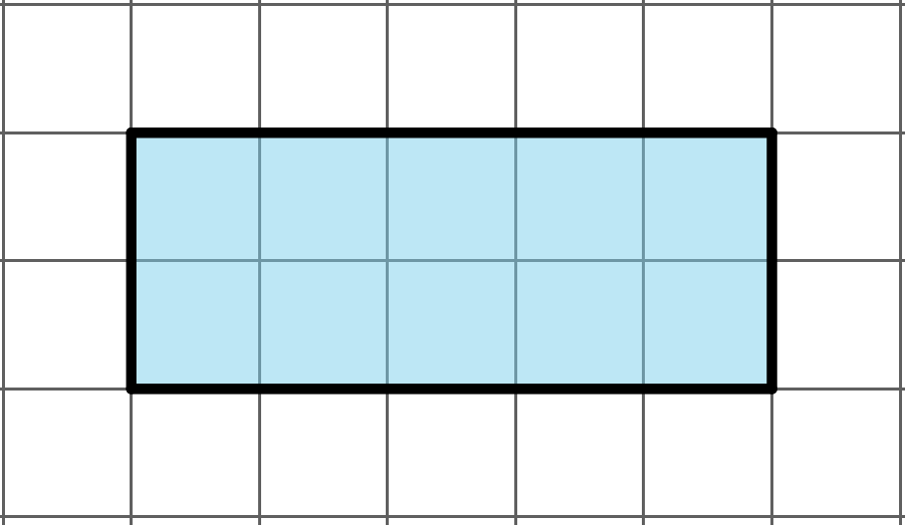

Student Task Statement
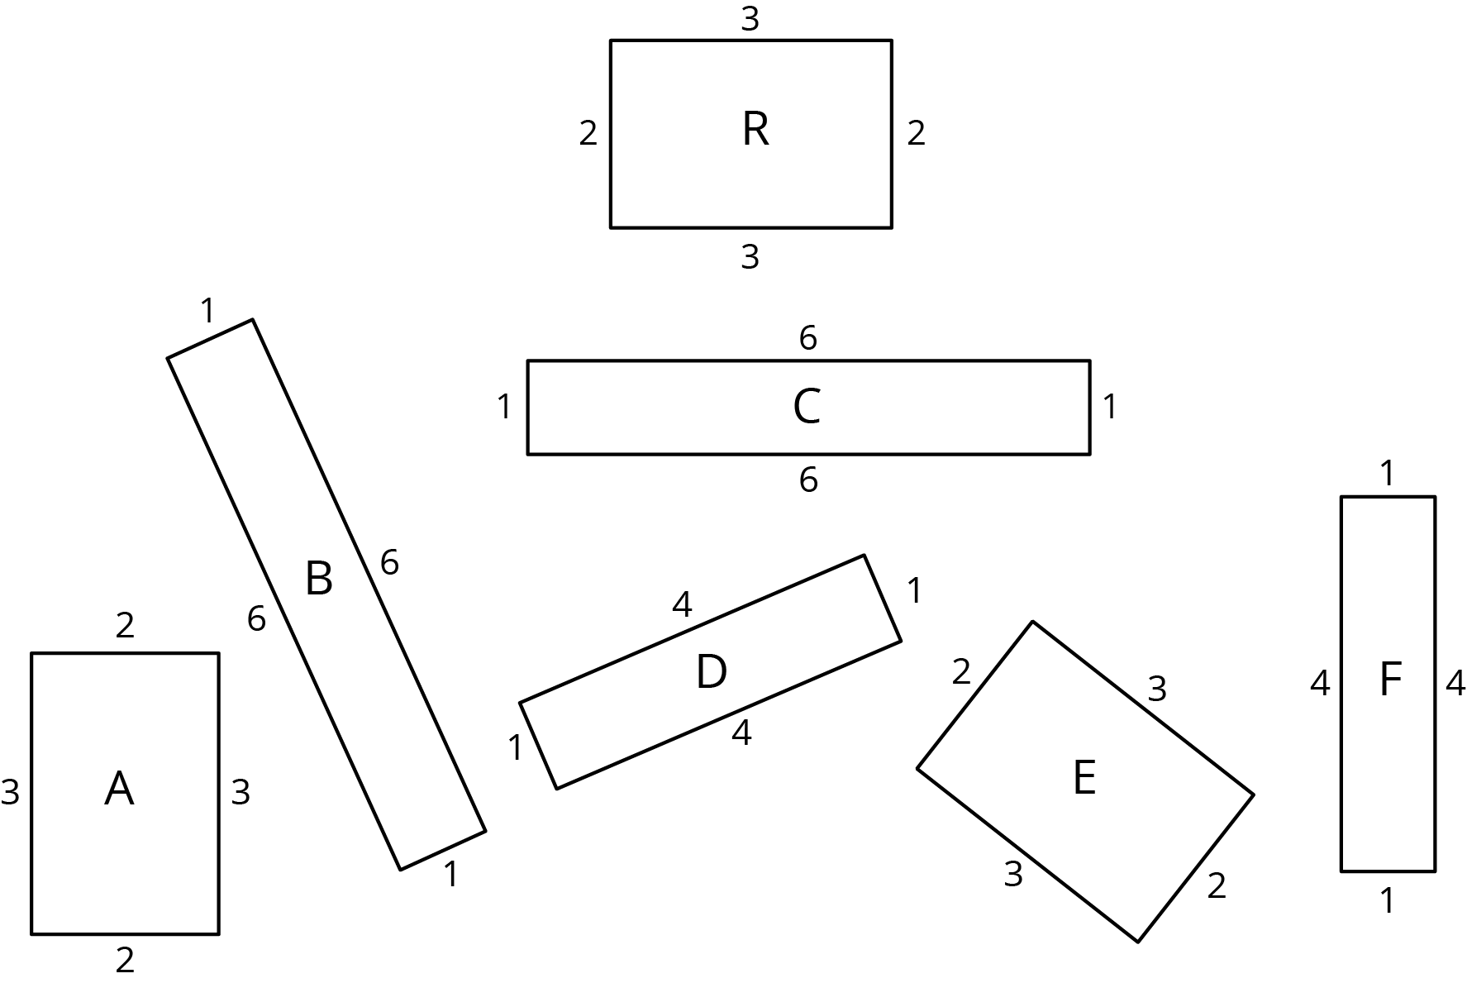
- Which of these rectangles have the same area as Rectangle R but different perimeter?
- Which rectangles have the same perimeter as Rectangle R but different area?
- Which have the same area and the same perimeter as Rectangle R?
- Use materials from the geometry tool kit to decide which rectangles are congruent. Shade congruent rectangles with the same color.

Activity Synthesis
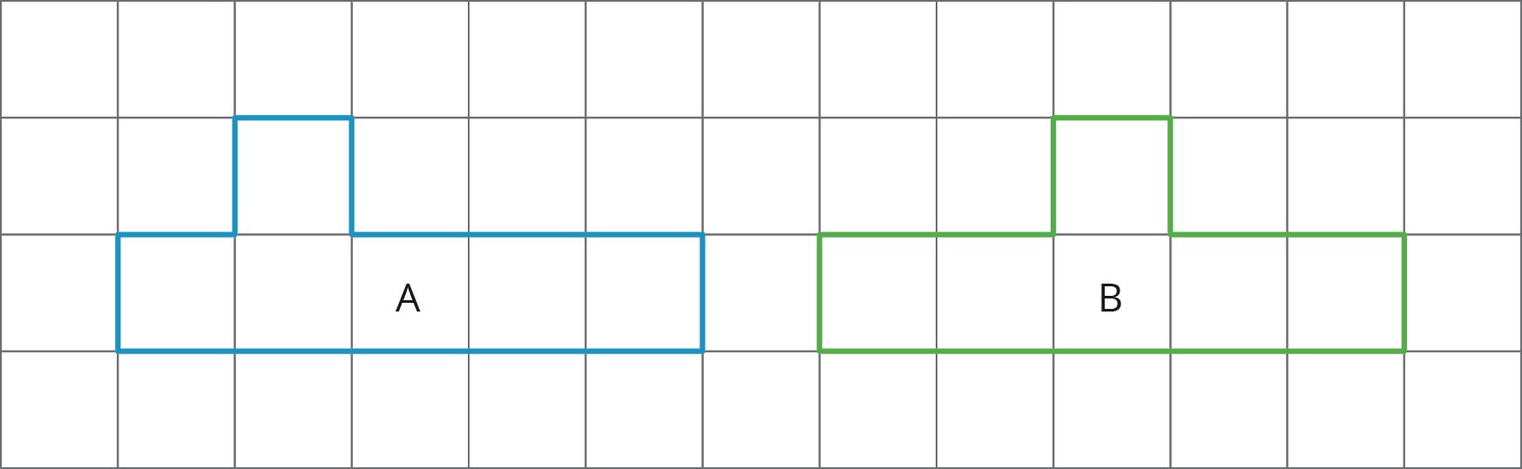
© CC BY Open Up Resources. Adaptations CC BY IM.

