Lesson 12: More Nets, More Surface Area
Let’s draw nets and find the surface area of polyhedra.

12.1: Notice and Wonder: Wrapping Paper
Kiran is wrapping this box of sports cards as a present for a friend.
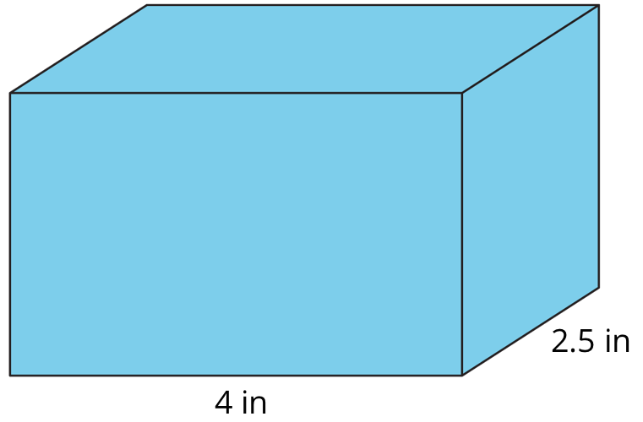
What do you notice? What do you wonder?

12.2: Building Prisms and Pyramids
Your teacher will give you a drawing of a polyhedron. You will draw its net and calculate its surface area.
- What polyhedron do you have?
- Study your polyhedron. Then, draw its net on graph paper. Use the side length of a grid square as the unit.
- Label each polygon on the net with a name or number.
- Find the surface area of your polyhedron. Show your thinking in an organized manner so that it can be followed by others.

12.3: Comparing Boxes
Here are the nets of three cardboard boxes that are all rectangular prisms. The boxes will be packed with 1-centimeter cubes. All lengths are in centimeters.
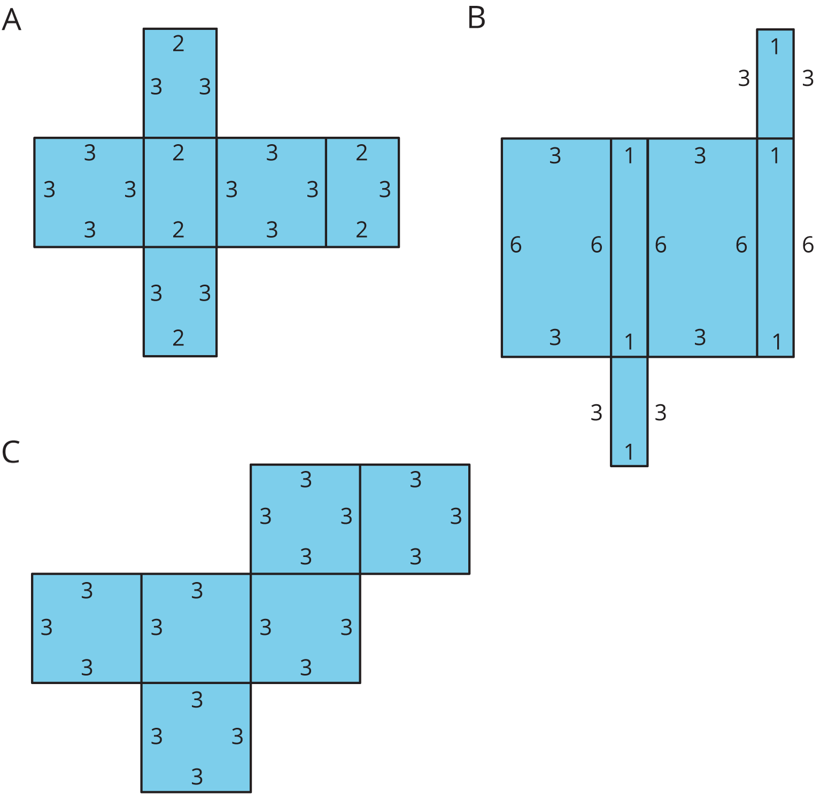
- Compare the surface areas of the boxes. Which box will use the least cardboard? Show your reasoning.
- Now compare the volumes of these boxes in cubic centimeters. Which box will hold the most 1-centimeter cubes? Show your reasoning.

Are you ready for more?
Figure C shows a net of a cube. Draw a different net of a cube. Draw another one. And then another one. How many different nets can be drawn and assembled into a cube?

Lesson 12 Summary
The surface area of a polyhedron is the sum of the areas of all of the faces. Because a net shows us all faces of a polyhedron at once, it can help us find the surface area. We can find the areas of all polygons in the net and add them.
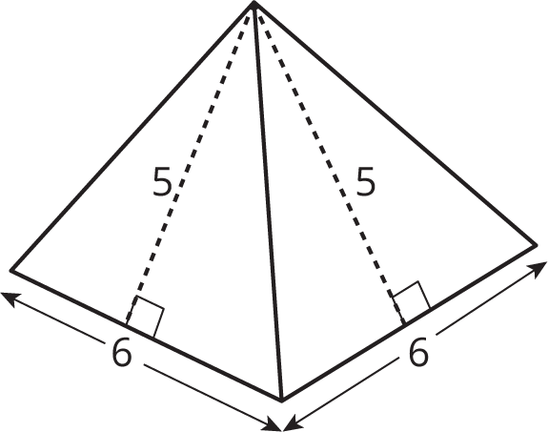
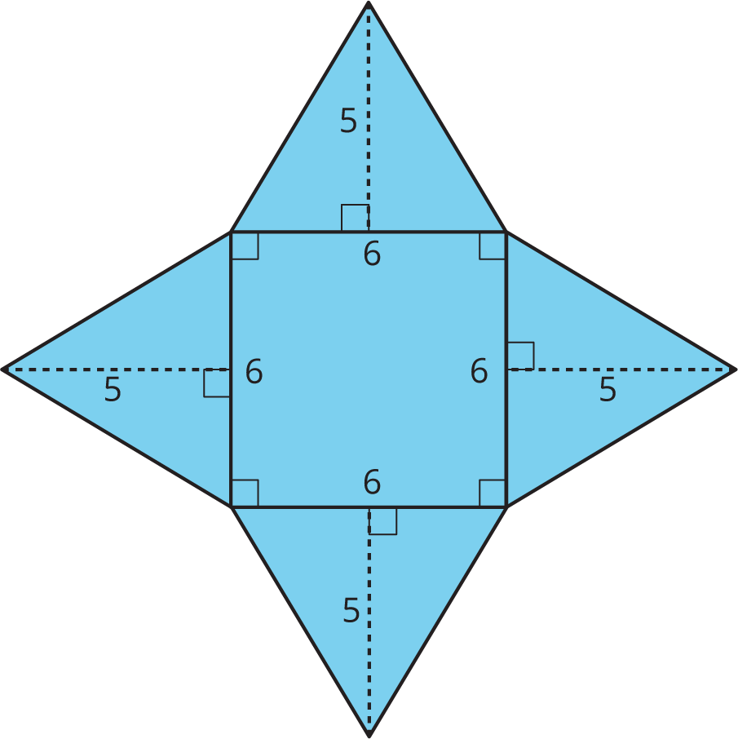
A square pyramid has a square and four triangles for its faces. Its surface area is the sum of the areas of the square base and the four triangular faces:
$\left(6⋅6\right)+4⋅\left(\frac{1}{2}⋅5⋅6\right)=96$
The surface area of this square pyramid is 96 square units.
© CC BY Open Up Resources. Adaptations CC BY IM.

