Lesson 14 Practice Problems
- The absolute value function can be defined using piecewise notation.
- $A\left(x\right)=\left\{\begin{matrix}x, & x≥0 \\ \text{-}x, & x<0\end{matrix}\right.$
- Use this notation to find the following values:
  - $A\left(10\right)$
  - $A\left(0\right)$
  - $A\left(\text{-}3\right)$
  - $A\left(3.14159\right)$
  - $A\left(x\right)=7$
  - $A\left(x\right)=\text{-}5$
- Here are four equations of absolute value functions and three coordinate pairs. Each coordinate pair represents the vertex of the graph of an absolute value function.
- Match the equation of each function with the coordinates of the vertex of its graph. The vertex coordinates of the graph of one equation are not shown.
  - $p\left(x\right)=\left|x−9\right|$
  - $q\left(x\right)=\left|x\right|+9$
  - $r\left(x\right)=\left|x+9\right|$
  - $t\left(x\right)=\left|x\right|−9$
  - $\left(\text{-}9,0\right)$
  - $\left(9,0\right)$
  - $\left(0,\text{-}9\right)$
- Function $G$ is defined by the equation $G\left(x\right)=\left|x\right|$.
- Function $R$ is defined by the equation $R\left(x\right)=\left|x\right|+2$.
- Describe how the graph of function $R$ relates to the graph of $G$, or sketch the graphs of the two functions to show their relationship.
- Here is the graph of a function.
- Select the equation for the function represented by the graph.
- 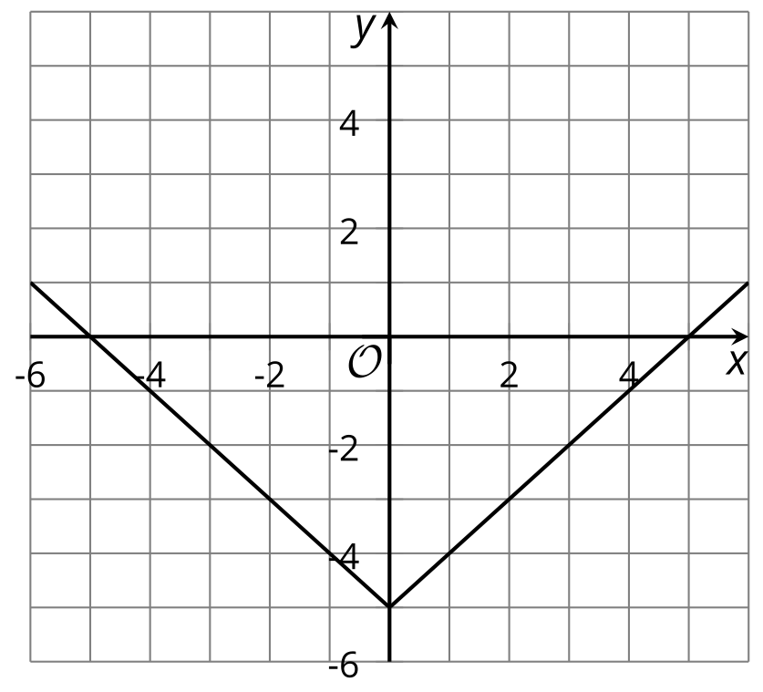
  - $y=\left|x\right|−5$
  - $y=\left|x\right|+5$
  - $y=\left|x−5\right|$
  - $y=\left|x+5\right|$
- The temperature was recorded at several times during the day. Function $T$ gives the temperature in degrees Fahrenheit, $n$ hours since midnight.
- Here is a graph for this function.
  - Pick two consecutive points and connect them with a line segment. Estimate the slope of that line. Explain what that estimated value means in this situation.

  - 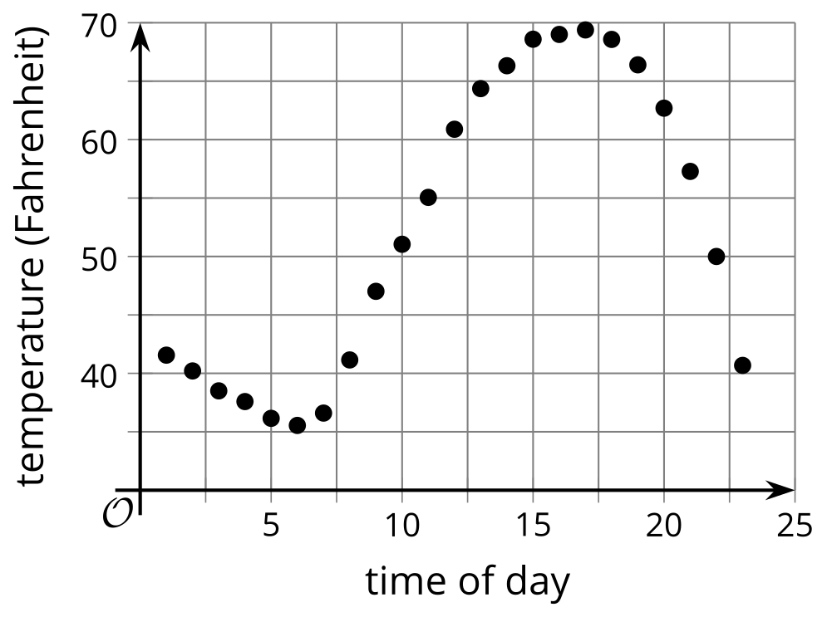
  - Pick two non-consecutive points and connect them with a line segment. Estimate the slope of that line. Explain what that estimated value means in this situation.
- (From Unit 4, Lesson 7.)
- A tennis ball is dropped from an initial height of 30 feet. It bounces 5 times, with each bounce height being about $\frac{2}{3}$ of the height of the previous bounce.
- Sketch a graph that models the height of the ball over time. Be sure to label the axes.
- (From Unit 4, Lesson 8.)
- Here are two graphs representing functions $f$ and $g$.
- Identify at least two values of $x$ at which the inequality $g\left(x\right)>f\left(x\right)$ is true.
- 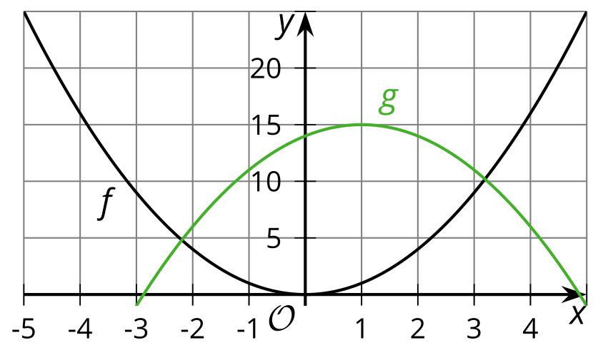
- (From Unit 4, Lesson 9.)
© CC BY 2019 by Illustrative Mathematics®

