Lesson 21: Cylinders, Cones, and Spheres

21.1: Sphere Arguments
Four students each calculated the volume of a sphere with a radius of 9 centimeters and they got four different answers.
- Han thinks it is 108 cubic centimeters.
- Jada got $108π$ cubic centimeters.
- Tyler calculated 972 cubic centimeters.
- Mai says it is $972π$ cubic centimeters.
Do you agree with any of them? Explain your reasoning.

21.2: Sphere’s Radius
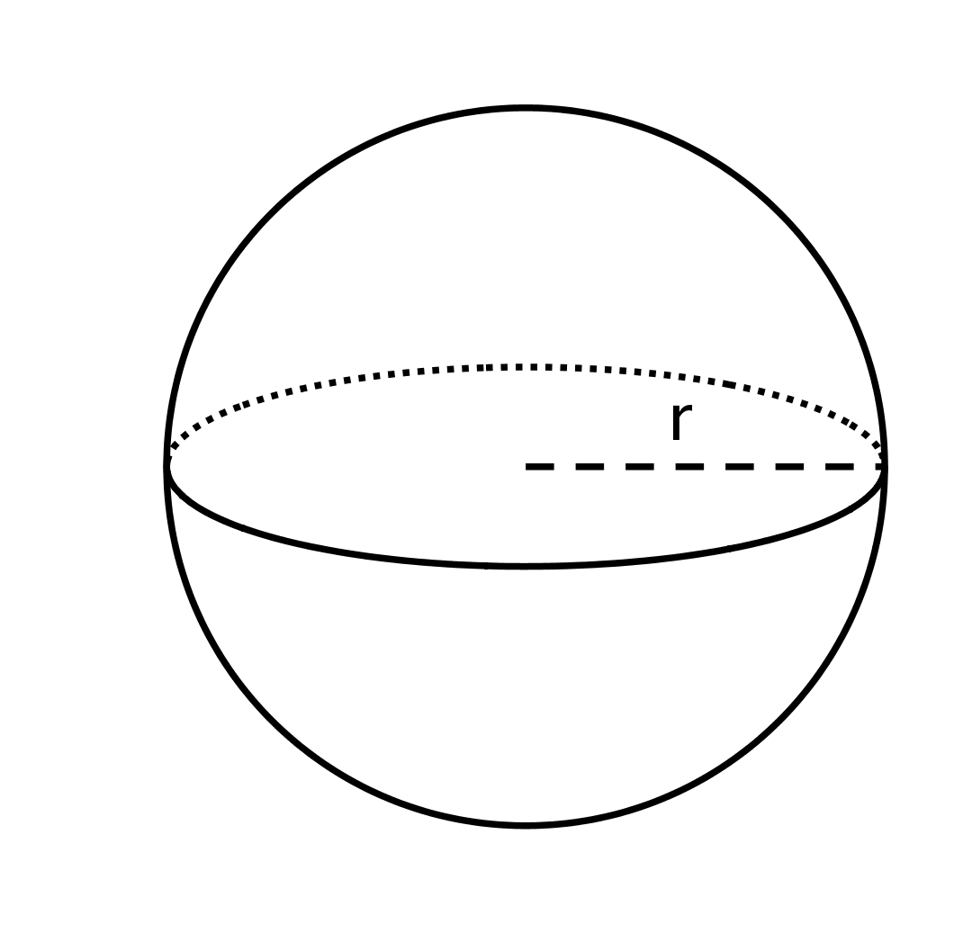
The volume of this sphere with radius $r$ is $V=288π$. This statement is true:
$288π=\frac{4}{3}r^{3}π.$ What is the value of $r$ for this sphere? Explain how you know.

21.3: Info Gap: Unknown Dimensions
Your teacher will give you either a problem card or a data card. Do not show or read your card to your partner.
If your teacher gives you the problem card:
- Silently read your card and think about what information you need to be able to answer the question.
- Ask your partner for the specific information that you need.
- Explain how you are using the information to solve the problem.
- Continue to ask questions until you have enough information to solve the problem.
- Share the problem card and solve the problem independently.
- Read the data card and discuss your reasoning.
If your teacher gives you the data card:
- Silently read your card.
- Ask your partner “What specific information do you need?” and wait for them to ask for information.
- If your partner asks for information that is not on the card, do not do the calculations for them. Tell them you don’t have that information.
- Before sharing the information, ask “Why do you need that information?” Listen to your partner’s reasoning and ask clarifying questions.
- Read the problem card and solve the problem independently.
- Share the data card and discuss your reasoning.
Pause here so your teacher can review your work. Ask your teacher for a new set of cards and repeat the activity, trading roles with your partner.

21.4: The Right Fit
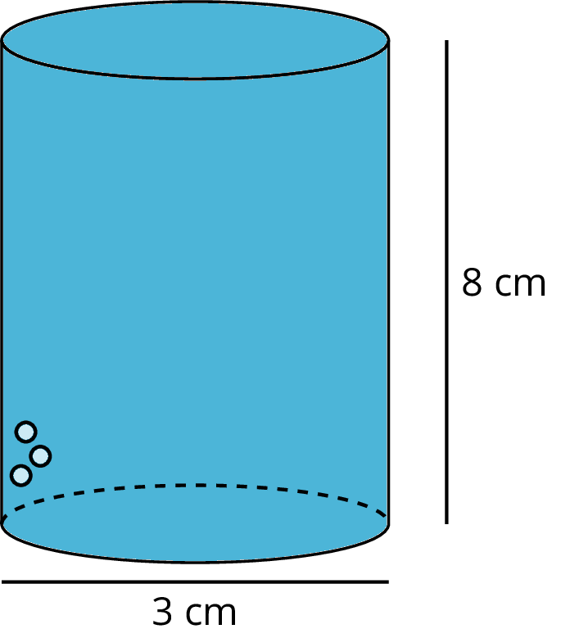
A cylinder with diameter 3 centimeters and height 8 centimeters is filled with water. Decide which figures described here, if any, could hold all of the water from the cylinder. Explain your reasoning.
- Cone with a height of 8 centimeters and a radius of 3 centimeters.
- Cylinder with a diameter of 6 centimeters and height of 2 centimeters.
- Rectangular prism with a length of 3 centimeters, width of 4 centimeters, and height of 8 centimeters.
- Sphere with a radius of 2 centimeters.

Are you ready for more?
A thirsty crow wants to raise the level of water in a cylindrical container so that it can reach the water with its beak.
- The container has diameter of 2 inches and a height of 9 inches.
- The water level is currently at 6 inches.
- The crow can reach the water if it is 1 inch from the top of the container.
In order to raise the water level, the crow puts spherical pebbles in the container. If the pebbles are approximately $\frac{1}{2}$ inch in diameter, what is the fewest number of pebbles the crow needs to drop into the container in order to reach the water?

Lesson 21 Summary
The formula
$V=\frac{4}{3}πr^{3}$
gives the volume of a sphere with radius $r$. We can use the formula to find the volume of a sphere with a known radius. For example, if the radius of a sphere is 6 units, then the volume would be
$\frac{4}{3}π(6)^{3}=288π$
or approximately $904$ cubic units. We can also use the formula to find the radius of a sphere if we only know its volume. For example, if we know the volume of a sphere is $36π$ cubic units but we don't know the radius, then this equation is true:
$36π=\frac{4}{3}πr^{3}$
That means that $r^{3}=27$, so the radius $r$ has to be 3 units in order for both sides of the equation to have the same value.
Many common objects, from water bottles to buildings to balloons, are similar in shape to rectangular prisms, cylinders, cones, and spheres—or even combinations of these shapes! Using the volume formulas for these shapes allows us to compare the volume of different types of objects, sometimes with surprising results.
For example, a cube-shaped box with side length 3 centimeters holds less than a sphere with radius 2 centimeters because the volume of the cube is 27 cubic centimeters ($3^{3}=27$), and the volume of the sphere is around 33.51 cubic centimeters ($\frac{4}{3}π⋅2^{3}≈33.51$).
© CC BY Open Up Resources. Adaptations CC BY IM.

