Lesson 14: Area Situations
- Let’s apply what we’ve learned about fraction multiplication.

Warm-up: Number Talk: Multiply Fractions
Find the value of each expression mentally.
- $3×\left(10÷2\right)$
- $\frac{3}{2}×10$
- $\left(\frac{14}{7}\right)×10$
- $14×\frac{10}{7}$

14.1: Info Gap: Area
Your teacher will give you either a problem card or a data card. Do not show or read your card to your partner.
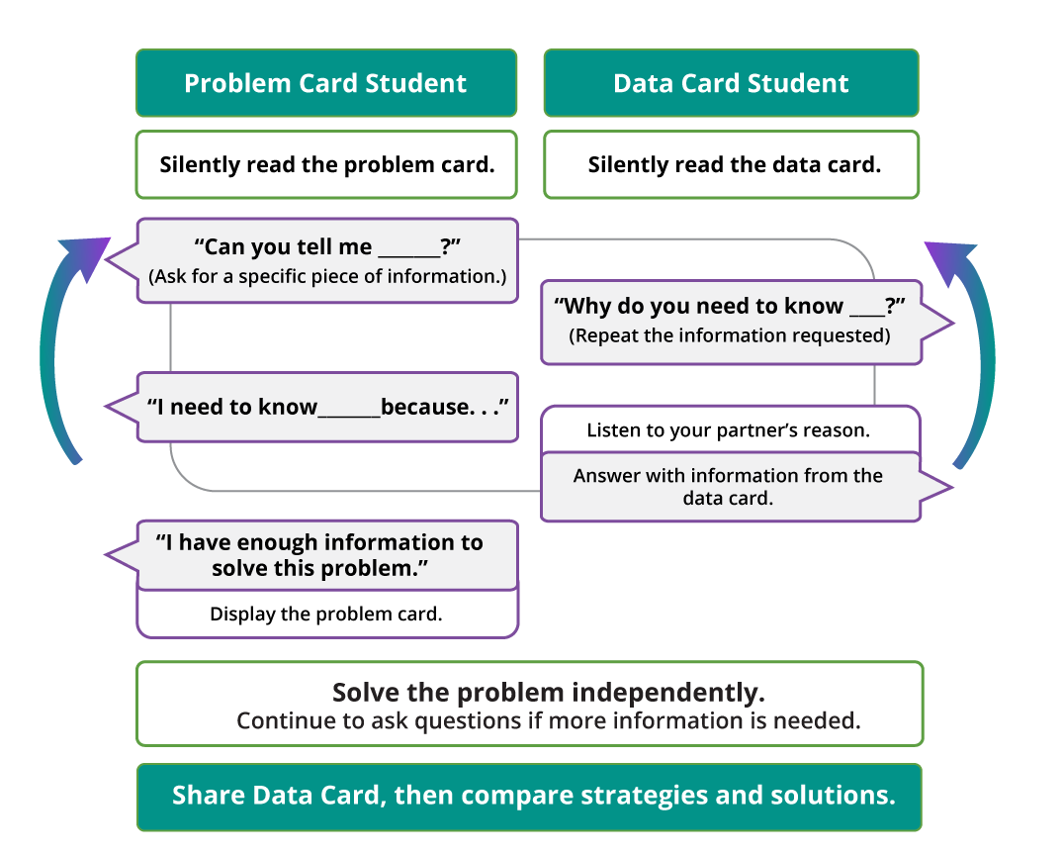
Pause here so your teacher can review your work. Ask your teacher for a new set of cards and repeat the activity, trading roles with your partner.

14.2: Fill in the Blank
Fill in the blanks to make each equation true. Be prepared to explain your reasoning.
- $\frac{1}{3}×18=\underset{_}{}$
- $\frac{7}{9}×\underset{_}{}=\frac{21}{9}$
- $\frac{1}{15}×\underset{_}{}=2$
- $9×6\frac{2}{3}=\underset{_}{}$
- $14\frac{99}{100}×10=\underset{_}{}$
- $7\frac{3}{5}×6=\underset{_}{}$
- $4×6\frac{9}{10}=\underset{_}{}$
© CC BY 2021 Illustrative Mathematics®

