Unit 8 Lesson 7: Create Number Books (Part 2)

WU How Many Do You See: Different Dots (Warm up)

Student Task Statement
How many do you see?
How do you see them?
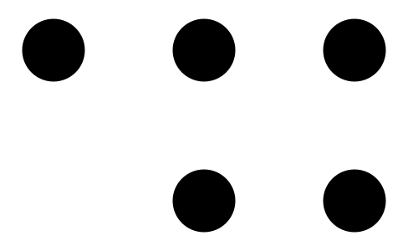

1 Make Number Books

Student Task Statement

2 Share Number Books

Student Task Statement
© CC BY 2021 Illustrative Mathematics®

