Lesson 4: Solid Shapes
- Let’s identify and describe solid shapes.

Warm-up: Notice and Wonder: What is That Shape?
What do you notice? What do you wonder?
A
B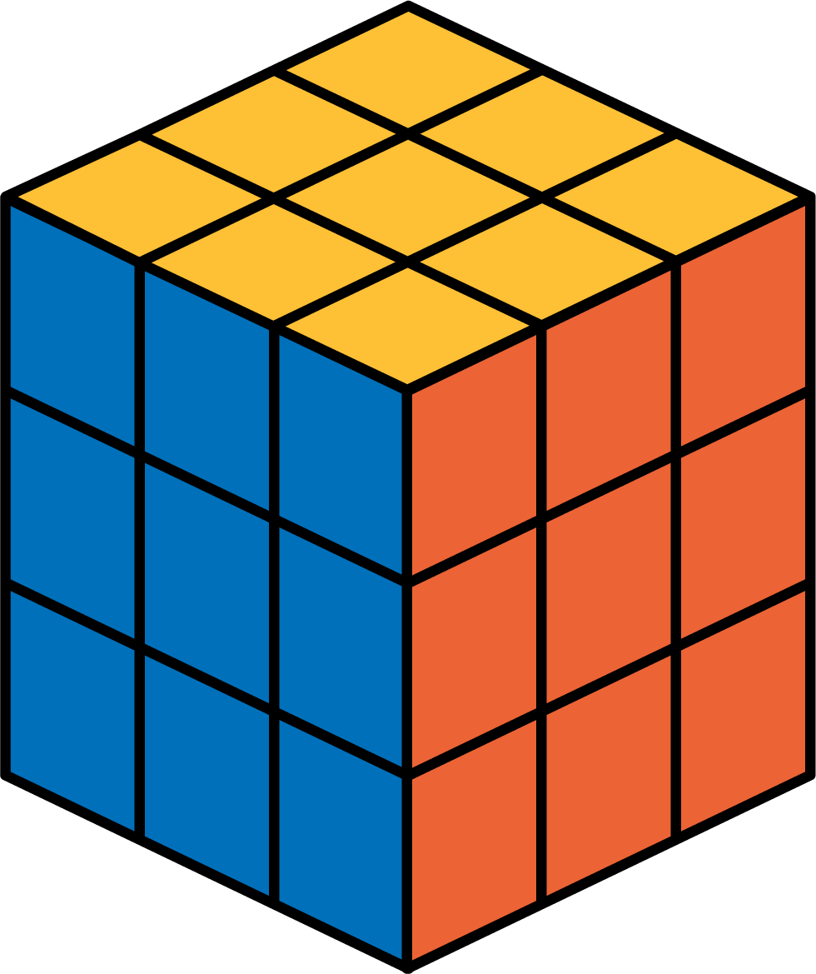
C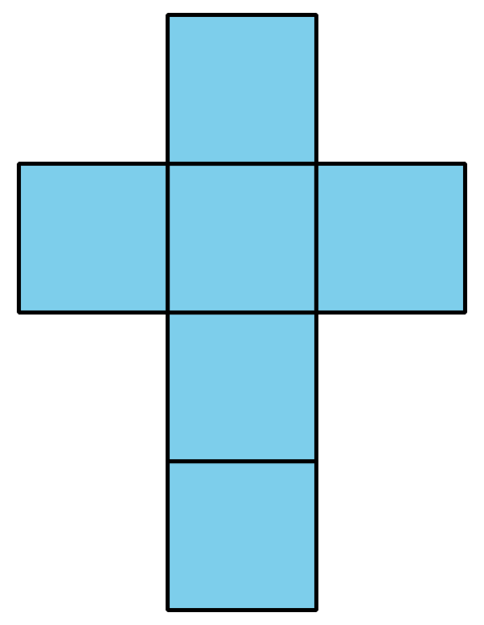
D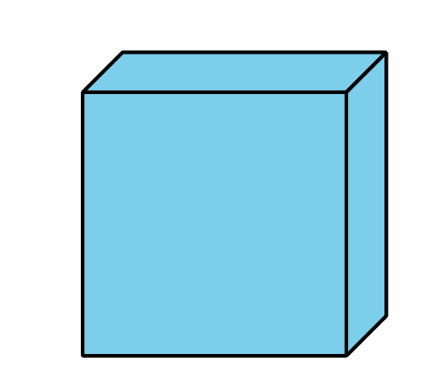

4.1: What is the Missing Shape?
Make a poster to describe your solid shape. Use words, numbers, and drawings to help other groups name your shape.

4.2: Sort and Build Solid Shapes
- Sort your shape design cards into groups. Be prepared to describe how you sort the cards.
- Match one of your cards to a solid shape. Explain your match.
- Which shape designs could be folded to make cubes? Explain.
- Your teacher will give you 2 shape designs. Fold the shape designs to make cubes. Compare your cube with your partner’s cube.

Section Summary
Section Summary In this section, we named and drew shapes based on the number of sides and corners. We also drew shapes with different side lengths. We described solid shapes based on the number of faces and their shapes.
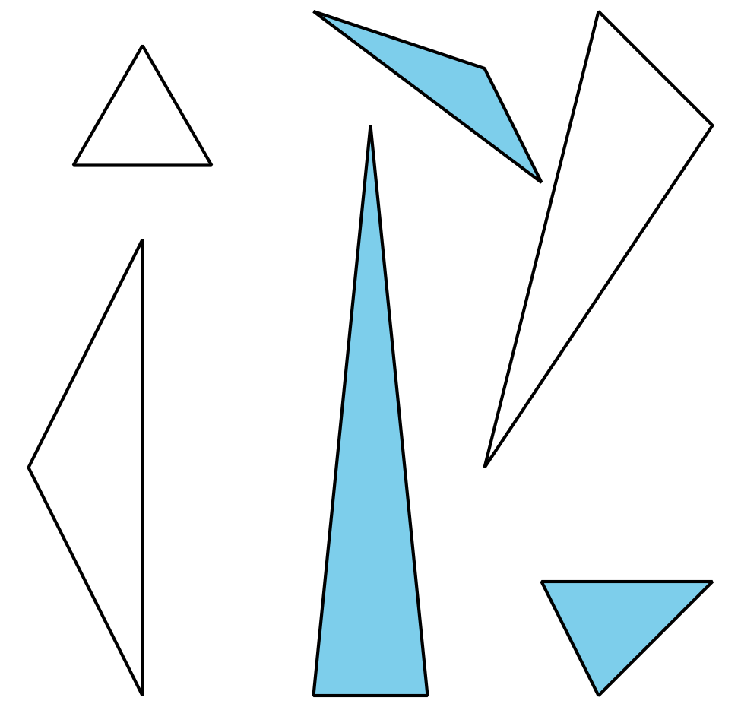
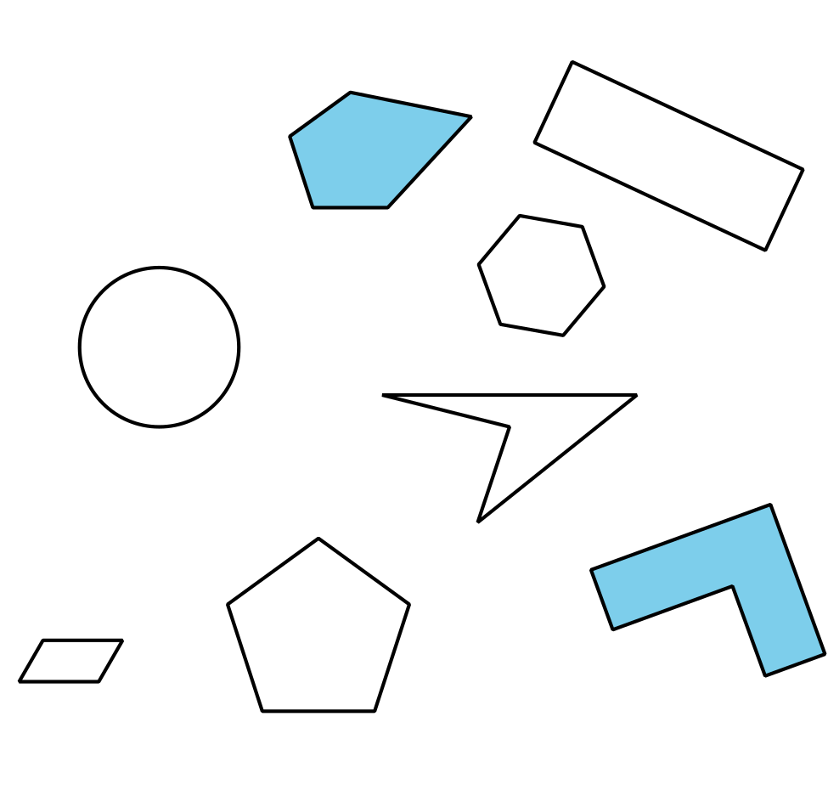
© CC BY 2021 Illustrative Mathematics®

