Unit 7 Lesson 11: Center Day 2

WU Number Talk: Make 100 (Warm up)

Student Task Statement
Find the value of each expression mentally.
- $80¢+20¢+37¢$
- $80¢+20¢+37¢+42¢$
- $75¢+37¢+25¢$
- $75¢+80¢+25¢+20¢$

1 Introduce How Close?, Add to 1,000

Student Task Statement

2 Introduce Five in a Row, Add Within 1,000 with Composing

Student Task Statement
Choose a center.
Five a Row: Addition and Subtraction
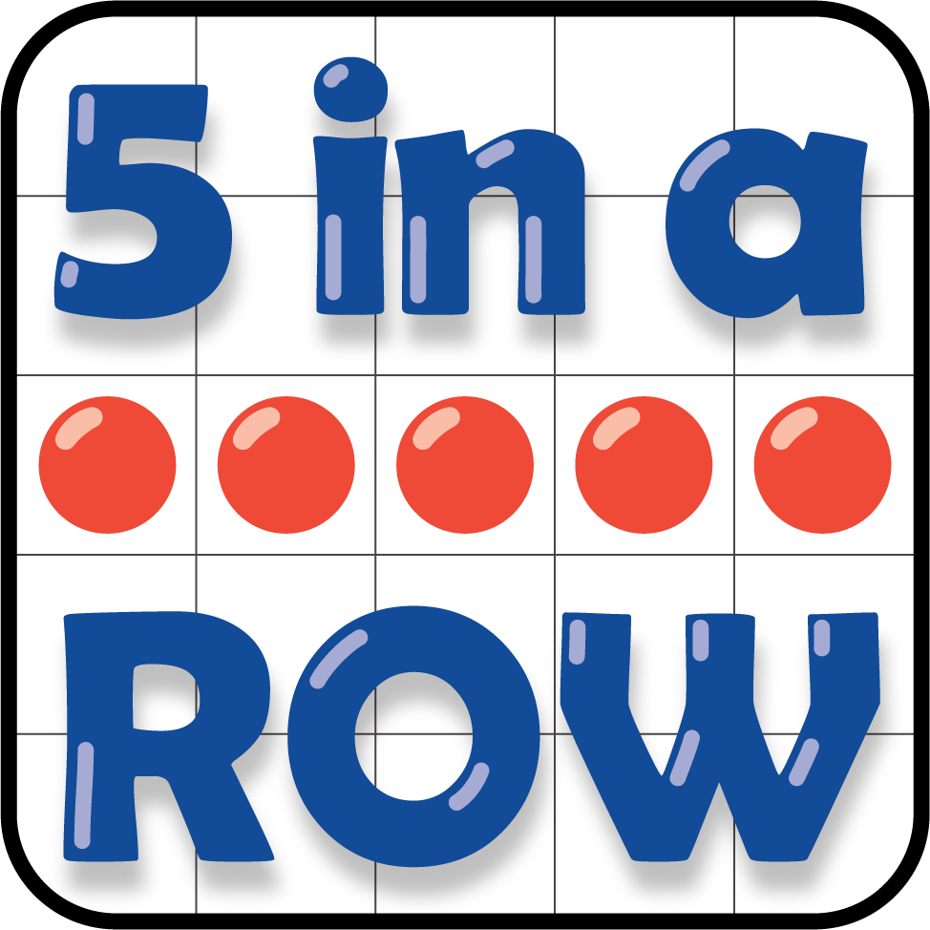
How Close?
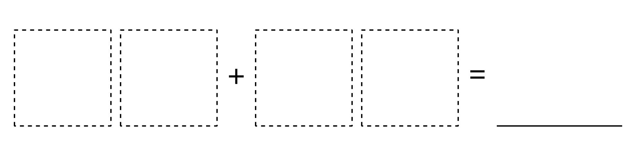
© CC BY 2021 Illustrative Mathematics®

