Lesson 11: Use a Protractor to Draw Angles

Standards Alignments
Addressing | 4.G.A.1, 4.MD.C.5.a, 4.MD.C.6, 4.MD.C.7

Teacher-facing Learning Goals
- Use a protractor to draw angles of given measurements.

Student-facing Learning Goals
- Let’s draw some angles.

Lesson Purpose
The purpose of this lesson is for students to use a protractor to draw angles of given measurements.
In earlier lessons, students reasoned about angle measurements, learned to use a protractor, and measured given angles. They have sketched angles by referring to clock faces and sketched estimates of angles of a given size based on benchmark angles.
In this lesson, students use a protractor to draw angles of specified measurements (not limited to benchmark angles) and to verify the size of angles in their peers’ drawings. They begin to use known angle measurements to reason about unknown measurements and notice relationships between the measurements of angles that share a common endpoint.
This lesson has a Student Section Summary.

Access for:

Students with Disabilities
- Action and Expression (Activity 1)

English Learners
- MLR8 (Activity 1)

Instructional Routines
Estimation Exploration (Warm-up)

Materials to Gather
- Index cards: Activity 2
- Protractors: Activity 1, Activity 2
- Rulers or straightedges: Activity 1, Activity 2

Lesson Timeline
Warm-up | 10 min
Activity 1 | 15 min
Activity 2 | 20 min
Lesson Synthesis | 10 min
Cool-down | 5 min

Teacher Reflection Question
What were some of the challenges students encountered when measuring and drawing angles? What support might help students overcome those hurdles?

Cool-down
(to be completed at the end of the lesson) 5min
A Ray or Two

Standards Alignments
Addressing | 4.G.A.1, 4.MD.C.6, 4.MD.C.7

Student-facing Task Statement
- Draw a new ray starting from point $Z$ to create a ${25}^{∘}$ angle.
- 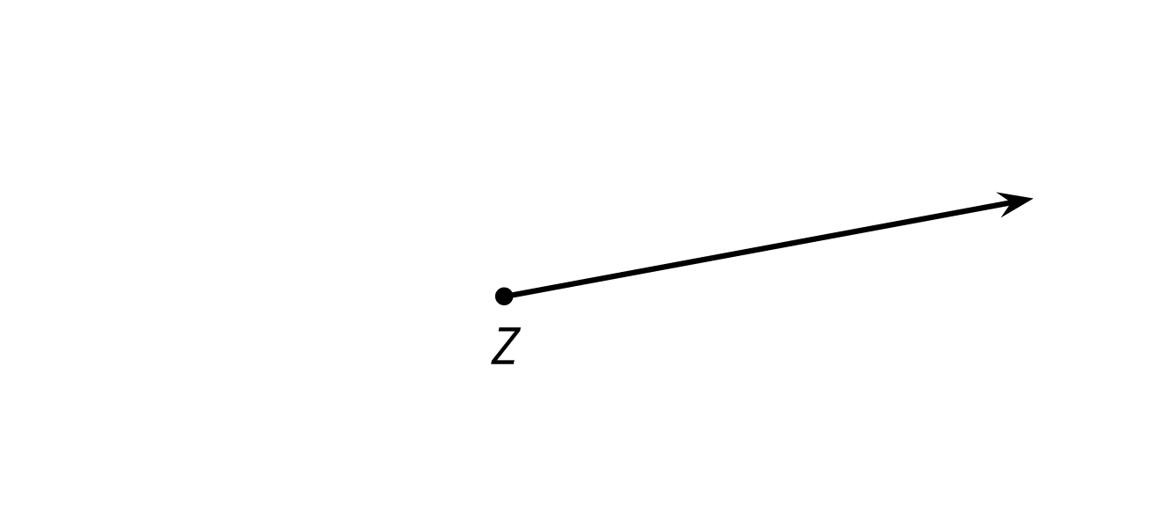
- Draw two rays to create an angle that is ${165}^{∘}$.

Student Responses
- Sample responses:
- 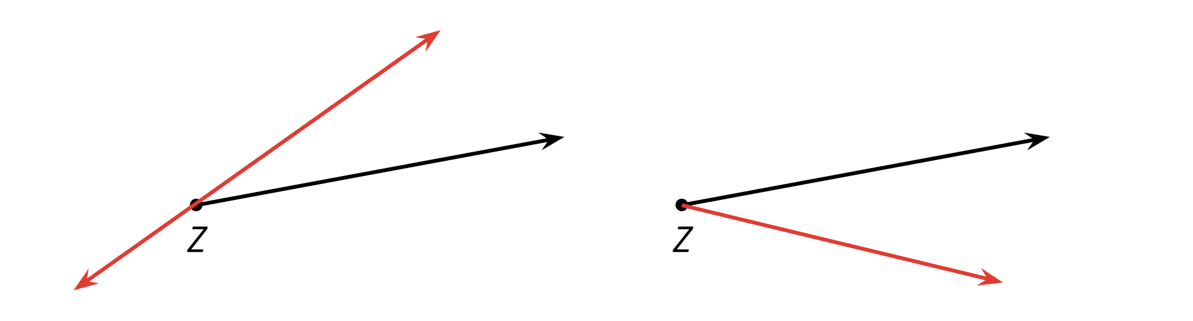
- Sample response:

