Unit 3 Lesson 1: One Piece of One Part

WU Notice and Wonder: Baked Macaroni and Cheese (Warm up)

Student Task Statement
What do you notice? What do you wonder?
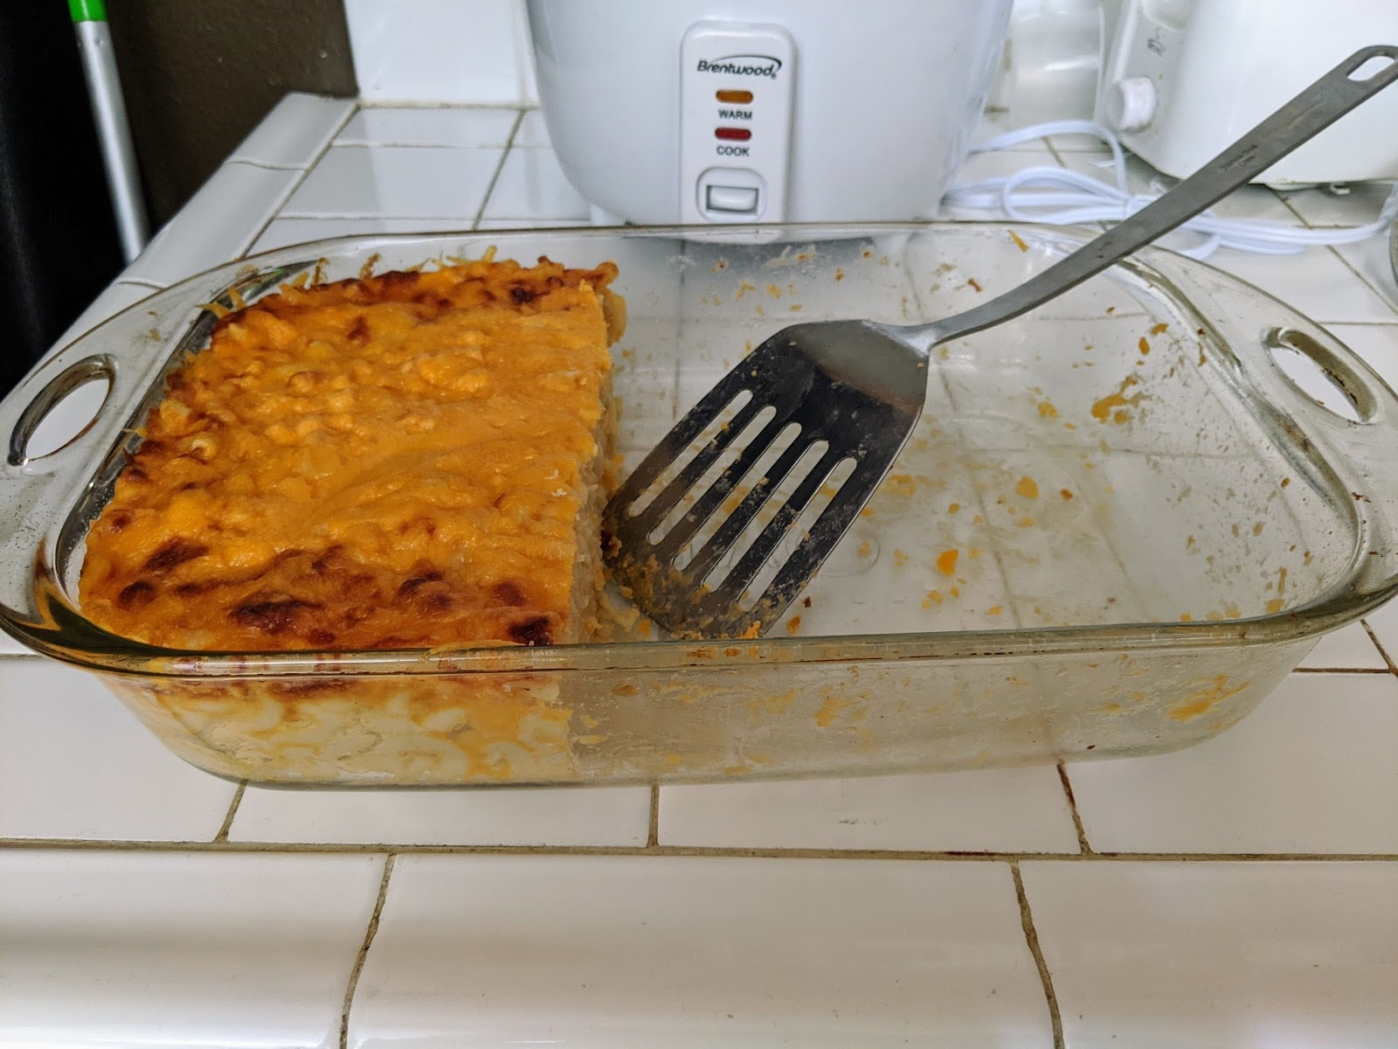

1 Of What?

Student Task Statement
At a family dinner, a pan of macaroni and cheese is $\frac{1}{2}$ full. Lin eats $\frac{1}{3}$ of the remaining macaroni and cheese in the pan.
- Draw a diagram to represent the situation.
- Explain or show how you know your diagram represents the situation.

2 The Same, but Different

Student Task Statement
- Explain or show how each diagram represents $\frac{1}{4}$ of $\frac{1}{2}$ of a pan of macaroni and cheese.
- A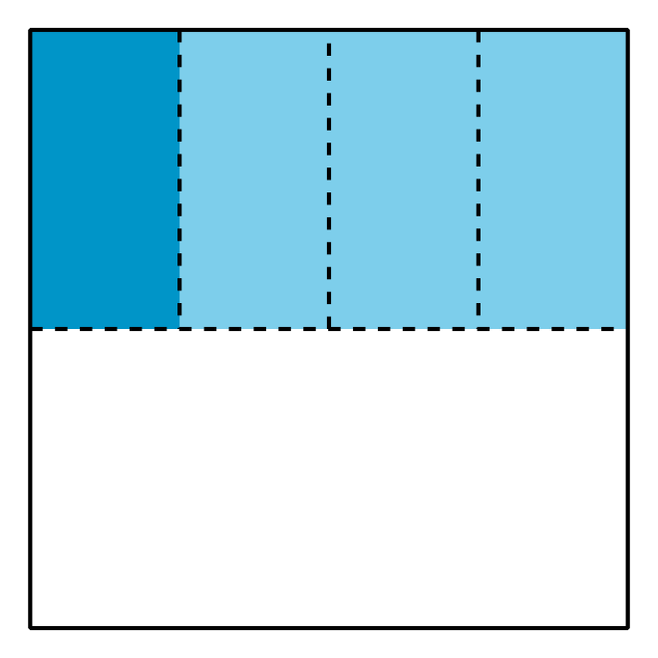
- B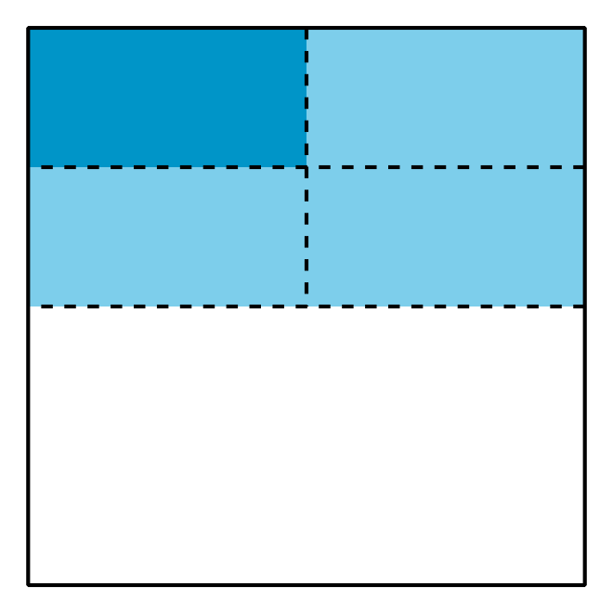
- Use the diagrams to show that $\frac{1}{4}$ of $\frac{1}{2}$ is $\frac{1}{8}$ of the whole pan.
© CC BY 2021 Illustrative Mathematics®

