Unit 5 Lesson 10: Tens and Tens, Ones and Ones

WU How Many Do You See: Tens and Ones (Warm up)

Student Task Statement
How many do you see?
How do you see them?
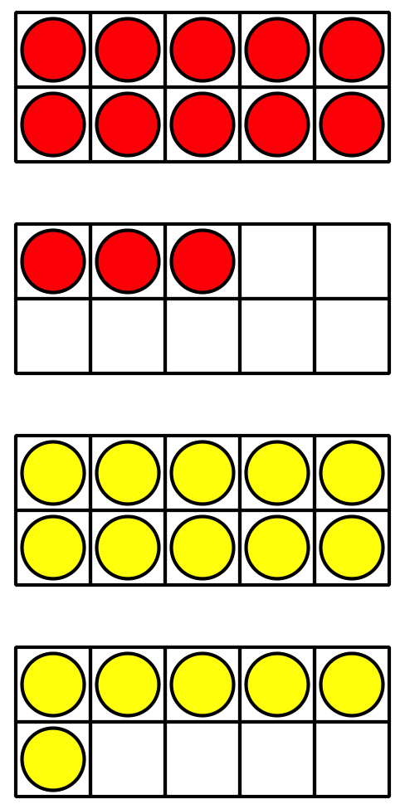
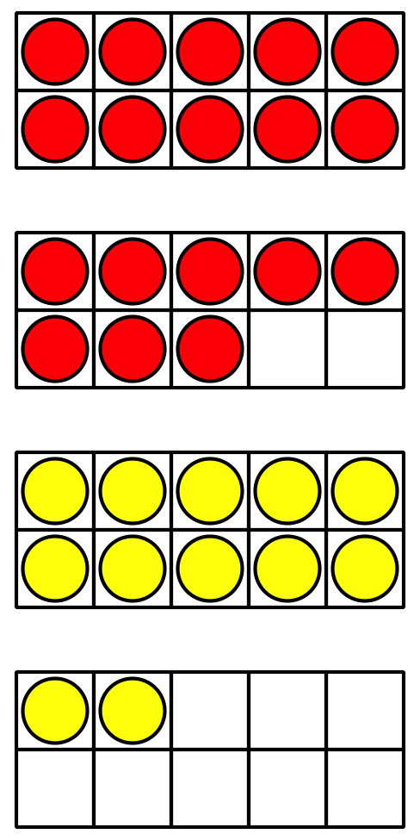
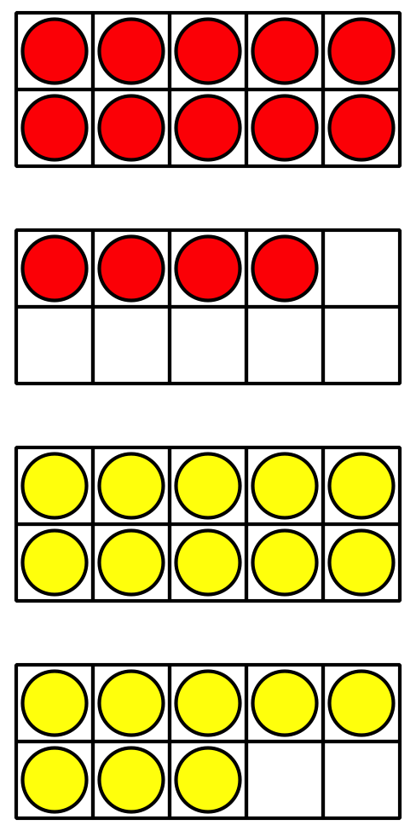

1 Priya‘s Work

Student Task Statement
Find the value of $37+26$.
Priya's work
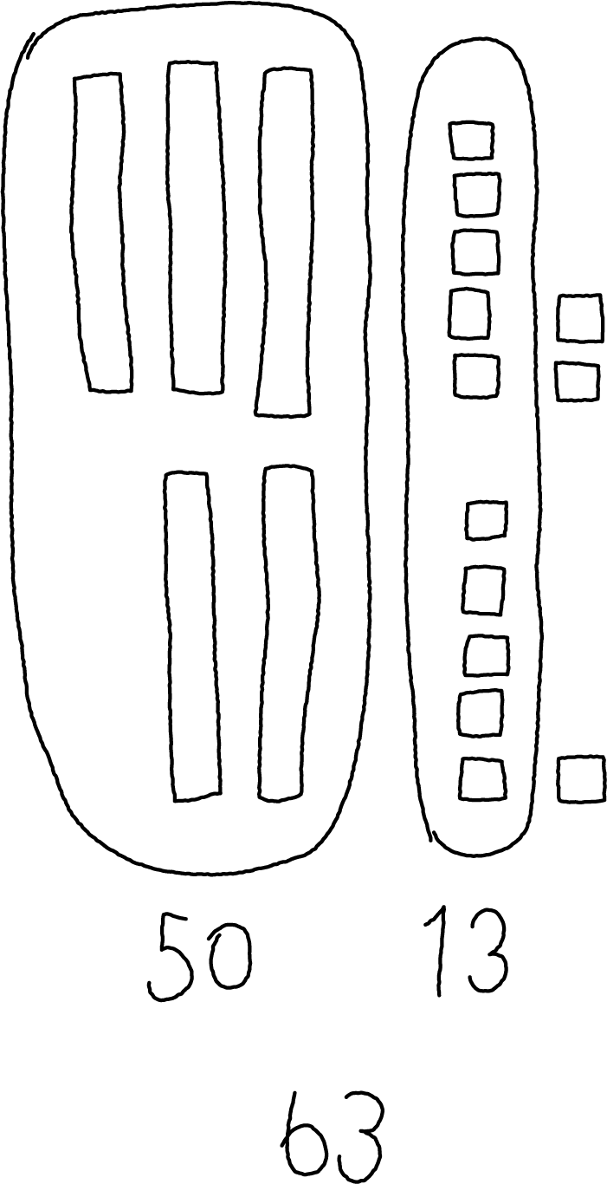
How did Priya find the value?

2 Finish the Work

Student Task Statement
- Each expression shows a first step to find the number that makes each equation true.
Finish the work to find the number that makes each equation true.
Show your thinking using drawings, numbers, or words.
  - 28+56=aaaiaaai
  - First step: $20+50$
  - 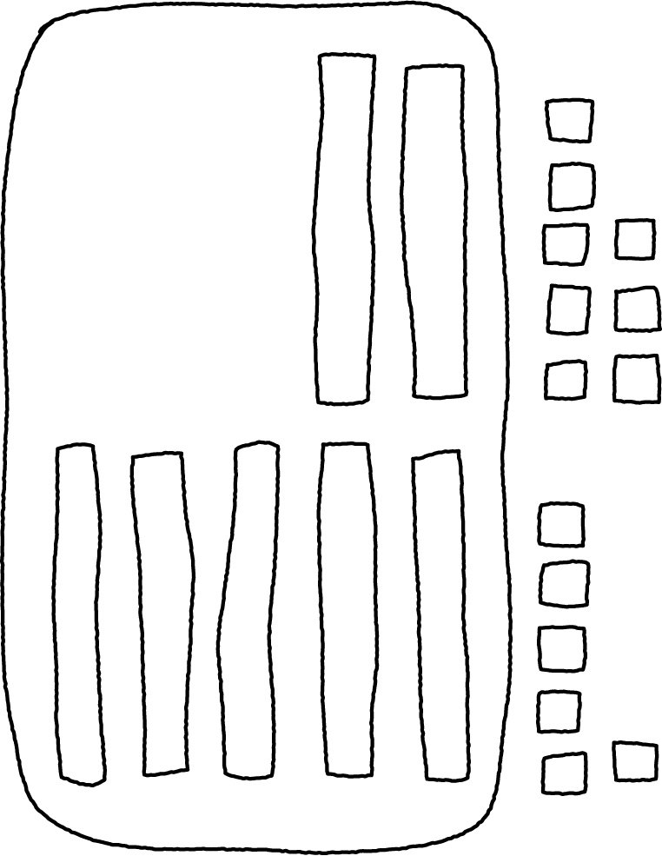
  - 27+44=aaaiaaai
  - First step: $7+4$
  - 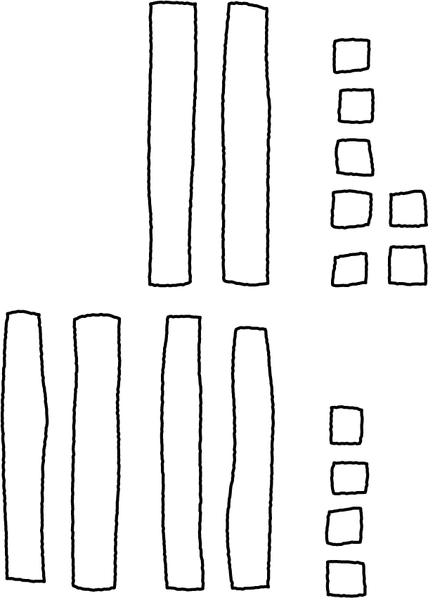
- Find the value of each sum.
Show your thinking using drawings, numbers, or words.
  - $34+57$
  - $18+55$

3 Introduce Number Puzzles, Within 100 with Composing

Student Task Statement
© CC BY 2021 Illustrative Mathematics®

