Lesson 17: Center Day 3
- Let’s work with shapes and numbers.

Warm-up: Which One Doesn’t Belong: Clocks
Which one doesn’t belong?
A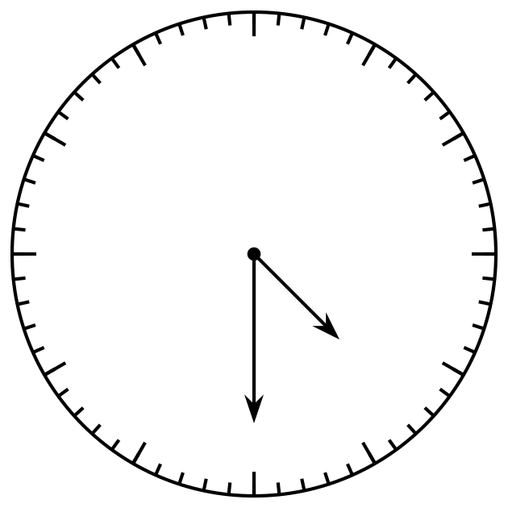
B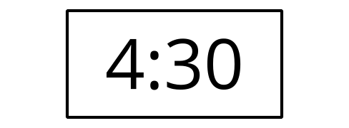
C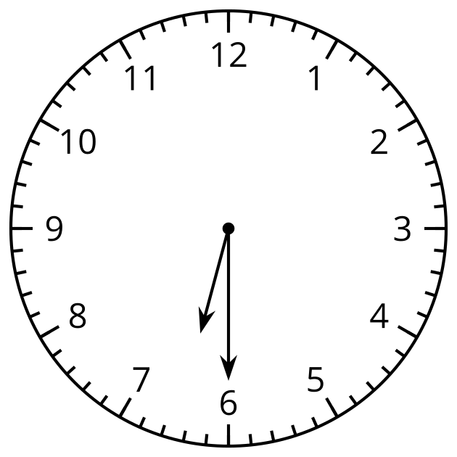
D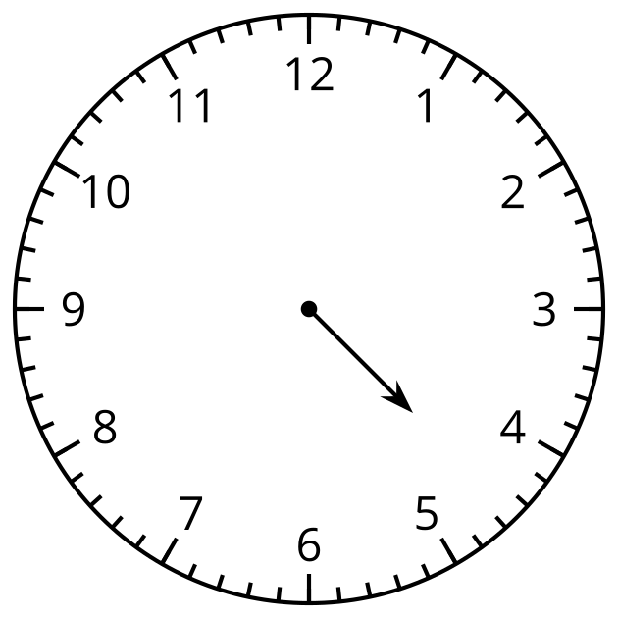

17.2: Centers: Choice Time
Choose a center.
Can You Draw It?
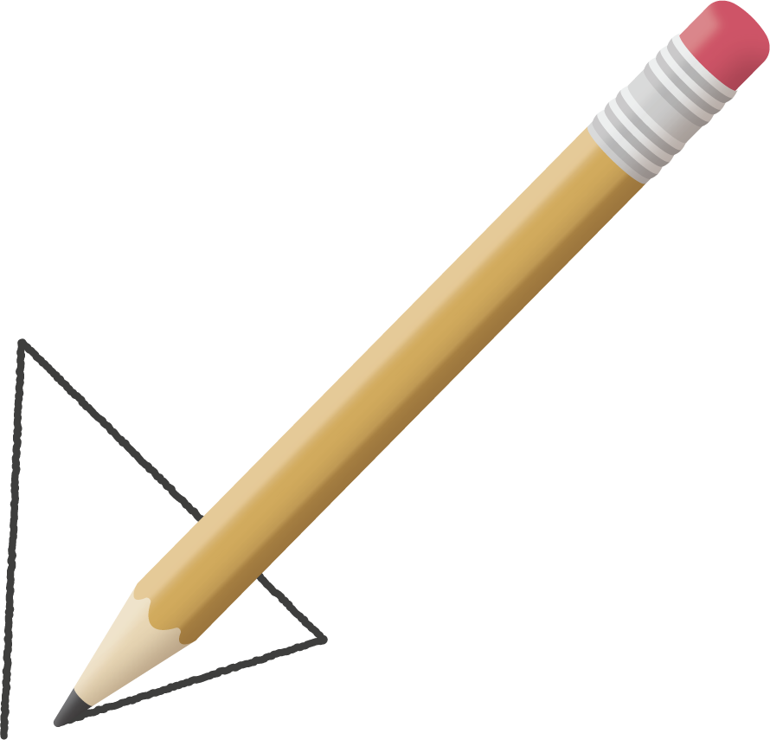
Match Mine
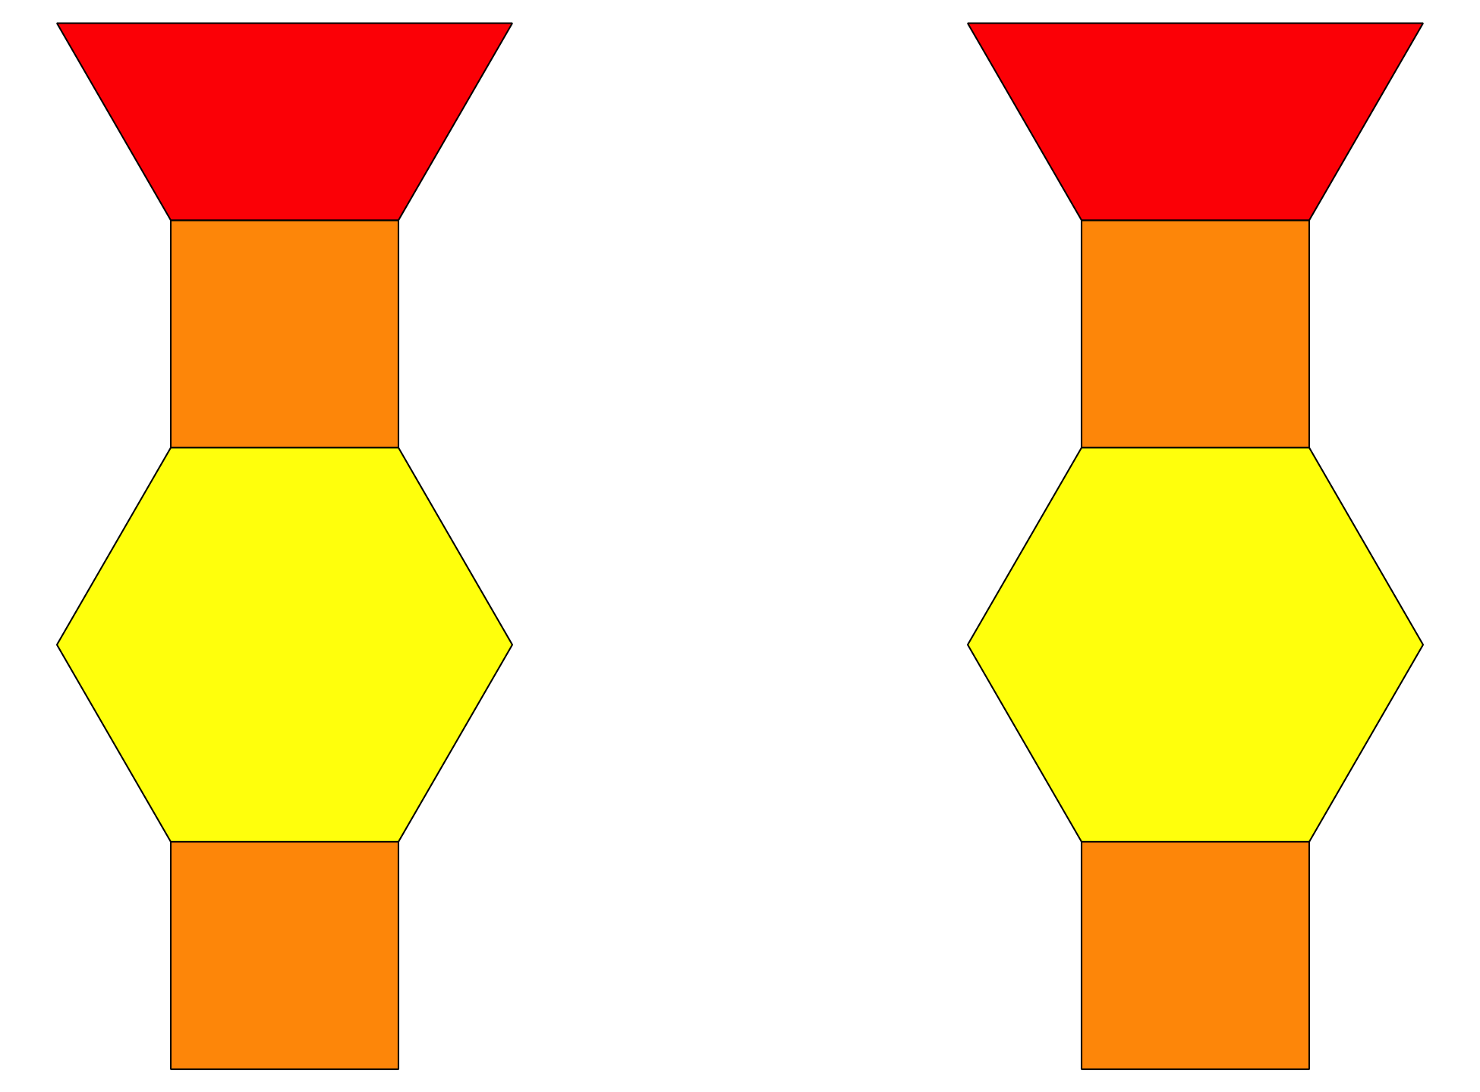
Capture Squares
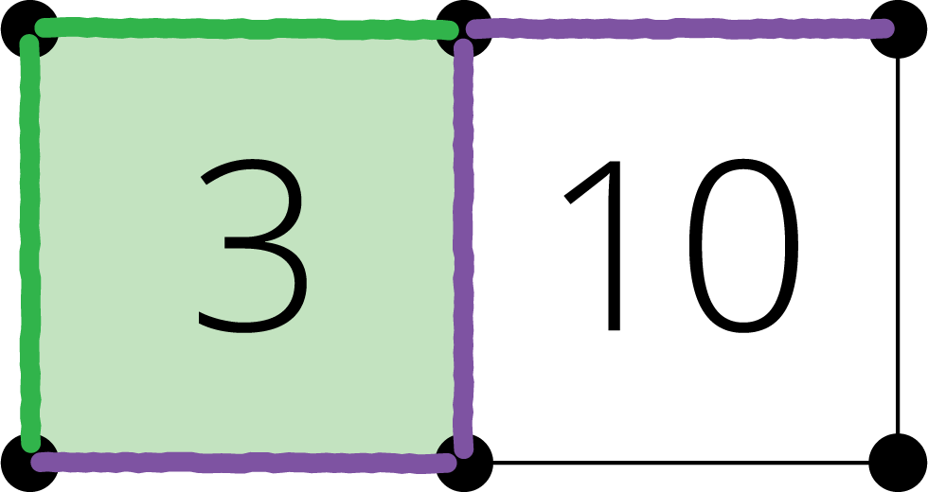
Target Numbers
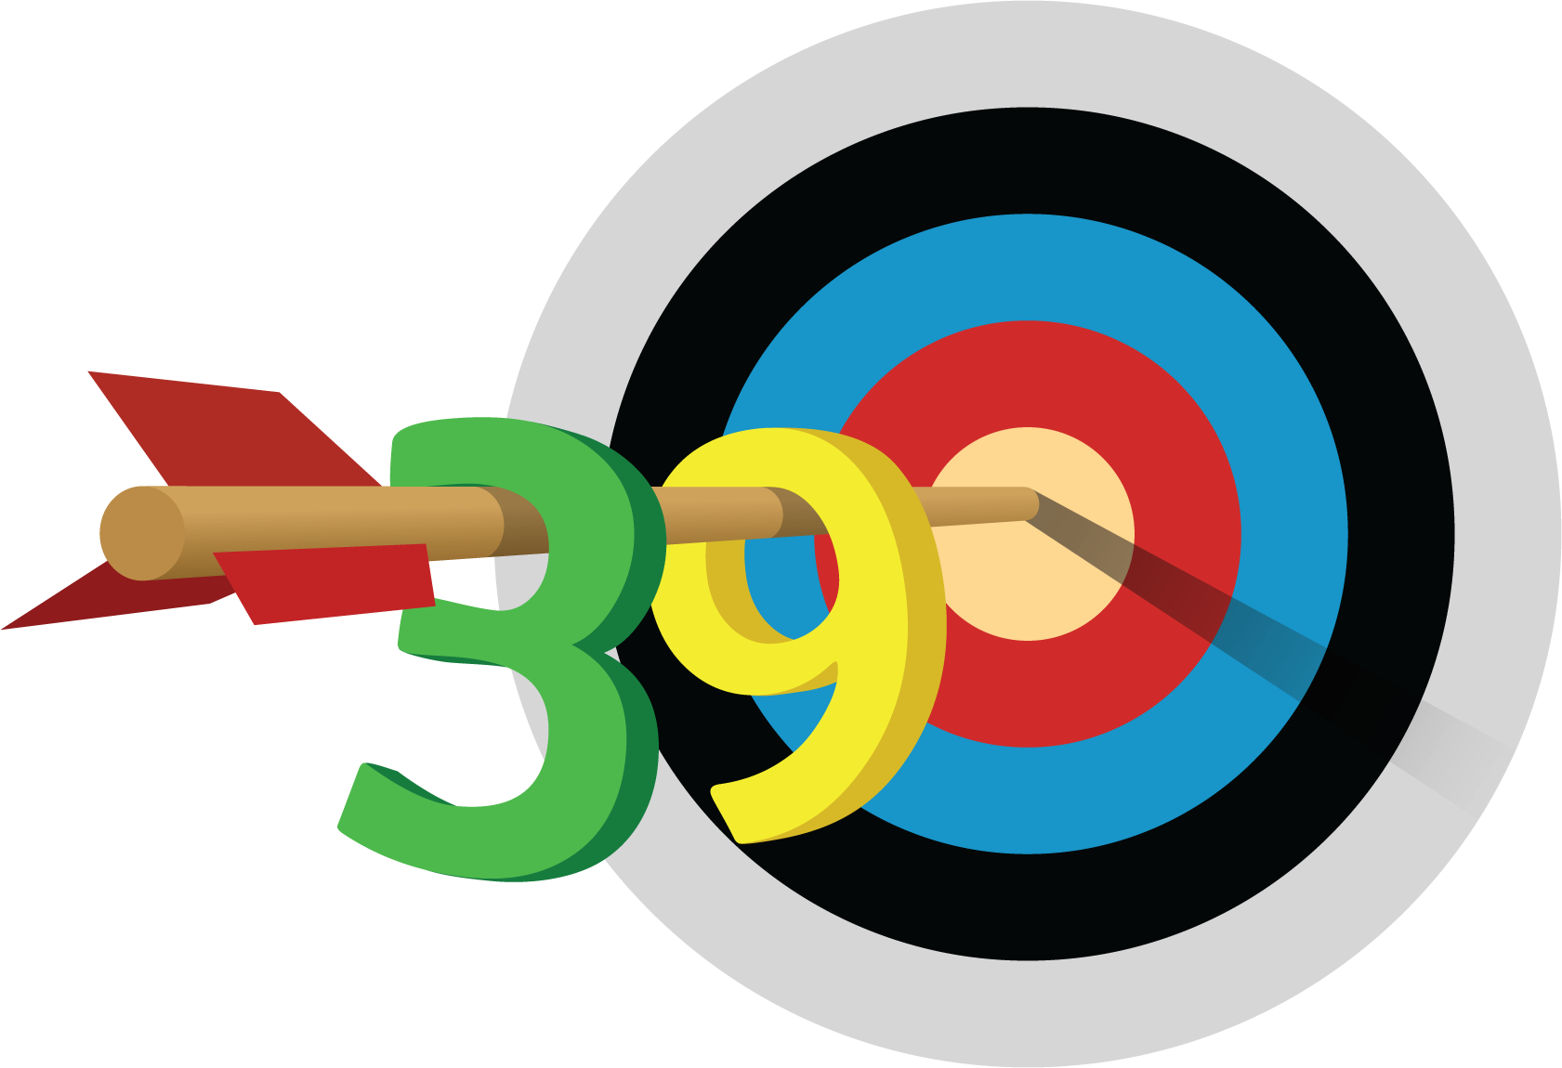
© CC BY 2021 Illustrative Mathematics®

