Lesson 1: Compare, Count on, and Count Back

Standards Alignments
Addressing | 2.NBT.A.2, 2.NBT.B.7, 2.NBT.B.8
Building Towards | 2.NBT.B.7

Teacher-facing Learning Goals
- Add and subtract within 1,000 using number relationships.

Student-facing Learning Goals
- Let’s compare numbers and add or subtract.

Lesson Purpose
The purpose of this lesson is for students to add or subtract within 1,000 using number relationships.
In a previous unit, students compared three-digit numbers using a number line and considered how close they were to one another and their distance from zero. In this lesson, students compare numbers and use the number line to consider ways to find the difference between 2 three-digit numbers. When locating numbers on the number line, students recognize that when the numbers are relatively close, they can simply count on or count back to determine the difference between the two numbers.
In the second activity, students analyze number lines and counting sequences that increase or decrease by 10 or 100. Using these number relationships, students label number lines by counting on or back by 10 or 100. The work of this activity helps prepare students to use and make sense of computation methods based on counting or adding on by place in upcoming lessons.

Access for:

Students with Disabilities
- Engagement (Activity 1)

English Learners
- MLR8 (Activity 2)

Instructional Routines
Number Talk (Warm-up)

Lesson Timeline
Warm-up | 10 min
Activity 1 | 20 min
Activity 2 | 15 min
Lesson Synthesis | 10 min
Cool-down | 5 min

Teacher Reflection Question
In previous lessons, students located and compared numbers on the number line. How did the number line help them make sense of subtraction methods based on counting on by place? How could you use number lines to help students make their thinking visible for others?

Cool-down
(to be completed at the end of the lesson) 5min
Subtract and Count

Standards Alignments
Addressing | 2.NBT.A.2, 2.NBT.B.7, 2.NBT.B.8

Student-facing Task Statement
- Locate and label 562 and 559 on the number line.
- Find the value of $562−559$. Show your thinking.
- Complete the list of numbers to show counting on by 100.
- 552, __________, __________, 852, 952
- Explain how you know your list shows counting on by 100 and not counting on by 10.

Student Responses
- $562−559=3$
- 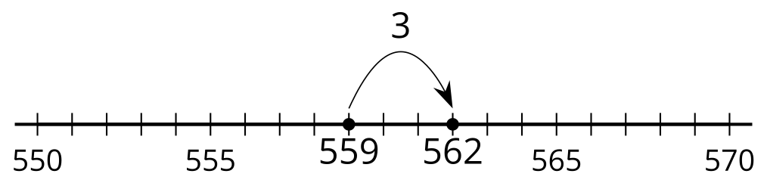
- 552, 652, 752, 852, 952. Sample response: I know it shows counting on by 100 and not 10 because the digit in the hundreds place changes and the digit in the tens place stays the same.

