Lesson 6: Survey the Class, Survey the School
- Let’s survey a large group.

Warm-up: Notice and Wonder: Survey
What do you notice? What do you wonder?
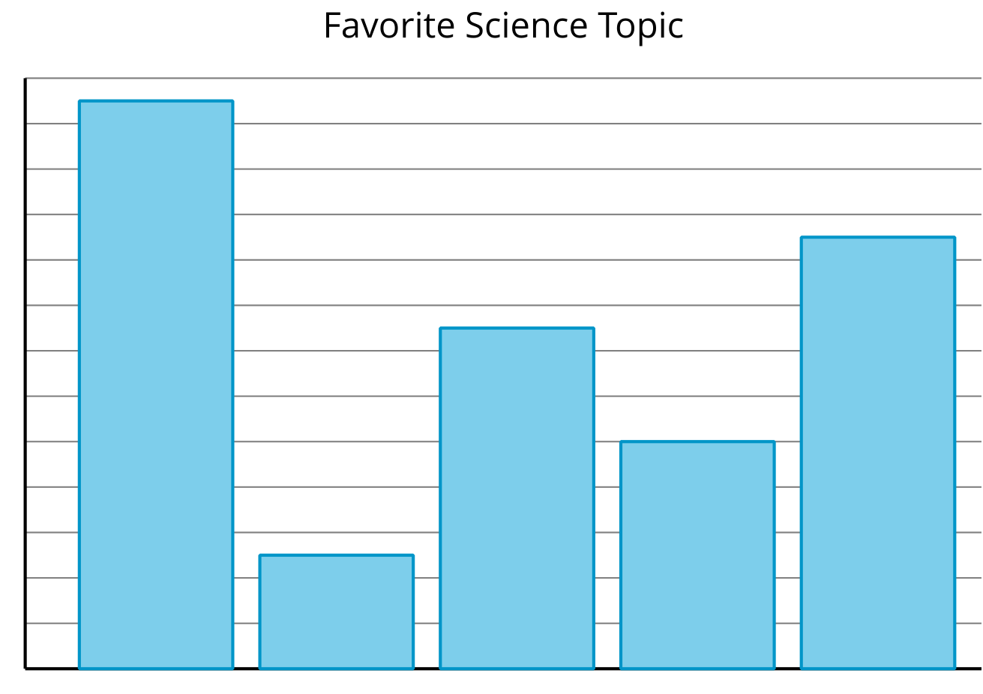

6.1: Create a Survey
Create a survey that you’ll use with a large group of students. It should include:
- a question
- up to 6 answer choices

6.2: Survey a Large Group
Your group will be surveying a lot of people. This means asking your survey question and giving the answer choices repeatedly.
To prepare for the work ahead, discuss these questions with your group:
- How will you present the survey question and answer choices? Who will present them?
- How will you record and organize the responses? Who will record them?
- How will you make sure you don't record a response from the same student multiple times?
© CC BY 2021 Illustrative Mathematics®

