Unit 2 Lesson 7: Equivalent Fractions

WU True or False: Equivalence (Warm up)

Student Task Statement
Decide if each statement is true or false. Be prepared to explain your reasoning.
- $\frac{4}{8}=\frac{7}{8}$
- $\frac{3}{4}=\frac{6}{8}$
- $\frac{2}{6}=\frac{2}{8}$
- $\frac{6}{3}=\frac{4}{2}$

1 Two or More Fractions

Student Task Statement
- Each entire diagram represents 1 whole. Write two or more fractions that the shaded part of each diagram represents. Be prepared to explain your reasoning.
  - 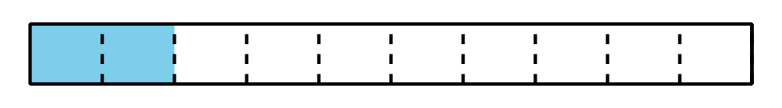
- Write two or more fractions that the point on each number line represents. Be prepared to explain your reasoning.
- Place a new point on a tick mark on one of the last two number lines (in part c or d). Then, write two fractions that the point represents.

2 Equivalent for Sure?

Student Task Statement
For each fraction, find two equivalent fractions.
Partner A
- $\frac{3}{2}$
- $\frac{10}{6}$
Partner B
- $\frac{4}{3}$
- $\frac{14}{10}$
Next, show or explain to your partner how you know that the fractions you wrote are equivalent to the original. Use any representation that you think is helpful.
© CC BY 2021 Illustrative Mathematics®

